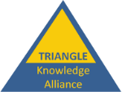
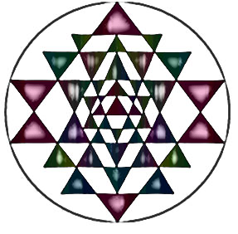
TRIANGLE
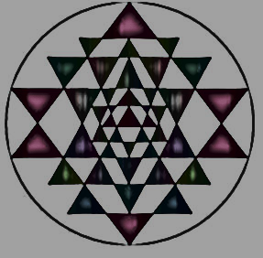
TOURISM RESEARCH, INNOVATION AND NEXT GENERATION LEARNING EXPERIENCE
A European Sustainable Tourism Research and Monitoring Higher Education & Business Network focused on ensuring the sustainability of Europe’s protected areas through the vector of tourism
=
TOURISM
Going GREEN 2030!
Orienting to the contemporary critical socio-economic and environmental challenges using the

+

cross-cutting vector of tourism for sustainable development
focused on protected areas and green destinations
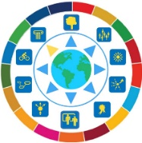
RESEARCH AND INNOVATION
The ‘European University’ Concept
HEIs collaborating to create knowledge acquisition and innovation transfer learning systems from research to market-place for multiple stakeholders across the European territory to meet our contemporary socio-economic and environmental 2030 Agenda.
NEXT GENERATION LEARNING EXPERIENCE .
An EU ERASMUS Knowledge Alliance
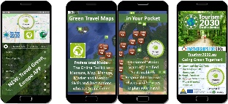
Defining the European Knowledge Economy through
multi-stakeholder knowledge and innovation communities
that shape student life-long learning by developing skills of
communication, creativity, critical thinking, collaboration, care and choice
applied to sustainability in tourism activity.
TOURISM 2030 TRIANGLE SERVICES –
COLLABORATIVE COURSE DEVELOPMENT & COMMON SUSTAINABILITY IMPLEMENTATION TOOLKIT
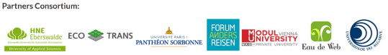
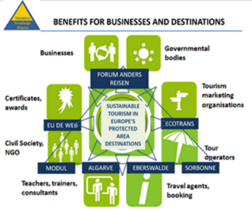
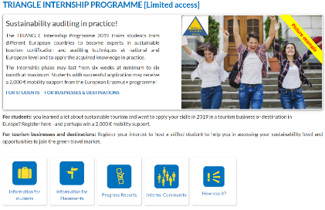
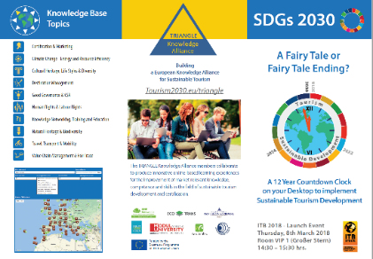
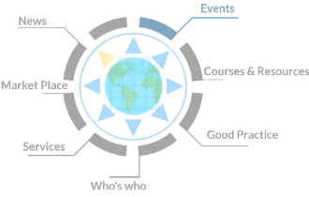
www.tourism2030.eu

