TRIANGLE Knowledge Alliance Members Agreement for Higher Education Institutes
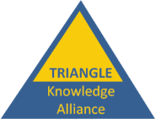

Vienna 11th September 2019

The Tourism Research, Innovation And Next Generation Learning Experience (TRIANGLE) project has created through the EU Erasmus Programme a knowledge alliance of higher education institutes and businesses across Europe, organised to deliver a common collaborative sustainable tourism information and training system to be used to support sustainable development in protected area and green destinations in Europe.

Members of the TRIANGLE Knowledge Alliance will benefit in the following ways:
- Have access to a professional and global sustainable tourism knowledge base (Tourism2030) including the Going Green Toolkit
- Have exclusive access to specifically designed online courses
- Be able to exclusively use the online course materials for future teaching
- Have exclusive access to a European internship database for students in the field of sustainable tourism
- Be part of a collaborative network of universities from all over Europe specialized in tourism research and education
- Be part of a collaborative funding and resourcing process for implementing the system
- Enjoy the status of becoming a National Sustainable Tourism Education and Training Centre

Members of the TRIANGLE network understand they will have the following responsibilities

- Appointing a contact person for your university to deal with the Alliance network management:
- Updating relevant information on the Tourism2030 knowledge base
- Peer reviewing and/or creating contents for the online courses
- Providing businesses for the internship programme at the European level
- Facilitating students able to join the internship programme
- Providing contacts for other universities that may be interested in joining the Alliance in the event of expanding the network
- Be part of a collaborative funding and resourcing process for implementing the system
- Work towards establishing the legal framework for a European Association or another appropriate legal form.

A temporary Governance Structure shall be established until 31st October 2019 depending on European Association rules and regulations.

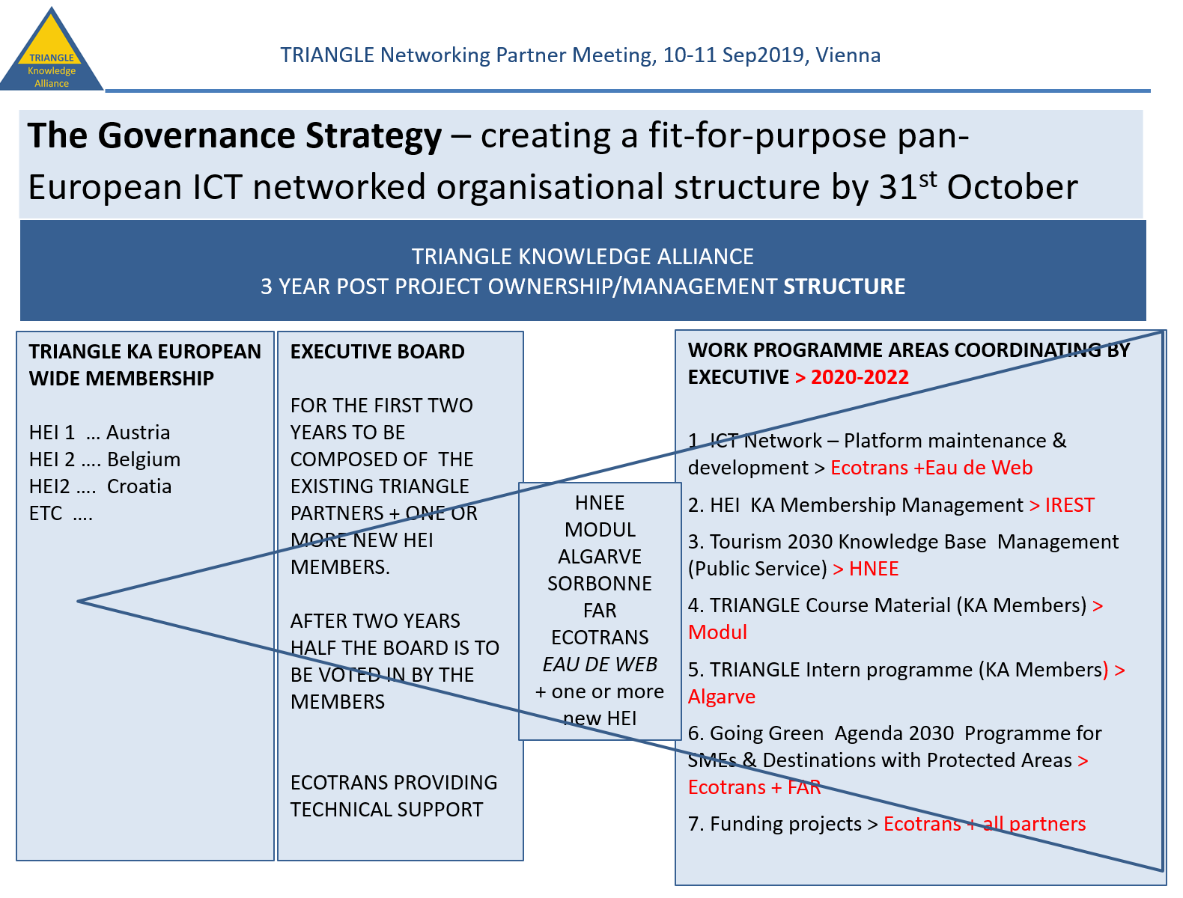

This document records those Higher Education Institutes and other Alliance members who participated in the final TRIANGLE project conference in Vienna who have expressed intention in being part of the TRIANGLE Knowledge Alliance. It is signed by the contact persons of the respective organisations attending the meeting.

The undersigned persons have consensus over forming collaboration will be based on a set of principles that are transversal to the European projects. This alliance will ensure principles and values of tolerance, mutual respect, transparency, openness, accountability and effectiveness.

I represent a HEI in Europe and am interested to join the TRIANGLE Knowledge Alliance.

Please contact me for further details:
Name of HEI
Website
Contact Person
Email address
Date, Place
Signature

