**Nin, Croatia – unique secret in the Lagoon – development of the Eko-park Ninska Laguna**

Nin - European Destinations of Excellence, is only 14 km from the regional center Zadar. Nin is located in a unique lagoon on the Adriatic coast, at the beginning of the fertile lowland areas.

After receiving the EDEN Award, the Tourist Board of the City of Nin established a clear vision of the development Eco-park Lagoon of Nin. Development based on a recognizable cultural and natural heritage and sustainable development. Nin is located in a lagoon on the eastern part of the Adriatic sea, surrounded by natural sandy beaches and linked with the mainland by two stone bridges (16th century). The heart of Nin is its historical centre on an islet that is 500 m in diameter and approximately covers 15 hectares surface area. The present-day city core of the town on the islet developed 3000 years ago and belongs to the older towns on the Mediterranean. The municipality takes a great deal of pride in conserving the historical city core. Nin is recognizable as a Prehistorical and Liburnian centre on the Adriatic coast and as a Roman municipality in the past. Nin is the oldest Croatian royal town and is the cradle of the Croatian state so called "The Croatian Bethlehem."

**Natural wealth**

Natural wealth that Nin possesses are:

- long natural sandy beaches,

- salt,

- medicinal mud,

- NATURA 2000 habitats,

- endemic and sensitive plant

- and special bird world.

To the east of the city core in the lagoon lie the salt pans and to the west is the mud fields (estimated reserve is approx. 120 m3) that have been used for rehabilitations for 44 years and sandy beaches that encompasses the old town. The sandy beaches surrounding Nin are 8 km long and are situated in the middle of 8 NATURA 2000 habitats which contains: 5 endemic, 4 critically endangered 1 endangered and 5 sensitive plant (registered in 2010). In 2010 biologists registered over 200 species of birds and endangered bird species whose numbers in Croatia and Europe are declining, especially the Stilt (Himantopus himantopus) and Marine Plover. In April and May you can see the rare and endemic plants in bloom, and also the juvenile Stilts because they nest at the salt pans in Nin. This knowledge of the rare plant and bird species that live in the lagoon has driven the Tourist Board to organize numerous educational workshops.

The oldest economic activity in Nin is salt harvesting in a traditional manner using sunlight and wind. This method of producing salt comes from Roman times. The salt producing enterprise in Nin is called Solana Nin (Salt Pans Nin). After Nin won the EDEN award, the population and enterprises in Nin received a kind of enlightenment and started to become ecologically, economically and environmentally aware of Nin’s wealth.

Educational work-shops held by famous Croatian biologists (Goran Šafarek and Jasenka Topić) educated the population of Nin on the NATURA 2000 habitat and the animal and plant diversities that live within the lagoon of Nin. This was extremely beneficial to Nin because the residential population of Nin was given a sense that they live in a unique environment and that they had to cherish and preserve this habitat, plant and animal diversity that live alongside them.

**Ecological activities**

Every year there are 2 days were residents of Nin go into action to help clean their surroundings. One day is called "The Big Green Clean," where people walk around the lagoon and pick up any garbage or other items that shouldn’t be in the environment, people also go scuba diving in the harbour of Nin and clean any bottles, cans or other garbage that might be there and haul it out by row boat and brought to shore to be disposed. The other day is called "Action Beach Cleaning," where people of Nin help clean the beach, plant flowers around the city, plant new trees for shade at the beach and rack the sand to clean any branches and leaves. This is particularly important because Nin is a summer destination and our beaches, nature and clean sea water is our greatest strength and attraction for tourist who come to Nin.

**Project Eko-park Ninska Laguna (Eco-park Lagoon of Nin)**

The project contains many sub-projects that are connected. The purpose of this project is to allow tourists to experience the soul of Nin: natural heritage which includes the: sandy beaches, medicinal mud fields, NATURA 2000 habitats, rare and endangered plant species and the flora and fauna that peacefully live there due to low traffic in the lagoon, and the rich history of producing salt in Nin close the cultural city core.

The main issue and challenge of this Eco-park is to try and find a balance between creating a diverse tourism offer, creating new employment in Nin and all this with producing the least amount of adverse effects on the surrounding environment. Since many birds use Nin’s natural habitat as a breeding ground and many fish use it as a spawning ground, drastic efforts must be used to avoid disturbing the balance of life within the lagoon.

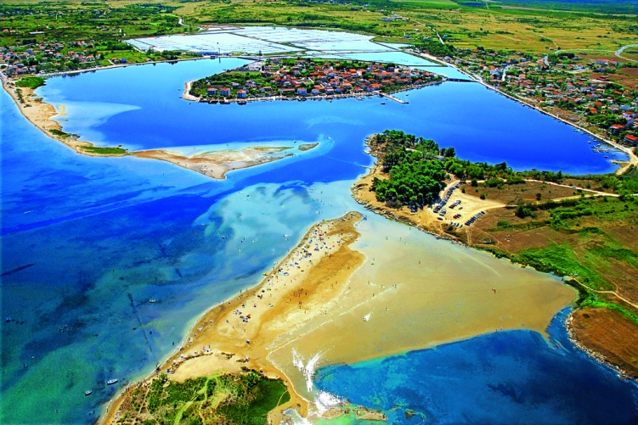

**How**

At the location of Queens beach a 5 km wooden trail was planned to be constructed which will allow easier access to the mud-fields and beach for individuals with disabilities, families with small children, tourists and locals to walk through the unique habitat. With strong effort of municipality of Nin and recognition of the Tourism Ministry of Croatia almost 1 km of trails are completed (2010 – 2013).

The tourist board helped advise, promote and develop tourism offer of Solana Nin. Solana Nin (salt pans Nin) offers: traditional production of salt, walking tours around the salt fields and the museum of salt.

In 2011, park Solana Nin was started. This project in its primary phase included a museum, a walking trail around the salt pans to see how salt is made and a covered picnic area for guests to use during their walks around the park and festivals that are held at the salt pans. A trail used for bird-watching since 2010 was also renovated because many bird species (over 200 species) use the salt pans as a breeding ground or as a stop-over in their long migration; south during fall and north during spring, and with the partnership with Solana Nin since 2010. organize annual European Bird-watching day.

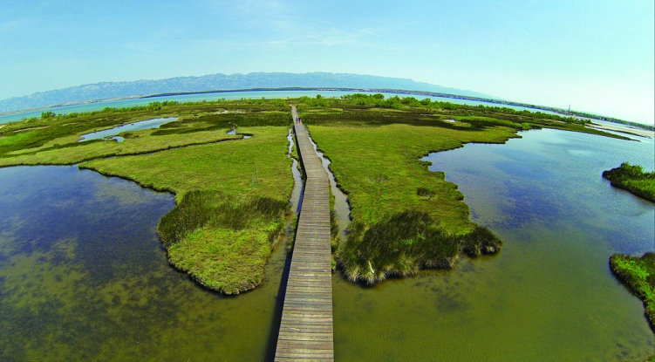

**Results**

- because of the interesting elements of the salt pans of Nin, several agencies from Croatia and foreign agencies offered the program of coming to salt pans and walking through these paths,

- easier mud field accessibility,

- increased visibility of the destination,

- enlightening the local population on Nin’s economic, environmental and ecological (plant and animal diversification) wealth,

- educating local youth, residential and tourist on the process of producing different types of salt and the significance of salt in Nin’s past,

- continuous increase in number of tourists and nights spent in the destination of Nin,

- countless educational signs that were erected to inform guests on the plant and bird bio diversity that lives in the habitat in the lagoon of Nin,

- numerous festivals that have been started to engage locals and tourists to partake in educational and entertaining events,

- development of trails that have been made in an ecological friendly manner around the NATURA 2000 habitats and future trails that will be built on the pre-existing trails has contributed to sustainable tourism and the promotion of tourism in Nin,

- attracting guests who are interested in local culture, heritage and customs,

- Eco-park lagoon Nin will diminish the effects of seasonality and it will lead to new job creation and increased employment and as an additional source of income in the destination.

**CONCLUSION**

Environment and nature comes first. Nin is a destination rich with natural beauty and if the local population and our projects are not ecologically friendly Nin will lose its advantages of development of sustainable tourism. The local municipality, tourist board, local population and the local enterprises all have started to work as a collusive team which has led to numerous awards and recognitions and will lead to the completion of Eco-park Lagoon of Nin.