RIO 2016 Olympic Truce POETRY TO SONG ENTRY FORM
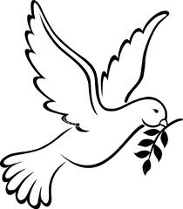
29th JULY –
25th SEPTEMBER
OLYMPIC GAMES
RIO 2016
OLYMPIC GAMES

Rules
The poem can be found online on the Olympic Truce Coordinators blog. Just put the words to music/or music and video:
https://brazil2016olympictruce.wordpress.com/2016/05/28/this-summers-games-the-heaven-days/
The competition will have two winners - one for best song, and one for best graphics. Entries have to be made online by 29 July 2016, the day the Truce starts. The Olympic Truce Peace Ambassadors will form a jury to judge the entries, with a decision announced on 5th August at the start of the Games.
To enter, please post your submission on Youtube and/or send the URL to Gordon.destinet@ecotrans.de along with your entry form
NAME
CONTACT EMAIL
ADDRESS
MALE/FEMALE
AGE
OCCUPATION
URL OF ENTRY ON YOUTUBE

PLEASE RETURN THIS FORM TO THE RIO 2016 OLYMPIC TRUCE PEACE CAMPAIGN ORGANISERS
BY
29TH July 2016

