rio 2016 Olympic Truce Responsible Stakeholder Report Card
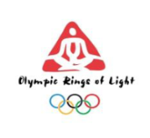
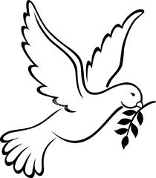
29th JULY –
25th SEPTEMBER
OLYMPIC GAMES
RIO 2016
OLYMPIC GAMES

This report card is designed to make the contribution of key stakeholders who are responsible for the implementation of the Olympic Truce transparent. It should be filled in with the cooperation of each stakeholder.
Name of Stakeholder | Support/  Cooperation with promotion & reporting process | Financial Contribution to the Truce/  Resources Mobilised  ($) | Human Resource Application to the Truce  (Personnel) | Media/Events Arranged to Highlight/  Celebrate the Truce  (Date and Description) | Contributions to National Olympic Truce Processes  (Country engaged) | Other Support  (Please state type of support)
 | Yes/No | 0  >1,000  >5,000  >10,000  >100,000  >1,000,000  1,000,000 > | 0  > 1 p/t  > 2 p/t  > 3 p/t  > 1 f/t  > 2 f/t  > 3 f/t  3 f/t >
PLEASE RETURN THIS FORM TO THE RIO 2016 OLYMPIC TRUCE PEACE CAMPAIGN ORGANISERS BY September 30TH 2016
Text of the UN Resolution 20 October 2015 – UN General Assembly Seventieth Session Agenda item 12 – Sport for Development and Peace: Building a Peaceful and Better World through Sport and the Olympic Ideal, p5
‘Urges Member States to observe the Olympic Truce individually and collectively, within the framework of the Charter of the United Nations, throughout the period from the seventh day before the start of the XXXI Olympic Summer Games until the seventh day following the end of the XV Paralympic Summer Games, to be held in Rio de Janeiro, Brazil; Underlines the importance of cooperation among Member States to collectively implement the values of the Olympic Truce around the world, and emphasizes the important role of the International Olympic Committee, the International Paralympic Committee and the United Nations in this regard; … Welcomes the cooperation among Member States, the United Nations and the specialized agencies, funds and programmes, and the International Olympic Committee and the International Paralympic Committee, to maximize the potential of sport to make a meaningful and sustainable contribution to the achievement of the Sustainable Development Goals within the 2030 Agenda for Sustainable Development, and encourages the Olympic and Paralympic movements to work closely with national and international sports organizations on the use of sport to this end;’

