RIO 2016 Olympic Truce AWAReNESS REport Card
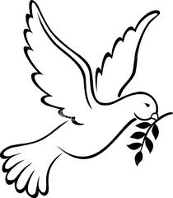
29th JULY –
25th SEPTEMBER
OLYMPIC GAMES
RIO 2016
OLYMPIC GAMES

This report card is designed to indicate the level of awareness of the Olympic Truce in countries participating in the Olympic Games. It should be based on a survey of 1000 or more people randomly interviewed during the Truce period, answering the following questions: a) Are you aware of the Olympic Truce? b) If so, where did you learn about it? c) Do you think the Truce has been successful? (NB Questionnaire sheets can be downloaded separately).
Country/Region/City:
Number of people aware of the Truce  % of 1000 | Source of awareness about the Truce (1) | Perception of Implementation Effort  No attempt | Perception of Implementation Effort  Failed | Perception of Implementation Effort  Partial | Perception of Implementation Effort  Full
< 5%
< 10%
< 15%
< 20%
< 25%
< 30%
< 40%
< 50%
< 60%
< 70%
< 80%
< 90%
100%
(1) Source code: A= Mainstream media B= Social Media C = Family/friends D = School E = Other

PLEASE RETURN THIS FORM TO THE RIO 2016 OLYMPIC TRUCE PEACE CAMPAIGN ORGANISERS BY
AUGUST 30TH 2016

