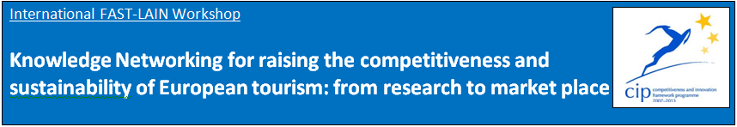

**Tasks covered in DestiNet Portal**

|  |  |
| --- | --- |
| **Content list** | **La Palma has completed:** |
| **Our knowledge base folder on DestiNet** | <http://destinet.eu/who-who/civil-society-ngos/fastlain/fast-lain-virtual-office/partner-sections/2.consorzio-insular-de-la-reserva-mundial-de-la-biosfera-la-palma-spain> |
| **Our sustainable tourism thematic framework**  **Select 30-60 most relevant keywords for your cluster from the DestiNet Keyword Glossary** | <http://destinet.eu/who-who/civil-society-ngos/fastlain/fast-lain-virtual-office/partner-sections/2.consorzio-insular-de-la-reserva-mundial-de-la-biosfera-la-palma-spain/i.-innovation-cluster/cluster-keywords/topics-keywords-la-palma> |
| **Our cluster organisations on the DestiNet Atlas / Our regional/national information sources** | <http://destinet.eu/who-who/civil-society-ngos/fastlain/fast-lain-virtual-office/partner-sections/2.consorzio-insular-de-la-reserva-mundial-de-la-biosfera-la-palma-spain/i.-innovation-cluster/1.3-information-sources> |
| **Our cluster workshop/s** | <http://destinet.eu/who-who/civil-society-ngos/fastlain/fast-lain-virtual-office/partner-sections/2.consorzio-insular-de-la-reserva-mundial-de-la-biosfera-la-palma-spain/ii.-regional-workshop> |
| **Our regional/national/ thematic publications** | <http://destinet.eu/who-who/civil-society-ngos/fastlain/fast-lain-virtual-office/partner-sections/2.consorzio-insular-de-la-reserva-mundial-de-la-biosfera-la-palma-spain/i.-innovation-cluster/1.3-information-sources/publications> |
| **Our monitoring and observatory environment** | Sent by e-mail to Gordon |
| **Our good practice “market solutions”** | <http://destinet.eu/who-who/civil-society-ngos/fastlain/fast-lain-virtual-office/partner-sections/2.consorzio-insular-de-la-reserva-mundial-de-la-biosfera-la-palma-spain/iii.-research-market-place/3.2-good-practices-organisations/good-practice-selection-criteria> |
| **Our list of businesses “towards sustainable tourism” on the DestiNet Atlas** | <http://destinet.eu/who-who/civil-society-ngos/fastlain/fast-lain-virtual-office/partner-sections/2.consorzio-insular-de-la-reserva-mundial-de-la-biosfera-la-palma-spain/iii.-research-market-place/3.2-good-practices-organisations> |
| **Our cluster good practice examples on the DestiNet Atlas** | Sent by e-mail to Herbert |
| **Our national language portal: our folder title page in national language** | To be seen in Paris |
| **Our national language information flyer** | Sent by e-mail to Herbert |
| **Our own website linked with DestiNet** | We have no web designer at this moment |
| **Helpful information on DestiNet (examples)** | To be seen in Paris |
| **Our questions to experts** | <http://destinet.eu/who-who/civil-society-ngos/fastlain/fast-lain-virtual-office/fast-lain-project-work-packages-and-deliverables/wp6-broadcasting-project-outcomes/fast-lain-international-workshop-24-25-may-2012-paris/ask-expert-questions> |
| **Our knowledge networking continuation plan for the portal use** | <http://destinet.eu/who-who/civil-society-ngos/fastlain/fast-lain-virtual-office/partner-sections/2.consorzio-insular-de-la-reserva-mundial-de-la-biosfera-la-palma-spain/iv.-administrative-documents/4.4-reports> |
| **DestiNet for Destinations: our 3 suggestions** | <http://destinet.eu/who-who/civil-society-ngos/fastlain/fast-lain-virtual-office/fast-lain-project-work-packages-and-deliverables/wp6-broadcasting-project-outcomes/fast-lain-international-workshop-24-25-may-2012-paris/destinet-destinations-suggestions> |