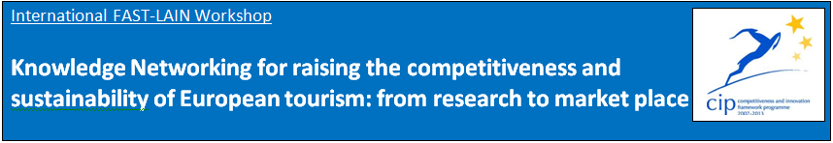

**Tasks covered in DestiNet Portal**

|  |  |
| --- | --- |
| **Content list** | **IREST has completed:** |
| **Our knowledge base folder on DestiNet** | <http://destinet.eu/who-who/civil-society-ngos/fastlain/fast-lain-virtual-office/partner-sections/4.irest-universite-paris-i-pantheon-sorbonne-france> |
| **Our sustainable tourism thematic framework**  **Select 30-60 most relevant keywords for your cluster from the DestiNet Keyword Glossary** | To be done |
| **Our cluster organisations on the DestiNet Atlas / Our regional/national information sources** | <http://destinet.eu/demo-design/portal_map?lat_center=48.7362668466753&lon_center=2.40875244140625&map_zoom=9&map_engine=google&base_layer=satellite&geo_types%3Alist=symbol921&geo_types%3Alist=symbol806&geo_types%3Alist=symbol906&geo_types%3Alist=symbol395&geo_types%3Alist=symbol446&geo_types%3Alist=symbol678&geo_types%3Alist=symbol984&geo_types%3Alist=symbol130&geo_types%3Alist=symbol683&geo_types%3Alist=symbol834&geo_types%3Alist=symbol930&geo_types%3Alist=symbol009&geo_types%3Alist=symbol338&geo_types%3Alist=symbol092&geo_types%3Alist=symbol247&geo_types%3Alist=symbol998&geo_types%3Alist=symbol029&geo_types%3Alist=symbol078&geo_types%3Alist=symbol876&country=&path=&geo_query=Fast-Lain> |
| **Our cluster workshop/s** | <http://destinet.eu/who-who/civil-society-ngos/fastlain/fast-lain-virtual-office/partner-sections/4.irest-universite-paris-i-pantheon-sorbonne-france/ii.-regional-workshop> |
| **Our regional/national/ thematic publications** | <http://destinet.eu/who-who/civil-society-ngos/fastlain/fast-lain-virtual-office/partner-sections/4.irest-universite-paris-i-pantheon-sorbonne-france/i.-innovation-cluster/1.3-information-sources/information-sources-irest> |
| **Our monitoring and observatory environment** | To see with Gordon |
| **Our good practice “market solutions”** | Separation between organizations and good practices has still to be done. The criteria has to be updated: certified by + link…,or member of…+link, etc |
| **Our list of businesses “towards sustainable tourism” on the DestiNet Atlas** | To be done in order to make the previous point. |
| **Our cluster good practice examples on the DestiNet Atlas** | Same comment as above. |
| **Our national language portal: our folder title page in national language** | To be discussed in Paris meeting |
| **Our national language information flyer** | To see with Herbert |
| **Our own website linked with DestiNet** | To be done |
| **Helpful information on DestiNet (examples)** | To be done |
| **Our questions to experts** | To be discussed in Paris meeting |
| **Our knowledge networking continuation plan for the portal use** | To be done |
| **DestiNet for Destinations: our 3 suggestions** | To be done |