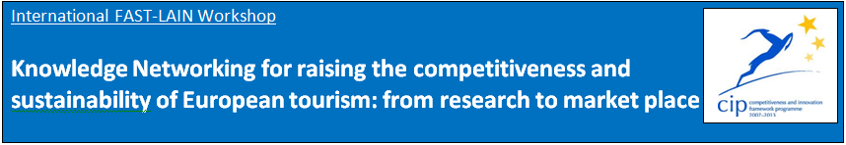

**Tasks covered in DestiNet Portal**

|  |  |
| --- | --- |
| **Content list** | **ALGARVE has completed:** |
| **Our knowledge base folder on DestiNet** | <http://destinet.eu/who-who/civil-society-ngos/fastlain/fast-lain-virtual-office/partner-sections/8.universidade-do-algarve-portugal> |
| **Our sustainable tourism thematic framework**  **Select 30-60 most relevant keywords for your cluster from the DestiNet Keyword Glossary** | <http://destinet.eu/who-who/civil-society-ngos/fastlain/fast-lain-virtual-office/partner-sections/8.universidade-do-algarve-portugal/i.-innovation-cluster/cluster-keywords> |
| **Our cluster organisations on the DestiNet Atlas / Our regional/national information sources** | <http://destinet.eu/who-who/civil-society-ngos/fastlain/fast-lain-virtual-office/partner-sections/8.universidade-do-algarve-portugal/iii.-research-market-place/3.1-stakeholders-contacts> |
| **Our cluster workshop/s** | <http://destinet.eu/who-who/civil-society-ngos/fastlain/fast-lain-virtual-office/partner-sections/8.universidade-do-algarve-portugal/i-fast-lain-workshop> |
| **Our regional/national/ thematic publications** | <http://destinet.eu/who-who/civil-society-ngos/fastlain/fast-lain-virtual-office/partner-sections/8.universidade-do-algarve-portugal/i.-innovation-cluster/1.3-information-sources/publications/national-regional-thematic-publications> |
| **Our monitoring and observatory environment** | Sent by e-mail to Gordon |
| **Our good practice “market solutions”** | <http://destinet.eu/who-who/civil-society-ngos/fastlain/fast-lain-virtual-office/partner-sections/8.universidade-do-algarve-portugal/preparation-checklist-partners/good-practice-market-solutions/good-practice-selection-criteria>  Selection criteria + hyperlinks to be done. |
| **Our list of businesses “towards sustainable tourism” on the DestiNet Atlas** | <http://destinet.eu/who-who/civil-society-ngos/fastlain/fast-lain-virtual-office/partner-sections/8.universidade-do-algarve-portugal/iii.-research-market-place/3.2-good-practices-organisations/> |
| **Our cluster good practice examples on the DestiNet Atlas** | <http://destinet.eu/who-who/civil-society-ngos/fastlain/fast-lain-virtual-office/partner-sections/8.universidade-do-algarve-portugal/iii.-research-market-place/good-practices-examples> |
| **Our national language portal: our folder title page in national language** | Done, please see destinet.eu (Portuguese option)  To be discuss in Paris |
| **Our national language information flyer** | <http://destinet.eu/who-who/civil-society-ngos/fastlain/fast-lain-virtual-office/partner-sections/8.universidade-do-algarve-portugal/preparation-checklist-partners/destinet-and-fast-lain-flyers> |
| **Our own website linked with DestiNet** | Done.  Note that our cluster official page is on Facebook: <http://www.facebook.com/pages/FAST-LAIN-Algarve-Nature-Tourism-Network/416979558320238> |
| **Helpful information on DestiNet (examples)** | <http://destinet.eu/who-who/civil-society-ngos/fastlain/fast-lain-virtual-office/partner-sections/8.universidade-do-algarve-portugal/preparation-checklist-partners/helpful-information-destinet> |
| **Our questions to experts** | To be discussed in Paris |
| **Our knowledge networking continuation plan for the portal use** | To be done and discussed in Paris |
| **DestiNet for Destinations: our 3 suggestions** | To be done and discussed in Paris |