Good Practice in Sustainable Tourism

Developing a Measurement System by Providing a Model Assessment Procedure

Wei Huang

Supervisors

Mikael Backman

Lars Hansson

Thesis for the fulfilment of the

Master of Science in Environmental Management and Policy

Lund, Sweden, September 2011

© You may use the contents of the IIIEE publications for informational purposes only. You may not copy, lend, hire, transmit or redistribute these materials for commercial purposes or for compensation of any kind without written permission from IIIEE. When using IIIEE material you must include the following copyright notice: ‘Copyright © Wei Huang, IIIEE, Lund University. All rights reserved in any copy that you make in a clearly visible position. You may not modify the materials without the permission of the author.

Published in 2011 by IIIEE, Lund University, P.O. Box 196, S-221 00 LUND, Sweden,

Tel: +46 – 46 222 02 00, Fax: +46 – 46 222 02 10, e-mail: iiiee@iiiee.lu.se.

ISSN 1401-9191

Acknowledgements

I am very grateful to my thesis supervisors and advisors Mikael Backman and Lars Hansson, who have been invaluable with their teaching, advise, guidance and patience, allowing me to find my biggest interests in sustainable tourism area, and enjoy a pleasant trip to the beautiful village Sigri.

I would also like to express my sincere appreciation to the FAST-LAIN project and the staff from FAST-LAIN project group, Herbert Hamele, Gordon Sillence and Tamar Chelidze who were not only kind enough to offer me their assistance but also had the patience to answer my questions.

I am deeply indebted to my close families, Tim David Ronny Fors, Keqin Cheng and Bin Huang, as well as my dear friends Yunwen Bai, Xiao Li and some new friends I met in Sigri this year, Meiling Su, Hui Zhou and Xin Ouyang, with their constant support, help and tight relationship, I could finally make this project to its completion in a time of personal hardship. To all of you, I am eternally grateful. Tack så mycket, Xie xie and thank you very much!

I still want to send my great thanks to the village Sigri and the friends in Greece, where I experienced a unique summer and kept company by a great number of good people, the farewell party in Adonis’ Restaurant was so impressive and unforgettable. Again, hereby I must thank to Mikael Backman and Lars Hansson who provided me this precious chance.

The last year at IIIEE has endowed me with plenty wealth knowledge and inspiration, and fire new skill and memorable experiences, without which this thesis would not have been possible. This I own to the 16th Batch of the 2009-2011 EMP programme, friends, and staff.

Abstract

There are many good practice examples in sustainable tourism, but the difficulty is how they can be transparently measured, monitored and disseminated. The study aims to develop a measurement system for good practice in sustainable tourism, meanwhile to make some contribution to the monitoring and reporting system. In order to accomplish this, the thesis allocates good practice examples into a Sustainable Tourism Research Framework and proposes a model assessment procedure by using the Global Sustainable Tourism Criteria. During the research studying course, samples selection was conducted, followed by the assortment of the selected good practice examples into the research framework, by which good practices can be monitored through the huge research framework as a network and platform. To further measure and monitor these in sustainable tourism, it requires a model assessment procedure to provide a standard process for evaluating and assessing the tourism sustainability. Hence a nine steps’ procedure is developed based on the previous assessment research studies.

**Keywords:** sustainable tourism, good practice example, sustainable tourism research framework, global sustainable tourism criteria, tourism assessment procedure

Executive Summary

It is widely acknowledged, that tourist industry has been influencing the development of current world rapidly and significantly. While due to the fast development of tourism, growing pressure is being wrought on the sensitive environment and ecosystem locally and globally. By widely recognizing these crucial problems and raising awareness among human beings, more and more concrete and motivated initiatives and programmes which tend to achieve sustainable development in tourist industry, are being launched from local level to international range.

Though there are huge amount of initiatives attempting to promote a sustainable tourism; sustainable tourism development system, as an idea, it is still vague itself. Lack of consolidated criteria and indicators, specially a well developed measurement system, is sounding the alarm for the development of sustainable tourism; since the existing measurements systems for tourism sustainability tend to depend on subjective evaluation with referencing very few criteria and/or indicators.

This study’s primary focus is to develop a measurement system, a system that is based on a commonly used and widely accepted criteria and indicators system. In order to be able to construct a model assessment procedure, an extensive literature review was conducted to provide a theoretical and conceptual basis. The literature review identified the relationship between sustainable development and tourism, as well as the definition, principles and key factors of sustainable tourism. The literature review is complemented by assisting a sustainable tourism course in Sigri, Greece. Interviews and group studies were conducted by guiding a group of master students under this course. All of these information and data collection establish a conceptual framework for further analysis.

During the process of analysis, the Global Sustainable Tourism Criteria and current indicators systems were introduced, to better understand the measurement systems and provide a basis for further utilization of these criteria and indicators. Current version of the Global Sustainable Tourism Criteria is constituted of four main indicators, which are emphasizing different impacts in terms of governance, social-economic, cultural and environmental aspects. Current commonly used indicators systems contains indicators developed by European Commission and the United Nations World Tourism Organization. According to the findings and evaluations done, it was found that the EC indicator system needs to be refined and adapted, thus an improved indicator system was developed under the sustainable tourism course.

Afterwards, the Sustainable Tourism Research Framework was provided with eight thematic topics. Though currently this research framework is still under developed stage, a hypothesis was proposed by FAST-LAIN project framework, that good practice examples can be sorted into this research framework. By a random selection of good practice samples from DestiNet’s Atlas of Excellence and sorting these examples, it is proved that good practice examples can be sorted into the Sustainable Tourism Research Framework.

In addition, the feasibility of this research framework can also be functioned as a huge network, to connect different stakeholders and share the knowledge and good practices showcase, finally works as a constant monitoring system. Moreover, by cross-reference the Global Sustainable Tourism Criteria and the Sustainable Tourism Research Framework, an observatory research framework is provided, in order to collect more information and open out a wide range of observation to transfer best practice knowledge into a regional level, eventually provide guidance and diverse research topics for further improvement.

After the allocation of good practice examples, it can be found that each good practice example can at least be sorted into one thematic topic within the research framework. However, the ultimate goal is leading the good practice examples towards more sustainable tourism and covering all the topics of this research framework. Thus, a measurement system needs to be provided, in order to assess and evaluate their current tourism sustainability and indicate a further development.

In line with developing a measurement system, this study attempts to provide a model assessment procedure for sustainable tourism. Based on literature reviews, a nine-step procedure is proposed, namely: identify the systems; identify the twelve principles/dimensions; identify the Global Sustainable Tourism Criteria; identify the main indicators; scale tourism sustainability; grade tourism sustainability; develop tourism sustainability assessment maps; continuous assessment; and estimations. Further analysis and discussions on how to possibly improve the proposed assessment procedure is also presented, followed by some conclusions regarding the assessment procedure.

The thesis sums up by drawing overall conclusions from each research questions and by recommending areas for future research. The overall findings are that good practice examples can be sorted by the Sustainable Tourism Research Framework and the potentials of this research framework is valuable in the development of sustainable tourism. As well as by combination using the sustainable tourism principles, the Global Sustainable Tourism Criteria and the relevant indicators systems, a proposed model assessment procedure for tourism sustainability can be provided. However, all of these still need to be proved in their actual practical application. Time can tell.

Table of Contents

List of Figures III

List of Tables IV

Abbreviations V

1. Introduction 1

1.1 Research Background 1

1.1.1 General Context 1

1.1.2 About the FAST-LAIN Project 2

1.1.3 Problem Identification 4

1.2 Thesis Objective 5

1.3 Scope 5

1.4 Limitations 6

1.5 Methodology 6

1.6 Thesis Content 7

2. Conceptual Framework for Sustainable Tourism 9

2.1 Sustainable Tourism Definition 9

2.1.1 Sustainable Development: a Cornerstone 9

2.1.2 Tourism and Sustainability: a Special Relationship 10

2.1.3 Creating a more Sustainable Tourism 11

2.2 Sustainable Tourism Principles 12

2.3 The Key Factors in Sustainable Tourism 14

2.3.1 Important Actors in Sustainable Tourism 14

2.3.2 Tourist Destination: an Indispensable Factor 16

3. Sustainable Tourism Criteria and Indicator System 18

3.1 Global Sustainable Tourism Criteria 18

3.1.1 Introduction and Development of GSTC Criteria 18

3.1.2 Elements of Global Sustainable Tourism Criteria 19

3.2 Sustainable Tourism Indicators and Measurements 22

3.2.1 Introduction of Indicators and Measurement System 22

3.2.2 Current Development and Improvement 22

4. Sustainable Tourism Research Framework 25

4.1 An Introduction and Development 25

4.1.1 Introduction of the Sustainable Tourism Thematic Framework 25

4.1.2 What is DestiNet 26

4.1.3 Elements of the Sustainable Tourism Thematic Framework 28

4.2 Future Steps and Considerations 29

4.2.1 Current Stage and the Next 29

4.2.2 Future Considerations 32

5. Information Collection for the Sustainable Tourism Research Framework 33

5.1 Allocation of Good Practice Examples 33

5.1.1 DestiNet's Atlas of Excellence 33

5.1.2 Sorting Good Practice Examples 34

5.2 The Value of Research Framework 36

5.2.1 Findings from the Sorting of Good Practice Examples 36

5.2.2 Observatory Research Framework 37

5.3 Conclusions 39

6. Sustainable Tourism Assessment Review 40

6.1 Previous Research Findings 40

6.1.1 Identifying Problems and Concerns 40

6.1.2 Important Factors in Assessment 40

6.2 Methods for Sustainable Tourism Assessment 41

7. A Proposed Model Assessment Procedure 43

7.1 Provide a Model Assessment Procedure 43

7.1.1 Identify the Systems 43

7.1.2 Identify the Twelve Principles 45

7.1.3 Identify Global Sustainable Tourism Criteria 46

7.1.4 Identify the Main Indicators 50

7.1.5 Scale Tourism Sustainability 50

7.1.6 Grade Tourism Sustainability 51

7.1.7 Develop Tourism Sustainability Assessment Maps 51

7.1.8 Continuous Assessment 57

7.1.9 Estimation 57

7.2 Further Analysis and Discussions 57

7.3 Conclusions 60

8. Conclusion and Recommendation 62

8.1 Final Conclusions and Recommendations 62

8.2 Recommendations for Future Research 65

Bibliography 66

Appendix 69

Appendix A - Global Sustainable Tourism Criteria 69

Appendix B - List of Indicators by Categories from MESPOM 2011 72

Appendix C - UNWTO Baseline Indicators of Sustainable Development for Tourism Destinations (ISDTD) 76

# List of Figures

Figure 1‑1 FAST-LAIN Project Partners and Supporters 3

Figure 1‑2 Overview of the FAST-LAIN Project 4

Figure 2‑1 Sustainable Tourism Guidelines 11

Figure 2‑2 Relationship between the Twelve Aims and the Three Pillars of Sustainability 14

Figure 2‑3 Tourism Sectors and the Geographical Aspects of the Tourism Industry 15

Figure 2‑4 Viewing Angles of a Tourist Destination 17

Figure 3‑1 Four Leading Topics of the Global Sustainable Tourism Criteria 19

Figure 3‑2 the Global Sustainable Tourism Criteria 20

Figure 4‑1 Administrative Levels for Sustainable Tourism Research Framework 26

Figure 4‑2 DestiNet Portal Overview 27

Figure 4‑3 Information and Stakeholders for Making Tourism more Sustainable 28

Figure 4‑4 Sustainable Tourism Thematic Research Topics /Framework 29

Figure 4‑5A De-centralized Observatory System for the Research Framework 30

Figure 4‑6 the Observatory Concept and Subject Matter Design 30

Figure 4‑7 From Research to Market Portal 31

Figure 5‑1 DestiNet’s Atlas of Excellence 33

Figure 6‑1 Five Level of a Spatial Scale 41

Figure 7‑1 A Matrixes between Sustainable Development Pillars and Twelve Aims 45

Figure 7‑2 Barometer of Sustainability 53

Figure 7‑3 Example Display of a BTS Map 54

Figure 7‑4 AMOEBA of Tourism Sustainability Indicators 54

Figure 7‑5 Example Display of an ATSI Map 55

Figure 7‑6 AMOEBA with STI Bands 56

Figure 7‑7 Example Assessment Map of an Improved BTS Model 58

Figure 7‑8 A Comparison with Hypothetical Data Showing in BTS Map 59

Figure 7‑9 A Comparison with Hypothetical Data Showing in an Improved BTS Map 59

# List of Tables

Table 2‑1Extended Explanations of Sustainable Development 9

Table 2‑2 Three Aspects between Tourism and Sustainability 10

Table 2‑3 Twelve Aims for Sustainable Tourism 13

Table 3‑1The Summaries of Different Indicators Systems 24

Table 4‑1 Category of Sustainable Tourism Products and Services 31

Table 5‑1 Samples’ Allocation of Good Practice Examples 34

Table 5‑2 Exemplified Observatory Research Framework 37

Table 7‑1 A Proposed Model Assessment Procedure for Tourism Sustainability 44

Table 7‑2 Matrix of Twelve Principles and Global Sustainable Tourism Criteria 46

Table 7‑3 Description of a Five-Sector Scale 51

Table 7‑4 Different Sustainability Level Presented in Various Colors 52

# Abbreviations

|  |  |
| --- | --- |
| ATSI | AMOEBA of Tourism Sustainability Indicators |
| BTS | Barometer of Tourism Sustainability |
| CIP | Competitiveness and Innovation Framework Programme |
| EC | European Commission |
| EEA | European Environment Agency |
| FAST-LAIN | Further Action on Sustainable Tourism – Learning Area Innovation Networks |
| GOST | Global Observatory on Sustainable Tourism |
| GSTC | Global Sustainable Tourism Council |
| GSTC Criteria | Global Sustainable Tourism Council's Criteria |
| ISDTD | Indicators of Sustainable Development for Tourism Destinations |
| ISSTD | Indicator System for Sustainable Tourism Destinations |
| SME | Small and Medium Enterprises |
| ST-EP | Sustainable Tourism-Eliminating Poverty |
| STI | Sustainability Tourism Indicator |
| STRF | Sustainable Tourism Research Framework |
| TOI | Tour Operators’ Initiatives |
| TSG | Tourism Sustainability Group |
| UNCED | The United Nations Conference on Environment and Development |
| UNEP | The United Nations Environment Programme |
| UNF | The United Nations Foundation |
| UNWTO | The United Nations World Tourism Organization |
| VISIT | Voluntary Initiative for Sustainability in Tourism |
| WCED | World Commission on Environment and Development |

# Introduction

In this chapter, the research background including a general context of sustainable tourism initiatives and measurement systems, a FAST-LAIN[1] project and the problem identification are described, and then the purposes of this thesis are introduced, followed by some research questions. On next step, the scope and limitations of this thesis, research methodology are both depicted, finally the brief thesis content is outlined.

## Research Background

The process in the development of sustainability has always involved many stakeholders and target groups; it requires some relatively complete monitoring, indicator and reporting systems, which can be widely spread and disseminated. For the purpose of helping and improving policy-making and research on sustainability issues, there is a need for such comprehensive support systems to be developed and refined and continuously updated.

However, there has been very little success in implementing many of these tools and systems up to the present, especially when it comes to tourist industry, which has even less coherent and consistent measurement system referring to the aspects of economic, environmental and social-cultural impacts. So as to improve and promote sustainable tourism and a sound environment, stakeholders and target groups need to better utilize the flow of research findings and knowledge transfer (Sillence & Hamele, 2011b).

### General Context

It is well known that tourist industry has always been influencing the development of the entire world highly and rapidly, in all the aspects of a global level. In terms of economic aspect, tourism activity has a great impact on the globalization and commercialization process; while regarding to the environment aspect, numerous issues were effected due to tourism related human activities, such as climate change, land degradation, water and air pollution, resource depletion and biodiversity loss, and so forth; besides, in respect of socio-cultural issues, cognition and perception are changing, inter-cultural relationships are in transition, whether some world cultural or natural heritage sites are sustainable is challenged and called into question.

Up to now, on account of the fast development of the tourism industry, incredible growing pressure is being wrought on the already vulnerable environment locally and globally. By extensively recognizing these soaring crucial problems, more and more concrete and motivated initiatives and programs which tend to achieve sustainable development in tourism industry, are being launched both on the level of top-down and bottom-up. A single website, in this case like the UNWTO, lists over fifteen global initiatives for sustainable tourism such as the Tour Operators’ Initiatives for Sustainable Tourism Development (TOI), the Global Observatory on Sustainable Tourism (GOST), the Sustainable Tourism-Eliminating Poverty (ST-EP), and so forth (UNWTO, 2002).

As well as those being presented at the regional and local level, sustainable tourism initiatives and actions have been gaining momentum for the past decade. For instance, three national parks in Wales have been working together on a sustainable tourism initiative for a long time, which is developed according to the local feature (BBNP, 2005). Even Dubai, a city depends on oil and featured by CO2 emissions, has announced its sustainable tourism initiative in 2009 (Nanos, 2009). Thanks to such sustainable tourism initiatives which represent stakeholders and target groups at various levels, tourism finally got a green engine marching on the road to sustainability.

Unfortunately, “sustainable tourism development system”, as an idea, is indeed vague itself. From the most literature reviews, as well as the previous research projects by corresponding organizations and institutes, whether or not an appropriate measurement, monitoring and reporting system exists or remains to be done, still needs to be studied (Eilleen, Lamoureux, Matus, & Sebunya, 2005; J. T. G. Ko, 2001; T. G. Ko, 2005; Sillence & Hamele, 2011b).

Though in 1990s, some indicator system for tourism and tourism destinations was brought up by UNWTO, and in the past two decades, the indicator system and some other existing indicator systems have been repeatedly tested, modified and improved in order to catch up with the fast growing tourism itself (UNWTO, 2004a). It still calls for some certain rectification and refinement for perfecting this system, in which a considerable relevant aspects in terms of both sustainability and tourism would be taken into account, to further bring into play the important role in judging the actual level of sustainable development.

### About the FAST-LAIN Project

The Further Action on Sustainable Tourism – Learning Area Innovation Networks (FAST-LAIN) project was initiated by the DG Enterprise (Directorate General Enterprise and Industry under European Commission) Call “*Knowledge networks for the competitiveness and sustainability of European tourism* (ACTION N°:/CIP/10/BN04S00)”. The goal of this call is to *“Strengthen the research potential on competitiveness and sustainability tourism-related issues on a European scale, in particular by encouraging and supporting the development across Europe of regional “research-driven clusters”, associating universities, research centres, enterprises and regional authorities”* (Hamele & Sillence, 2011a).

To move forward a single step, this call also points out three other aims, in order to:

* Improve the knowledge exchange framework and strengthen the cooperation and coordination upon all research activities in terms of all kinds of sustainable tourism;
* Give countenance to related tourism research activities by adding an explicit EU value[2];
* Constitute a more realistic and practical tourism observatory on EU level.

The FAST-LAIN project groups has set up many objectives and plans, for instance, to ***create a tourism thematic research framework*** make research and activities relating to policy able to well connect with market innovation processes at a local and smaller level; On the ***European level***, a ***virtual tourism observatory*** ought to be defined clearly; as well as all the ***network*** should be mingled ***with other European and global stakeholders*** (Hamele & Sillence, 2011a).

There are many research institutes and supporters involved in this project, like bodies from Germany, Sweden, Norway, Spain, Portugal, France, Croatia – with full support from the European Commission’s CIP programme (Competitiveness and Innovation Framework Programme), UNWTO (the United Nations World Tourism Organisation), UNEP (the United Nations Environment Programme), EEA (the European Environment Agency), European Travel Commission, German Tourism Association and Italian Ministry of Regional Development etc., see Figure 1-1 (ECOTRANS, 2011; Hamele & Sillence, 2011a).

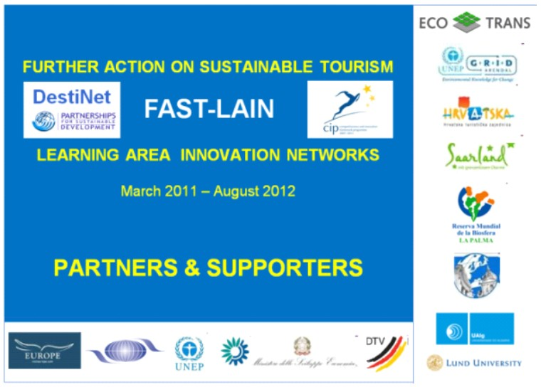

Figure 1‑1 FAST-LAIN Project Partners and Supporters

*Source: ECOTRANS, 2011; Hamele & Sillence, 2011*

Starting on March 2011 and is supposed to run till August 2012, the FAST-LAIN project group are about to establish and define a thematic research framework as mentions above, to collaborate with the entire system for sustainable tourism; they also try to build a foundation of regional clustering structures for a learning areas; moreover, they aim to provide a feedback system which can be specified alongside recommendations for the Observatory’s sustainability reporting system; and during last period, a final workshop with reporting and knowledge network constructing will be followed up, as well as a monitoring system be in ready for utilization by other global stakeholders. A whole structure of this project overview can be seen in Figure 1-2 (Hamele & Sillence, 2011a).

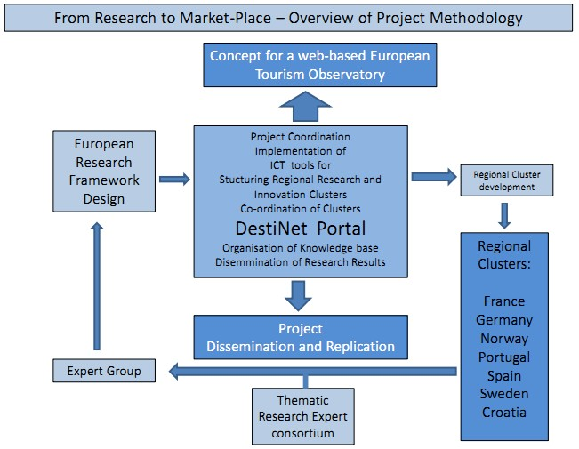

Figure 1‑2 Overview of the FAST-LAIN Project

*Source: Hamele & Sillence, 2011*

### Problem Identification

With the fast speed of development, a huge amount of human resources and funds have been invested in the sustainability issues. In terms of sustainable tourism development, though many authorities and researchers argue that tourism sustainability takes a big contribution to the sustainable development, still very little practical methods has been developed, while a plenty of theoretical research appeared on the stage since the beginning of the 1990s (Archer, 1996; Bell & Morse, 1999b; Green, 1995; Hunter, 1995; T. G. Ko, 2005). Especially, the existing measurements for tourist destinations tend to rely upon non-objective estimate with referencing very few criteria or indicators (Driml & Common, 1996; Griffin, 2000; J. T. G. Ko, 2001; T. G. Ko, 2005; Sofield & Li, 1998; Tosun, 1998).

Thus, to develop an objective and standard assessment procedure for sustainable tourism development is a crucial task currently. That is also the reason why the FAST-LAIN project group call for a scientific-based measurement system, from research theory to practical performance. To accomplish this, a clearly and wide-accepted criteria and indicators system should also be identified and recognized by public.

In addition, to further develop a measurement system, it requires not only a model assessment procedure, but also the complementary monitoring and reporting system. As a result, some thematic research framework needs to be provided, in order to establish a strong network to connect all stakeholders to share knowledge and showcase good practice examples.

## Thesis Objective

There are already many good practice examples available in sustainable tourism, but the difficulty is how they can be transparently measured, monitored and disseminated. In one of the FAST-LAIN project research framework, a hypothesis is proposed that good practice examples can be sorted by the Sustainable Tourism Research Framework. As well as by using the Global Sustainable Tourism Criteria, tourism sustainability can be measured and evaluated.

The main purpose of this thesis is to test the hypothesis, by taking examples from DestiNet’s Atlas of Excellence[3], allocating them to the Sustainable Tourism Research Framework and assessing how the Global Sustainable Tourism Criteria can provide a model assessment procedure for good practice examples in sustainable tourism.

In order to fulfil the purpose of this thesis and solve the problems identified, the following research questions are addressed:

* What is the relationship between sustainable development and tourism?
* What are the Global Sustainable Tourism Criteria and the Sustainable Tourism Research Framework?
* What are the sustainable tourism indicators systems and how to improve the indicators systems?
* How can good practice examples be sorted into the Sustainable Tourism Research Framework and how well this works?
* How to provide a model assessment procedure for assessing tourism sustainability by using the Global Sustainable Tourism Criteria?

## Scope

The thesis covers content about the development and practicability of the Sustainable Tourism Research Framework, and the Global Sustainable Tourism Criteria-based assessment procedure, issues in terms of sustainable tourism development will be addressed. Although the focus is based on good practice examples taking from DestiNet's Atlas of Excellence (including e.g. VESTAS[4] best practice examples, former Royal Award winners, etc.), it excludes a large number of other good practice examples outside Europe, where sustainable tourism development are also promoted well and sound systems for measuring, monitoring and reporting are provided.

When some good practice examples selected from DestiNet's Atlas of Excellence are allocated into the Sustainable Tourism Research Framework, the number of examples taken is not sufficient enough, since there are more than 300 good practice examples (mainly within Europe) listed in their records according to the statistic from DestiNet. The thesis is not intended to be a feasibility research nor a consultancy guideline on how best to allocate good practice examples to the framework and how scientifically to improve the framework. Although some recommendations are given, still there are no way meant to be exhaustive and comprehensive.

In line with FAST-LAIN project framework, the research is to develop a relatively elaborate and practical measurement, monitoring and reporting system based on scientific and objective judgement. Though this paper will try to describe how an entire system should look like, it needs to be scaled down to a small section, for examples in this thesis, mainly to provide a measurement process. In addition, since there are numerous types of tourism exist nowadays, this thesis study is based on taking tourist destination as an entire body, attempting to develop a model assessment procedure for tourism sustainability.

## Limitations

Limitations to this thesis were imposed by the fact that the Sustainable Tourism Research Framework is currently in a development phase, so it is fairly dynamic and undergoing many variables. As well as the Global Sustainable Tourism Criteria and indicator systems either by EC or UNWTO, or some other organizations and research bodies, they are periodically under through some open public comments and feedback, in order to improve and finalize the actual system. Therefore, the final analysis of the framework’s value and the provided model assessment procedure based on the use of Global Sustainable Tourism Criteria and indicator systems are also limited.

Another limitation is the rapid development of this area, the examples that have been taken, the relevant studies and research that have been used, may not have been identified, specially the more latest ones. In another way, limited amount of time available for this study is also a factor, reflected in interviews and personal communications of a finer or more comprehensive e.g. criteria and indicator matrix, was at times hampered.

The good practice examples involved in this study will be limited to the geographic borders of Europe, specially be scaled down to the DestiNet's Atlas of Excellence, which is jointly administrated by EEA, ECOTRANS (a European network of experts and organisations in the tourism sector), UNEP and UN WTO.

## Methodology

The general approach for writing this paper and collecting data was one of a multidisciplinary nature, since tourism area is pretty dynamic and multitudinous, containing enormous groups of stakeholders and factors.

Initially literature reviews were conducted so as to get a general overview of the tourist industry and its role and position globally and locally. Within the scope of reviews, a conceptual framework was examined, which includes the relationship between sustainability and tourism, the tree pillars involved in economic, environmental, social-cultural aspects, the definition of sustainable tourism, the principles namely twelve aims for sustainable tourism; followed by a main body of Global Sustainable Tourism Criteria and current indicator systems applied in the tourism sustainability development.

Qualitative data was collected from many sources:

First, attending and assist teaching the course named “Sustainable Tourism” in a village called Sigri in Greece. The course is under supervised by Mikael Backman and Lars Hansson from IIIEE[5], Lund University. During the course and staying in Sigri, a small fishing village in Lesvos, Greece, interviews around Sigri based upon current sustainable tourism criteria and indicators and measurements were conducted with different people (e.g. tourists, local residents, restaurant and bar owners, fisher man, and president of village etc.) Furthermore, dividing MESPOM[6] students into groups to study and work representing different views of stakeholders, to refine or develop more appropriate criteria and indicators for sustainable tourism measuring system.

Second, personal communications with FAST-LAIN project staff (e.g. Herbert Hamele, Mikael Backman and Tamar Chelidze), the Sustainable Tourism course professors and teachers (e.g. Mikael Backman, Lars Hansson, Chris Ryan and Jennie Larsson). The main communications used was on a basis of semi-structured form, allowing the clarification of qualitative information and also the elaboration of further more latitude dialogues.

Third, more specialised literature reviews, as well as reports, journals, books, and other sustainable tourism related publications were selected, to provide a better understanding of the background and research directions.

In line with one of the FAST-LAIN project objectives, a Sustainable Tourism Research Framework was brought forward to be tested by taking good practice examples from DestiNet's Atlas of Excellence. Moreover, a participation in the online survey for public comment period for the second version of the Global Sustainable Tourism Criteria was carried out, in order to better understand the current criteria.

## Thesis Content

The chapters of this paper are structured in the following manner:

In Chapter two, the definition of sustainable tourism and the special relationship between sustainable development and sustainable tourism is discussed, as well as the sustainable tourism principle with twelve aims is presented. The key actors in sustainable tourism and different types of tourism are introduced, to bedding a basic conceptual framework for the future discussion and analysis.

In Chapter three, the Global Sustainable Tourism Criteria is introduced; its development and structure are described in detail. Followed by the introduction of current commonly used sustainable tourism indicators and measurements, which is also the main part of the latter assessment procedure.

Chapter four explains how the current Sustainable Tourism Research Framework looks like, and the relevant project bodies DestiNet, as well as the current stage and future development of this research framework.

Chapter five mainly carries out the test of one hypothesis in this thesis, to see if good practice examples can be sorted by the Sustainable Tourism Research Framework. Followed by some findings from the allocation, example observatory research framework is also provided, to further help promoting good practice examples and assists the criteria collect relevant information for future assessment.

In Chapter six, a brief sustainable tourism assessment review is conducted, by identifying current problems and concerns in terms of tourism sustainability assessment. Beside, the methods using in this study to provide a model assessment is described shortly in this chapter.

Chapter seven explicitly describes a proposed mode procedure for assessing tourism sustainability, constituting nine steps process. Some further analysis and discussions are presented, followed by some conclusions concerning the proposed assessment procedure. The nine steps are: identify the systems; identify the twelve principles/dimensions; identify the Global Sustainable Tourism Criteria; identify the main indicators; scale tourism sustainability; grade tourism sustainability; develop tourism sustainability assessment maps; continuous assessment over time; and final estimation and evaluation.

Chapter eight summarizes the thesis by briefly concluding all research questions, some final discussion and conclusions of the Sustainable Tourism Research Framework and the proposed assessment procedure, and recommendations from this research work. In the last place, the thesis also provides some thoughts on further research which were out of scope in the context of this paper, but would be of interest to seek after the future development of the research framework and assessment procedure.

# Conceptual Framework for Sustainable Tourism

In order to make it clear what is tourism and what is meant by creating a more sustainable tourism, this section will address the relationship between sustainable development and tourism, and why tourism plays such an important role in improving and strengthening the process of three pillars: economic, environmental and social-cultural, within sustainable development. Based on this, some guiding principles for sustainable tourism will be outlined in the shapes of twelve aims, to further emphasize how governments play a critical role in making a more sustainable tourism in future.

## Sustainable Tourism Definition

### Sustainable Development: a Cornerstone

In the report of the World Commission on Environment and Development, a definition of sustainable development was given, and which is still widely used among current world, that the meaning is “*a process to meet the needs of the present without compromising the ability of future generations to meet their own needs*” (WCED, 1987).

According to this definition, sustainable development essentially contains two key concepts: one is the needs of people, especially the poor’s needs in the world, which is prioritized at a exceeding everything’s status; the second is the limitation of natural resources or environment, if the limitation is breakthrough, it will for certain to affect the living ability of people at present and in the future, and lead to various possible social problems. Under this context, it implicates that there are three important indicators for weighting sustainable development, these are: economical indicator, environmental indicator and social indicator, which all work together for the sustainability and cannot be separate.

In another word, sustainable development is to build a better life for all people in world, regardless of different age, race or gender, the world’s resource and benefits should be distributed equally on the basis of sound exploitation and utilization, and could be further recycled or reused or regenerated by future generation.

Table 2‑1Extended Explanations of Sustainable Development

|  |  |
| --- | --- |
| Three Essentials | Explanation |
| Economical Sustainability | An economically sustainable system must have the capacity of consecutively producing goods and services, to sustain a manageable level of government and external debt, also to ensure against the undermine of extreme unbalances in aspects of agriculture or manufacturing production. |
| Social Sustainability | A socially sustainable system must accomplish an equitable distribution and opportunity, adequate provision of social services, consisting of health and education, gender equity, political accountability and participation. |
| Environmental Sustainability | An environmentally sustainable system must sustains a steady resources foundation, avoiding an over exploitation of renewable resources, meanwhile preventing from a depletion of non-renewable resource. This contains maintenance of biodiversity, stable environment, and other ecosystem functions but not generally marked as economic resource. |

*Source: Adapted from Harris and Goodwin, 2001; Khatri, 2010*

This concept has evolved since the year 1987 and was specially addressed through Agenda 21 (UNCED, 1992), then further plan of implementation was emerged from the World Summit on Sustainable Development (WSSD & UN, 2002). Therefore, three worthy “pillars” or essentials for sustainable development are recognized, which are economic sustainability, social sustainability and environmental sustainability. Later Harris and Goodwin further explained and discussed the concept of sustainable development, showing as the three essences as below, see Table 2-1 above (Harris & Goodwin, 2001; Khatri, 2010).

### Tourism and Sustainability: a Special Relationship

Tourism activity occupies an important position in regarding to the contribution of sustainable development. At first, it is such a dynamic industry which grows tremendously fast and contributes a huge amount in terms of economic pillar year by year. Secondly, it is joint ligament which connects consumers, tourists, industry, environment and local communities (UNEP & UNWTO, 2005).

In line with the special relationship, visitors, regarded as consumers, always directly visit the product and producer which is so called tourism sites and communities. This lead to another three essential and exclusive factors of the relationship between tourism and sustainability, Table 2-2 (UNEP & UNWTO, 2005):

Table 2‑2 Three Aspects between Tourism and Sustainability

|  |  |
| --- | --- |
| Three Aspects | Relationship between Tourism and Sustainability |
| Interaction | The essence of tourism is to provide a brand new experience for visitors, served in a totally new and fresh place, which definitely involves and interacts with different hosts and local lands and surroundings. |
| Awareness | People can be educated through all the tourism activity and come to realize that the importance of sustainable development, not only in protect local environment and culture, but also be aware of the sustainable issues and apply themselves to the continuous efforts. |
| Dependency | Many of the tourist activities is founded on a popular site, which visitors can experience in a welcome atmosphere, such as beautiful natural areas, authentic history, challenged adventure and unique culture. This tourism industry relies upon these properties very much. |

*Source: Adapted from UNEP and UNWTO, 2005*

This special relationship can either destroy the tourism, or create a very positive circumstance for a more sustainable development. Regarding to the positive aspects, tourism can offer a great amount opportunities for employment in local communities, as well as attract more investment though some places are quite remote. Tourism can also rise up people’s the awareness of local culture and traditions’ protection, create a more peaceful and harmonious environment. However, with the fast-growing tourism industry and the endless greedy desire by beneficiary, a lot of tragedies appear on the stage: ecosystem becomes even more fragile, many rare species are on the edge of extinction, and natural resource turns to be scarce, local and global pollution shows everywhere and so on.

Therefore, all stakeholders and target groups who are involved in this tourism industry shoulder a significant responsibility to make the concerns and importance more obvious. Tourism holds its own giant power to do well, yet it also contains the potential forces to pressurizing the sustainable development. To build and develop tourism on a right way, governments and policy-makers should have to encourage the essential spirit to motivate people, not only superficially resist harms and accept benefits.

### Creating a more Sustainable Tourism

From the mass media and a lot of social public opinion, there is always a misunderstanding that sustainable tourism should be in a small scale, because it interacts with fewer environments so as not to undermine the landscape or over exploit natural resources and the like. This is a very dangerous misapprehension. Since the core essence of sustainable tourism is based on a principle of sustainable development.

In line with this innate character, sustainable tourism cannot be defined as some type of tourism, like small scale tourism or eco tourism or such like; it should be developed on the basis of sustainability. So if a high-volume large scale tourism is in well management and in the development based on continuable and long-term point of view, this, for sure, ought to be called sustainable, just like the small scale tourism.

The UN World Tourism Organization (UNWTO) has given a full explanation of sustainable tourism that (UNEP, 2004; UNEP & UNWTO, 2005; UNWTO, 2004b):

*Sustainable tourism development guidelines and management practices are applicable to all forms of tourism in all types of destinations, including mass tourism and the various niche tourism segments. Sustainability principles refer to the environmental, economic and socio-cultural aspects of tourism development, and a suitable balance must be established between these three dimensions to guarantee its long-term sustainability.*

Therefore, according to the explanation from UNWTO, sustainable tourism should follow the guidelines as below, see Figure 2-1:

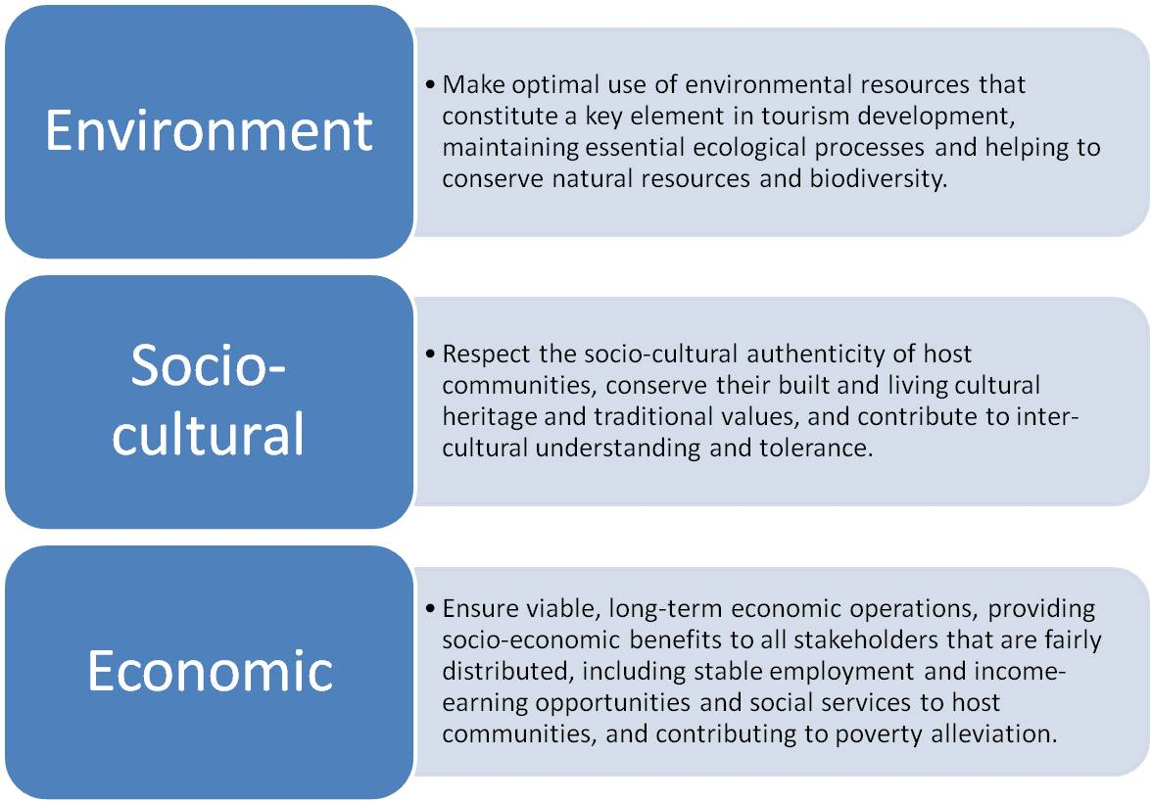

Figure 2‑1 Sustainable Tourism Guidelines

*Source: Adapted from UNEP, 2004; UNEP & UNWTO, 2005; UNWTO, 2004b*

Sustainable tourism needs efforts from all sides of stakeholders, and a strong acceptance. It is a sustaining process which contains constant monitoring and continuous improvement. It also ought to be a highly recommended tourism that satisfies tourists’ experience and feelings, as well as a profound educational approach, to enhance the significance of sustainability among people.

Moreover, there is a confusion over the meaning of sustainable tourism needs to be corrected. As “ecotourism” is often equally used as “sustainable tourism” by most of media and public. However, ecotourism refers explicitly to a product niche which involves relatively undisturbed or uncontaminated natural areas and people who travel to these destinations often enjoy the inherent scenery and its wild flora and fauna or admire the cultural heritage (Fennell, 1999). Ecotourism indeed comply with the principles of sustainable tourism, but it is not right to mix up the meaning, and the development of ecotourism can offer a profitable and helpful tool within broader strategies orientated sustainable tourism, as was elaborated in the Quebec Declaration on Ecotourism (Quebec, 2002; UNEP & UNWTO, 2005).

Creating a more sustainable tourism implies taking all needs and influence into account, to plan, develop and implement a relatively comprehensive system; meanwhile to build a baseline for continuous improvement, and apply to all types of tourism. In short, the definition of sustainable tourism can be described as:***“Tourism that takes full account of its current and future economic, social and environmental impacts, addressing the needs of visitors, the industry, the environment and host communities”*** (UNEP & UNWTO, 2005; UNWTO, 2004b).

## Sustainable Tourism Principles

According to the book Making Tourism More Sustainable published by UNEP and UNWTO, there is an agenda which can help to achieve a more sustainable tourism at an international level. There is two essential and integral constituent in this agenda, which are (UNEP & UNWTO, 2005):

* The ability of tourism to continue as an activity in the future, ensuring that the conditions are right for this; and
* The ability of society and environment to absorb and benefit from the impacts of tourism in a sustainable way.

Built upon this agenda, there are twelve aims which emphasize economic, social and environmental aspects can be well utilized as a framework to help making progress for a more sustainable tourism. Especially, there are two basic directions playing a very important role in the set of twelve aims (UNEP & UNWTO, 2005):

* Minimize the negative impacts of tourist industry in terms of environment, social-cultural and economic aspects;
* Maximize the positive contribution from tourist industry, and enlarging the benefits for local residents and visitors, protecting natural resources and cultural heritages.

The twelve aims for an agenda for sustainable tourism can be seen in the Table 2-3; and there is no priority in the list, each one is equally important (UNEP & UNWTO, 2005):

Table 2‑3 Twelve Aims for Sustainable Tourism

|  |  |
| --- | --- |
| **Twelve Aims** | **Descriptions and Explanations** |
| **Economic Viability** | To ensure the viability and competitiveness of tourism destinations and enterprises, so that they are able to continue to prosper and deliver benefits in the long term. |
| **Local Prosperity** | To maximize the contribution of tourism to the economic prosperity of the host destination, including the proportion of visitor spending that is retained locally. |
| **Employment Quality** | To strengthen the number and quality of local jobs created and supported by tourism, including the level of pay, conditions of service and availability to all without discrimination by gender, race, disability or in other ways. |
| **Social Equity** | To seek a widespread and fair distribution of economic and social benefits from tourism throughout the recipient community, including improving opportunities, income and services available to the poor. |
| **Visitor Fulfilment** | To provide a safe, satisfying and fulfilling experience for visitors, available to all without discrimination by gender, race, and disability or in other ways. |
| **Local Control** | To engage and empower local communities in planning and decision making about the management and future development of tourism in their area, in consultation with other stakeholders. |
| **Community Wellbeing** | To maintain and strengthen the quality of life in local communities, including social structures and access to resources, amenities and life support systems, avoiding any form of social degradation or exploitation. |
| **Cultural Richness** | To respect and enhance the historic heritage, authentic culture, traditions and distinctiveness of host communities. |
| **Physical Integrity** | To maintain and enhance the quality of landscapes, both urban and rural, and avoid the physical and visual degradation of the environment. |
| **Biological Diversity** | To support the conservation of natural areas, habitats and wildlife, and minimize damage to them |
| **Resource Efficiency** | To minimize the use of scarce and non-renewable resources in the development and operation of tourism facilities and services. |
| **Environmental Purity** | To minimize the pollution of air, water and land and the generation of waste by tourism enterprises and visitors. |

*Source: Excerpted from UNEP and UNWTO, 2005*

Moreover, the twelve aims are not independent; there is a strong correlation among each aims and tight links in terms of economic, environmental and social influence. For instance, economic viability relies upon sustaining a sound quality of local environment; visitor accomplishment requires satisfying visitor and offering chances, but is quite vital for economic sustainability too; community wellbeing can be regarded as a social goal, which is greatly linked to environmental management, such as clean water achievement and waste management and so on. Figure 2-2 below explains the relationship and combination of the twelve aims and three important pillars:

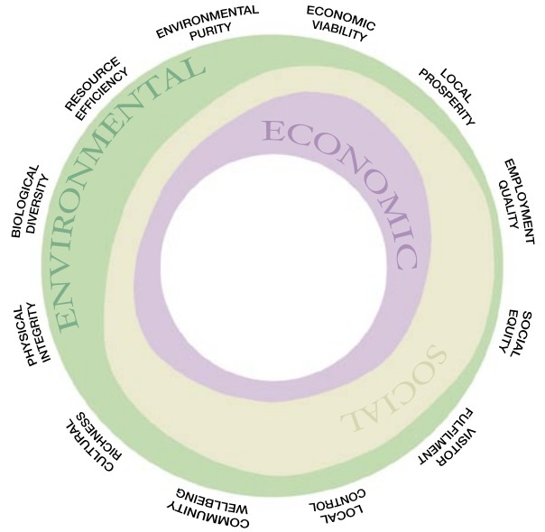

Figure 2‑2 Relationship between the Twelve Aims and the Three Pillars of Sustainability

*Source: UNEP and UNWTO, 2005*

The figure above expressly interprets that none of these twelve aims falls under any single aforementioned aspect of sustainability and that each individual aim relies upon the symbiotic relationship; each aim interacts with all these three pillars, although one may dominate some special area to some extent (UNEP & UNWTO, 2005)。

## The Key Factors in Sustainable Tourism

### Important Actors in Sustainable Tourism

According to the book Sustainable Tourism Management written by J. Swarbrooke, there are mainly six key actors involved in sustainable tourism, including: the public sector, the tourism industry, the voluntary sector organizations, the host community, the media and the tourist (Swarbrooke, 1999).

#### The Public Sector

The public sector refers to those bodies that are meant to stand for the entire community and/or public interests, and are supposed to act delegated to the total population (Swarbrooke, 1999). They are not advertising agencies trying to benefit from the activities, instead they are using revenue from taxation to allocate resources and carry on marketing strategy or implement relevant policies.

The public sector can play an potential role in the development of sustainable tourism by: e.g. legislation and regulation, funding, land usage, the provision of infrastructure, government control over tourism sustainability and so forth (Swarbrooke, 1999).

#### The Industry

The tourism industry is a complex phenomenon including many different dimensions. Figure 2-3 shows a range of sectors and the geographical aspects of the tourism industry. Also there are a wide range of size and types of organizations within tourism industry, like different locally, regionally, nationally owned and controlled small, medium, and large enterprises. (Swarbrooke, 1999)

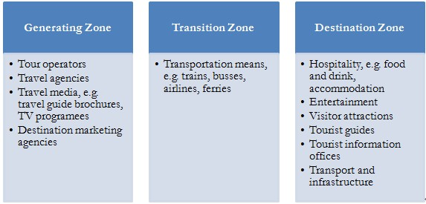

Figure 2‑3 Tourism Sectors and the Geographical Aspects of the Tourism Industry

*Source: Adapted from J. Swarbrooke, 1999[7]*

Many researchers argue that tourism industry is a major cause to the negative impacts of tourism, thus to create a more sustainable tourism, the sector of industry indeed play a crucial role in influencing the development of tourism sustainability.

#### The Voluntary Sector

In this context, the voluntary sector is composed by four groups:

* Public pressure groups, which lobby government and the relevant industry to support the concept establishment of tourism sustainability;
* Professional bodies, which take interests in perspective of sustainable tourism;
* Industry pressure groups, such as the World Travel and Tourism Council;
* Voluntary trusts, groups of which to get together to achieve some goals without making benefits individually.

All of these four groups can play a positive role in the development of tourism sustainability, with generally powerful and trustful help (Swarbrooke, 1999).

#### The Host Community

The host community simply means all people who live within a tourist destination. However, to some extent it is also a very complex concept since it involves with many groups with different interests, even sometimes the interests can be conflict to each other. J. Swarbrooke etc. suggested that instead of just effecting the decision by public sector, the host community ought to become an active player, using different methods to gain influence and get benefits, which can lead to ultimate community prosperity (Swarbrooke, 1999).

#### The Media

The media in generally can be categorized into two types (Swarbrooke, 1999):

* Travel media, which are initiated to direct and guide tourist, and influence the tourist straight-way;
* Non-travel media, which are not designed to guide and advice tourist, but indirectly play a role by some coincidence.

It is obvious that in the tourism area, travel media and non-travel media take a very important position in advising and guiding tourist, as well as shaping tourist’s behavior. Constructing a sound environment for the tourist and the tourism industry is the primary and crucial task by all kinds of media, and this is also a decisive foundation to move tourism towards more sustainability.

#### The Tourist

*A person who travels for the primary purpose of: business (e.g. consultations, conventions and inspections), other personal business (e.g. shopping, medical or legal appointment or an educational study trip), visiting friends and relatives (e.g. primary activities might include socialising, dining out or home entertainment) and pleasure (e.g. sport, recreation, sightseeing and dining out). As long as such a traveller is visiting (for less than one year) an unfamiliar destination (the host community) from that the person normally resides in, then that person may be regarded as being a tourist.*

--- Hunter & Green, 1995

It is traditionally seen that tourist is always the cause of problems and negative impacts in tourism industry, while many researchers argue that tourist can also bring profits and responsibilities (Hunter & Green, 1995; Swarbrooke, 1999). It is vital that raising awareness among tourist can significantly influence the development of sustainable tourism.

### Tourist Destination: an Indispensable Factor

Tourist destinations are inherently complex places, since there are many characteristics associated places such as cultural landscape, boundaries, absolute and relative location, scale, and spatial hierarchies. The types within destinations can be varied from tourism cities to other large urban areas, urban-rural fringe, protected areas, indigenous territories and small islands (Weaver, 2006). J. Swarbrooke addressed that tourist destinations are a complex phenomena involving a wide range of stakeholders, and sustainability issues also refer to destinations which been seen to take a positive standpoint on human right (Swarbrooke, 1999).

To clearly elaborate the complexity of a tourist destination, Figure 2-4 can show many angles of views of a tourist destination, in terms of scales, types, key actors and characteristics associated aspects.

Figure 2‑4 Viewing Angles of a Tourist Destination

*Source: Adapted from Swarbrooke, 1999 and Weaver, 2006[8]*

Moreover, in this paper, a *tourist destination* can be referred as “*a tourist attraction (human-made or natural), including the human system and the ecosystem, influenced by tourism activities*” (T. G. Ko, 2005). Later on in this paper, a tourist destination-based analysis is to be conducted, attempting to develop a model assessment procedure for tourism sustainability in terms of system quality[9]. In the context of this thesis, a tourist destination will be regarded as a whole society which includes two systems: the human system and the ecosystem. By first identifying the human system and the ecosystem, the tourism sustainability assessment can be carried out followed by some other procedure steps.

# Sustainable Tourism Criteria and Indicator System

In this chapter, the first Section 3.1 introduces the commonly used Global Sustainable Tourism Criteria, its development and core part – main body of these criteria, with four essential sections and their sub-criteria. In the Section 3.2, some widely-accepted indicators systems are presented, including a currently improved indicator system by a joint programme course.

## Global Sustainable Tourism Criteria

There are more than 900 million international tourists travelling around in the year 2010, and it is predicted that there will be 1.6 million tourists by the year 2020 according to UNWTO (GSTC, 2011b; UNF, 2011). For the purpose of minimizing the negative effects of this huge growth, and meanwhile maximizing the positive change and benefits, the plans and activities of sustainable tourism must be transferred from an empty talk to real actions, and made to be an essential for all tourism related groups and stakeholders.

### Introduction and Development of GSTC Criteria

The Global Sustainable Tourism Council (GSTC) is a global initiative addressed to the promotion of sustainability issues and practices within tourist industry in the world. The GSTC is flourishing in all UNWTO regions recently, including The Americas, South Asia, Europe, Middle East, East Asia and the Pacific, and Africa. The incipient tendency is ascending around this movement. By serving as the international body for pushing forward sustainable tourism knowledge and understanding, the GSTC adopts diverse universal sustainable tourism principles, compile and create global tools and training to apply in many tourism sustainability practices, and continuously make efforts to increase the demands for sustainable tourism products and services (GSTC, 2011b).

The core work of the Global Sustainable Tourism Council is the ***Global Sustainable Tourism Criteria***, trying to make it as the minimum requirements for all tourism business around the world to achieve, so as to protect and preserve the diverse and even scarce natural and cultural resources, at the same time to guarantee the achievement of tourism, as well as for the conservation of environment and alleviation of poverty.

According to the criteria preamble, the Global Sustainable Tourism Criteria are dedicated to extract a common comprehension of tourism sustainability, which are organized around four leading topics, see Figure 3-1 (GSTC, 2011a; UNF, 2011).

Starting in the year 2007, the Partnership for Global Sustainable Tourism Criteria, which included 27 organisations all gathered to create and improve the criteria. From that time, the council have contacted with almost 100 000 tourism stakeholders, tested and analyzed over 4 500 different criteria from above and beyond 60 subsistent certification and many other voluntary sets of criteria, and got feedback and reviews from more than 1 500 individuals (GSTC, 2011b).

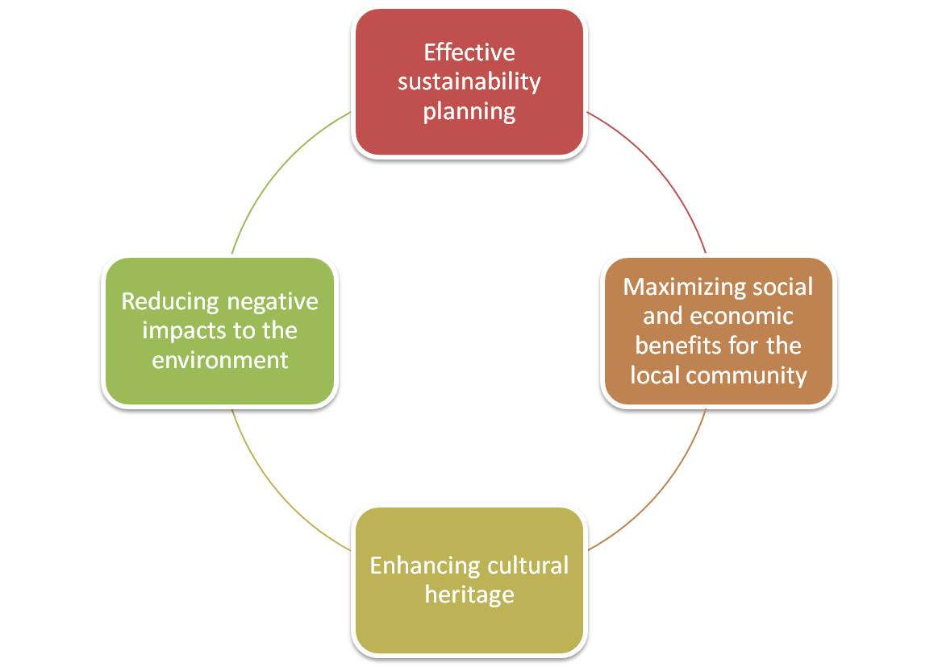

Figure 3‑1 Four Leading Topics of the Global Sustainable Tourism Criteria

*Source: Adapted from GSTC, 2011a; UNF, 2011[10]*

Though the criteria are supposed to be applied by accommodation and tour operation sectors, they are well applicable for the whole tourist industry, said by the Global Sustainable Tourism Council (GSTC, 2011b). In light of ISEAL[11] Code of Good Practice (ISEAL, 2009), the development of Sustainable Tourism Criteria have been through consultation every two years till the imputes of feedback is not provided anymore (GSTC, 2011a; UNF, 2011). In accordance with the GSTC Council’s latest announce: they have opened up a 60 day public comment period for the second version of the GSTC Criteria. The survey will be open until October 15, 2011 (GSTC, 2011b; Hamele, 2011; TF, 2011).

The criteria is initiated to serve as primary guides for all sizes of business to mash forward to a more sustainable area, and help different travel association to choose sustainable tourism programs and suppliers, meanwhile give a direction for diverse customers recognize sustainable tourism. Moreover, these criteria can guide the mass media, government and non-government, or even tourism related education and training schools to establish or ensure wide-accepted standards (GSTC, 2011a).

### Elements of Global Sustainable Tourism Criteria

From the criteria, there are four main themes (A to D) listed as below shown in Figure 3-2. Under each theme, there are many sub-criteria indicated what should be done, and all the details can be seen in Appendix A - Global Sustainable Tourism Criteria (GSTC, 2011a; UNF, 2011).

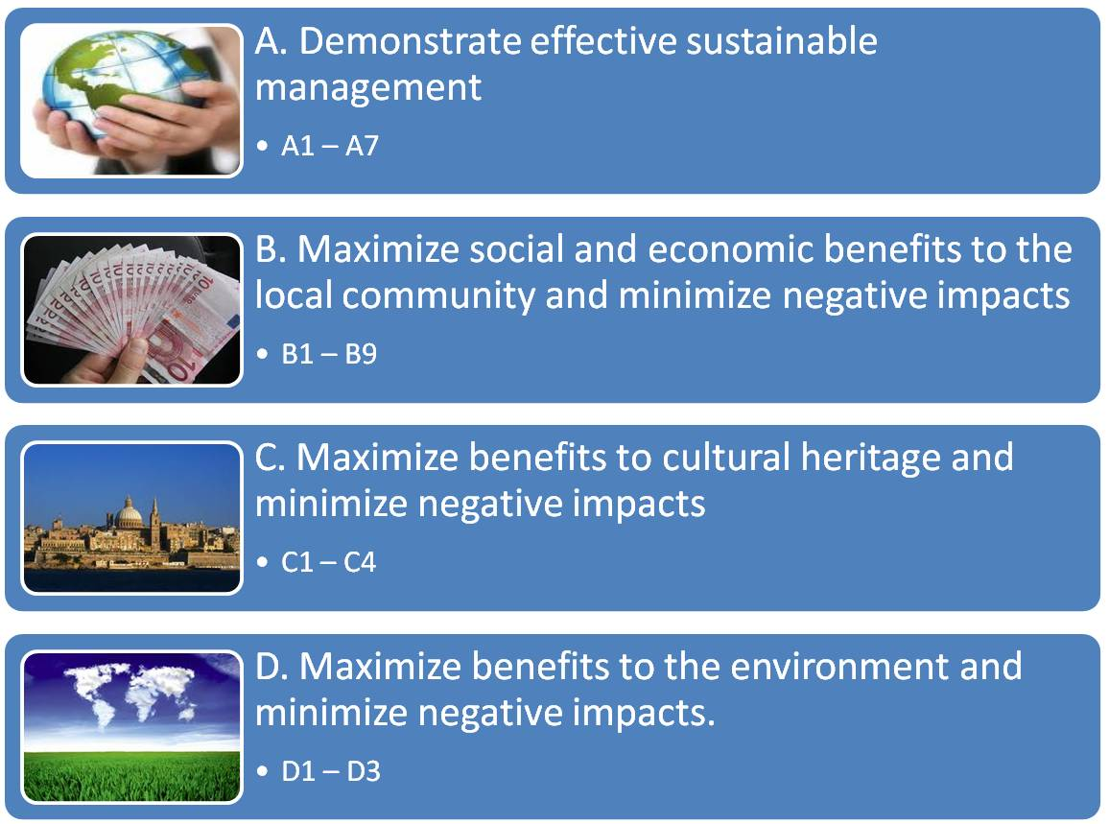

Figure 3‑2 the Global Sustainable Tourism Criteria

*Source: Adapted from GSTC, 2011 and UNF, 2011[12]*

In short and summary way, the four main criteria can be illustrated as below:

**Criteria A** describe what an effective sustainable management, which contains is:

1. a long-term implementation of a sustainable management system, applying to its current situation and size, as well as the consideration of environment, social-cultural, quality, health and safety facts;

(2-3) it complies with relevant legislation and regulation globally or locally; all staffs ought to active or engage in education and training practice in related with environment and social-cultural issues etc., to understand their role and tasks in this management model;

(4) Regularly evaluate the satisfaction of tourists and continuously develop and improve;

(5) the materials and approach for promotion should be in an integrated and corrective content in case exceeding the range of promise;

(6) in regarding to the design and construction of infrastructure, it ought to be in compliance with local regulations for protecting the nature resource and cultural heritage, and adopt sustainable developments as well as showing the respect to natural and cultural environment, above all things is to offer access for special-needed people;

(7) it also should provide relevant information and explication for visitors, and require people to obey the rules (GSTC, 2011a).

**Criteria B** explain the company ought to identify the importance of economic and social benefits and maximize it and meanwhile minimize the negative impacts:

(1-2) by actively supporting the relevant development in terms of education, public health issues, it also employ local residents and offer related training;

(3-4) the company should make good use of local and fair-trade products and services, develop and enlarge local produced characteristic goods;

(5) all regulations involved in local residents should be based on the agreement with local community;

(6-8) employment equity, legalization and legitimacy ought to be carried out in a sound environment;

(9) and the activities of the company can not endanger the basic needs of local community, e.g. water, energy, or public health (GSTC, 2011a).

**Criteria C** emphasize the maximization of the benefits from cultural heritage and reduction of attack:

1. the company ought to keeping the guidelines from fragile and weak cultural and historical sites, so that the attack and negative changes by tourists can be lowered down and fulfill visitors feeling and experience by using local unique resources;

(2-4) it also should initiatively promote the conservation and maintenance of local historical and cultural properties, respect the local residents’ rights and prohibit illegal selling and business (GSTC, 2011a).

**Criteria D** explain what should be done to enlarge good effects to the environment and scale down the passive impacts:

1. regarding to the resource saving aspects, the company should always consider environmental-friendly products for purchase and consumption, try to reduce the purchasing of disposable stuff; encourage the utilization of renewable energy and effectively measure and evaluate the entire consumption; pay special attention to water consumption too and using correctly;
2. for the decontamination aspect, it involves with greenhouse gas emissions reduction, waste water and solid waste management, the usage of hazardous material, and pollution from light, erosion, noise, ozone depletion compounds and so on;
3. in terms of biodiversity, ecosystem and landscapes conservation, wildlife flora and fauna cannot be harvested or sold beyond sustainable utilization and relevant regulations; the company ought to establish or build new sites based on original species, and prevent from the invasion of the exotic species; it also should actively support the programmes and actives in protecting biodiversity and landscape, sponsor the construction of natural protection area when available; the interactions and interference with wildlife and ecosystems should be reduced to lowest and rehabilitated when it is feasible (GSTC, 2011a).

## Sustainable Tourism Indicators and Measurements

### Introduction of Indicators and Measurement System

Indicators and measurements are selected and developed to clearly demonstrate (TSG, 2007):

1) The current actual status of tourism or tourism destinations;

2) The extent and level of impacts;

3) The changes in sustainable development over a certain period of time;

4) Make it possible to compare with norms and other tourist destinations.

However, many existing indicators may be not that strong to serve at the first purpose, since comprehensive and accurate date is difficult to acquire sometimes; on the other hand, they can still show advantages in tracing changes. For instance, by assuming that an equivalent approach is utilized in every destination, the indicators system can also be regarded as a benchmarking. In addition, a well analysis of the results from indicator system also could be used by political regime as a tool to set up policy and targets for sustainable tourism, or as an evaluation tool to test their performance (TSG, 2007).

Many indicators might be obtained on the foundation of existing records and some other direct measurable data; while rest indicators ought to be depend on some special surveys, e.g. investigating from tourists, tourism company, local residents and so forth, which may be time consuming and costly (TSG, 2007). The Tourism Sustainability Group (TSG) was established by the European Commission in the end of the year 2004, specifically contribute efforts to the European sustainable tourism. In October 2007, the European Commission launched a medium-long term strategy, in order to reach out the goal of building a more sustainable and competitive European tourism on the basis of TSG-Report (TSG, 2007; UNTWO & TSG, 2004).

In May 2011, the TSG group drew up a draft of Indicator System for Sustainable Tourism Destinations (ISSTD) which is under discussion and review by cooperation association and institution (TSG, 2011). Together with the Baseline Indicators of Sustainable Development for Tourism Destinations (ISDTD) by UNWTO (UNTWO, 2004), both of these are currently the main indicator systems for sustainable tourism in use.

### Current Development and Improvement

In the statements of the Indicator System - a Final Draft May 2011 by European Commission Tourism Sustainability Group (EC-TSG), there are three stages piloting objectives:

* Stage one: theoretically test and scope the destinations, assess current position, competence and capacity;
* Stage two: piloting the different indicators at the pilot destinations, learning by reviews and evaluations by means of conference or lessons.
* State three: refine the current set of indicator system and prepare for the future use.

From the previous studies by EC-TSG partnership, such as UAB (Universitat Autonoma de Barcelona), IIIEE from Lund University, Central European University etc., the indicators and measurements system by EC-TSG still needs to be improved and refined. The main reasons are identified as below:

* The EC-TSG indicators system only assigns one indicator to measure the performance of the economic aspect. In general, economic aspect plays a significant role in influencing tourism sustainability, if only one indicator assigned to this system, it can be leaded to a sufficient analysis and output.
* The indicators for governance and management are not clear stated in the EC-TSG indicators system. As the rapid development of tourist industry, a good governance and management would certainly guide tourism development towards a more sustainable area.
* The draft of EC-TSG indicators system is a little bit disordered and jumbled to some extent. For example, some “deleted” or “modified” items are messy; the “added” items are not clearly to understand.

Thus, during the summers of 2010 and 2011, a group of master students from MESPOM[13] programme conducted a series of research and studying under the course “Sustainable Tourism”, by taking Sigri - a small fishing village - as case study, to try to design a framework system of indicators for promoting sustainable tourism in coastal designations in EU. (Masters in Environmental Sciences Policy and Management 2009-2011 MESPOM, 2010; Masters in Environmental Sciences Policy and Management 2010-2012 MESPOM, 2011; UAB, 2010).

With one of the aims of improving the current EC-TSG indicators, the students were divided into several groups, working respectively on developing and improving a set of indicators in terms of governance, environment, socio-cultural and economic aspects, through the manners of literature reviews, interviews, brainstorm and assessment etc. According to one of the deliverable reports from the Sustainable Tourism course, a list of indicators by categories into “Management and Governance Indicators, Environmental Indicators, Economic Indicators, Socio-cultural Indicators” has been provided; see Appendix B - List of indicators by categories from MESPOM’s report 2011.

On the other hand, the UNWTO indicators for sustainable tourism destinations was relatively polished, but still needs to be combined with other existing indicator system to be applied at different level globally or regionally. The original finalized UNWTO indicators can be found in Appendix C - UNWTO Baseline Indicators of Sustainable Development for Tourism Destinations (ISDTD).

In short, all the existing indicator and measurement systems (e.g. by EC and UNWTO) are not perfect, together with other voluntary indicators system such as Voluntary Initiative for Sustainability in Tourism (Chelidze, 2011a), and some specific sets of indicators (landscape types, national etc.), ought to be continuously updated and improved in light of rapid changed sustainable tourism development. The summary of different indicators by EC, MESPOM and UNWTO is shown in Table 3-1.

Table 3‑1The Summaries of Different Indicators Systems

|  |  |  |  |  |
| --- | --- | --- | --- | --- |
| **Name of Indicator System** | **Sponsor Organization** | **Version** | **No. of Core Indicators** | **Measures and Baseline Indicators** |
| Indicator System for Sustainable Tourism Destinations | EC-TSG | 2011 | 20 | 76 |
| Improved EC-TSG Indicators by Categories by MESPOM | MESPOM | 2011 | 29 | 100 |
| Baseline Indicators of Sustainable Development | UNWTO | 2004 | 12 | 25 |

*Source: Adapted from* *TSG, 2011*; MESPOM Sigri report, 2011 *and UNWTO, 2004[14]*

In this thesis, to identify the main indicators according to different tourist destinations is also an important part in providing a model assessment procedure for tourism sustainability. Indicators can be selected from either UNWTO indicators system (Appendix C) or improved EC-TSG indicators system (Appendix B) mentioned above, or even other relevant destination-specific indicators.

# Sustainable Tourism Research Framework

This chapter mainly introduces what it means by Sustainable Tourism Research Framework in this context, and its eight main thematic topics under current development. The eight main topics are: climate change – energy and resource efficiency; natural and cultural heritage; quality assessment, certification and branding; sustainable supply chain management for SMEs; destination management and good governance; sustainable transport and travel; knowledge networking, training and education; sustainable consumption and production (SCP) and tourism (Sillence & Hamele, 2011a). Since this research framework is still under development at present, so the further improvements and future considerations are also discussed at the end of this chapter.

## An Introduction and Development

### Introduction of the Sustainable Tourism Thematic Framework

In the light of UN/EU Agenda 21 thinking (Sillence & Hamele, 2011a; UN & EU, 1992), and by identifying institutional, economic, environmental and socio-cultural themes fields, the FAST-LAIN project has scaled down all the areas into eight thematic research topics which are in connection with the competitive and sustainable tourism policy agenda, sc. climate change – energy and resource efficiency; natural and cultural heritage; quality assessment, certification and branding; sustainable supply chain management for SMEs[15]; destination management and good governance; sustainable transport and travel; knowledge networking, training and education; sustainable consumption and production (SCP) and tourism (overarching theme) (Sillence & Hamele, 2011a).

According to the project orientation from FAST-LAIN framework, the eight topics ought to be regarded as cross-cutting themes emphasized in the different EU policy communications, which are: health; food, agriculture and biotechnologies; information and communication technologies; nano-sciences, nano-thechonologies materials and new production technologies; energy (nuclear and non-nuclear); environment (including climate change); transport (including aeronautics); social-economic sciences and humanities; space; security (Sillence & Hamele, 2011a).

With the purpose of a more wide management level such as to a regional-level destination, all the eight thematic topics should be cross-referenced with the Global Sustainable Tourism Criteria and the Tourism Learning Area policy grid (DG-ETU, 2004). Also they will be classified based on some territorial category system to differentiate various tourism destinations, namely: rural, urban, mountain, coastal and protected (Sillence & Hamele, 2011a).

The next step is to build a work flow based on the existing global research framework for sustainable tourism. The process will involve the following bodies, see Figure 4-1:

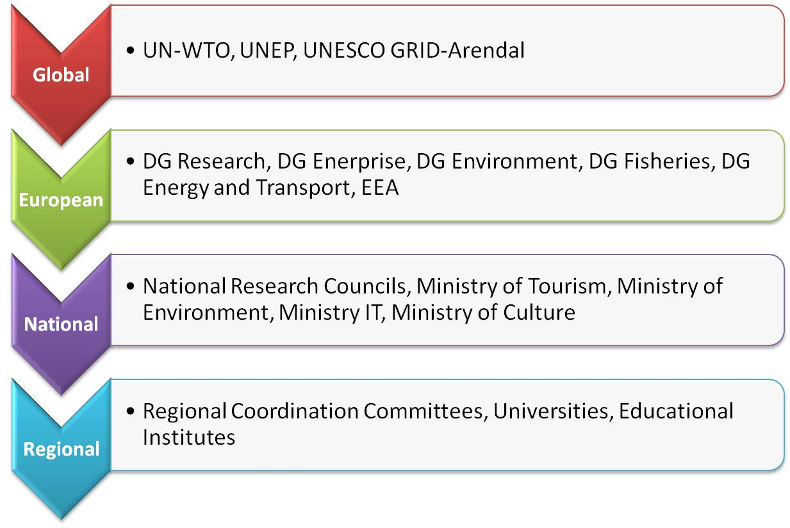

Figure 4‑1 Administrative Levels for Sustainable Tourism Research Framework

*Source: Excerpted from Sillence & Hamele, 2011a; FAST-LAIN project, 2011[16]*

Moreover, by combining and mapping all these components on certain platform, e.g. DestiNet ICT (Information Communications Technology), will make the information flow and sources more visible and accessible to diverse tourism stakeholders, and encourage them to innovate and improve the already existing information framework and platform, meanwhile transfer best practice knowledge in a regional level promptly (Sillence & Hamele, 2011a).

### What is DestiNet

*The DestiNet portal has been developed as a multi-stakeholder sustainable tourism observatory, knowledge networking tool, best practice database and global green market place.*

-Welcome to DestiNet-(DestiNet, 2007)

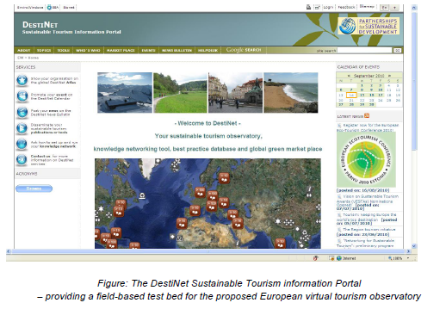



Figure 4‑2 DestiNet Portal Overview

*Source: ECOTRANS, 2011; DestiNet, 2011*

DestiNet is tourism information service platform (see Figure 4-2) which guides and supports different sustainable tourism stakeholders. By providing many diverse functions such as events, news, tools and so forth, people can for example, spread individual information to an international stage; plan and manage individual sustainable tourism activities at a local level; initiate discussions or conferences concerning sustainable tourism; access and contribute useful topics and tools to a global database etc. (see Figure 4-3) (ECOTRANS, 2011).

Through administrating by EEA, UNEP, UNWTO and ECOTRANS (a leading European level NGO linking network of experts and organizations in the tourism sector), it aims to build a user-friendly platform for various tourism stakeholder community to display good practices examples and share relevant information with DestiNet partnership (EEA, UNEP, UNWTO, ECPTRANS) and different users (DestiNet, 2003).

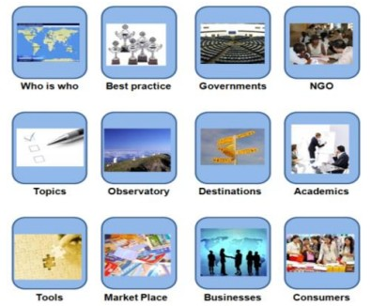

Figure 4‑3 Information and Stakeholders for Making Tourism more Sustainable

*Source: ECOTRANS, 2011; DestiNet, 2011*

### Elements of the Sustainable Tourism Thematic Framework

As mentioned above, many tourism authorities and research institutes from Germany, Spain, Croatia, France, Sweden, Norway and Portugal are working together to develop a monitoring system for the development of sustainable tourism, through which they have broken down into a set of theme topic, to map sustainable tourism stakeholders, tools and best practices, as well as to market the eco-certified tourism (ECOTRANS, 2011)

The main topics - a comprehensive sustainable tourism thematic research framework are listed in the Figure 4-4. This step is regarded as a pillar stone to move tourism sustainability from research area to market place (ECOTRANS, 2011; E. N. f. S. T. D. ECOTRANS, 2011).

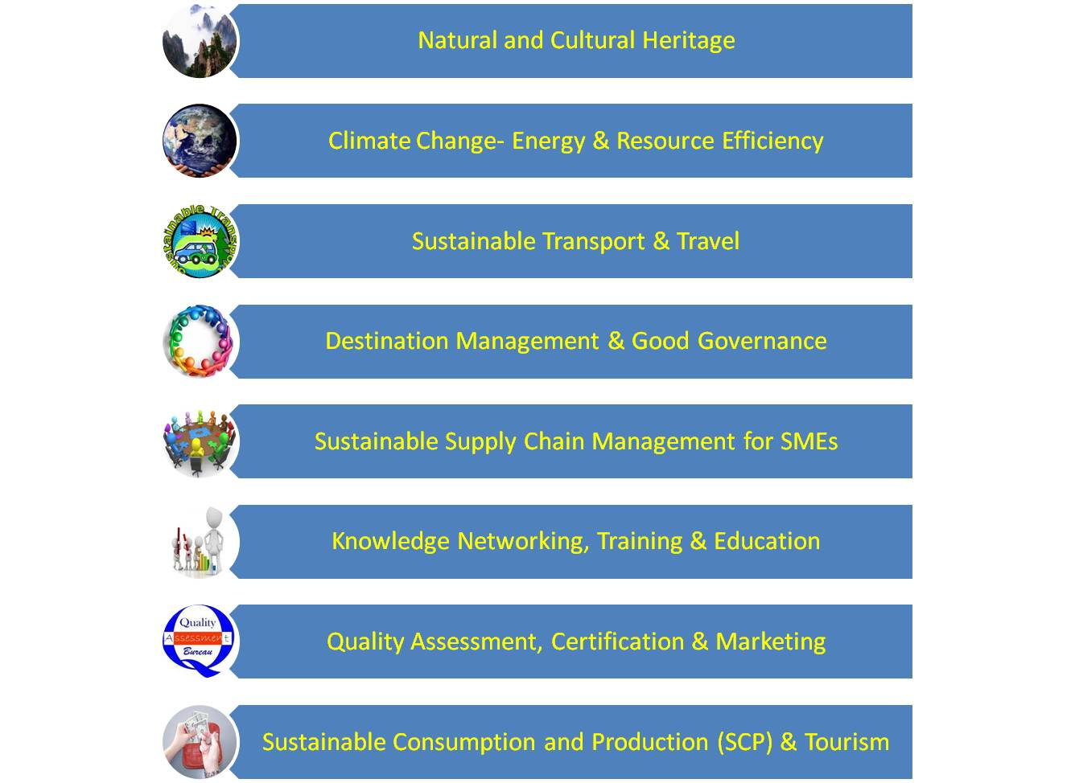

Figure 4‑4 Sustainable Tourism Thematic Research Topics /Framework

*Source: Adapted from ECOTRANS, 2011*

## Future Steps and Considerations

### Current Stage and the Next

Leading by Dr Richard Denman, an expert from the Tourism Company UK and a key member of DG Enterprise’s Tourism Sustainability Group, an expert consortium will be in charge of the further development of the thematic research framework (ECOTRANS & DestiNet, 2011)

The FAST-LAIN group is going to establish a field-tested feedback system to specify the structure and workflow of the virtual European Sustainable Tourism Observatory. By a combination using of Global Sustainable Tourism Criteria, TSG indicator system and so forth, the observatory content includes multi-stakeholder knowledge networks for each topic, a de-centralised observatory knowledge building process (see Figure 4-5), a monitoring system for tourism supply chain activity and the development of destination, good practice transfer platform (ECOTRANS & DestiNet, 2011).

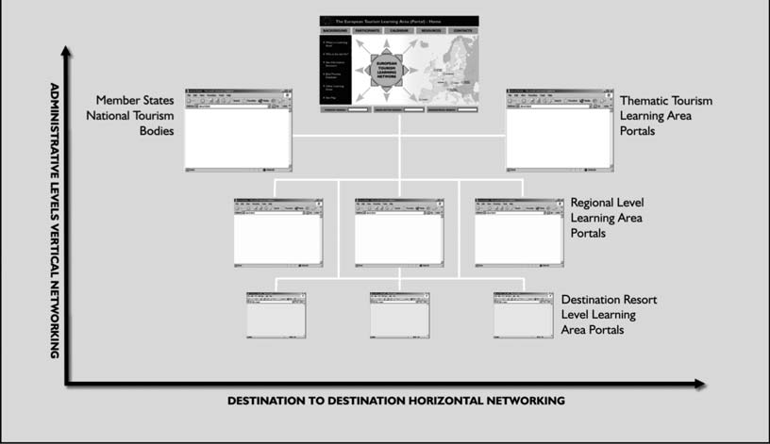

Figure 4‑5A De-centralized Observatory System for the Research Framework

*Source: ECOTRANS & DestiNet, 2011*

The Figure 4-6 below tries to display how the twelve aims/principles from UNEP and UNWTO guide(UNEP & UNWTO, 2005) can be matched with a the thematic research framework which illustrates the challenges, instruments and processes to develop tourism sustainability (E. N. f. S. T. D. ECOTRANS, 2011).

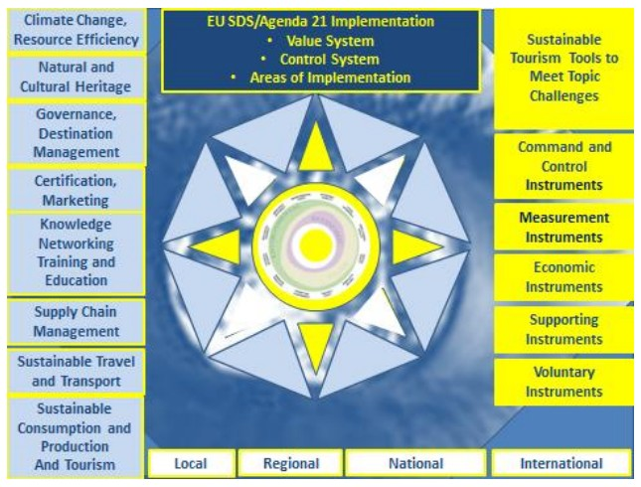

Figure 4‑6 the Observatory Concept and Subject Matter Design

*Source: ECOTRANS, 2011*

The project will also use DestiNet Market Place to give opportunities to different regional and local stakeholders to promote their eco-certified and awarded sustainable tourism products and services, using a category seen Table 4-1:

Table 4‑1 Category of Sustainable Tourism Products and Services

|  |
| --- |
| Category of Sustainable Tourism Products and Services |
| Transport & Mobility Services |
| Accommodation Providers |
| Restaurants & Catering Services |
| Visitor Attractions |
| Activities |
| Travel Packages |
| Tour operators, Travel Agents, Intermediaries |

*Source: Adapted from ECOTRANS, 2011; DestiNet, 2011*

All of which are aiming to bridge between theory and practice, namely “From research to Market”, see Figure 4-7 (ECOTRANS & DestiNet, 2011).

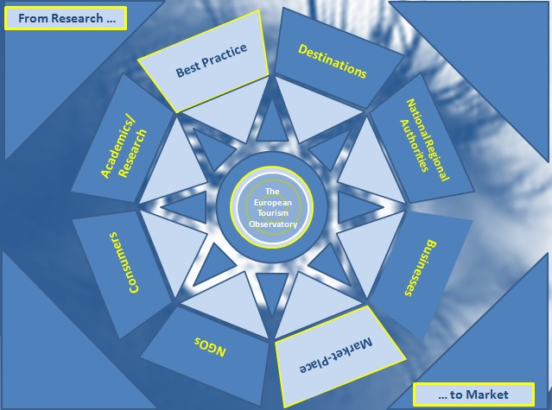

Figure 4‑7 From Research to Market Portal

*Source: ECOTRANS & DestiNet, 2011*

### Future Considerations

Such a gigantic system requires a sound measuring, monitoring and reporting environment, as well as a long-term continuous update and improvement. Once the information framework is filled up, the huge network system needs to be well broadcast and replicated at all relevant level.

Though the platform currently is initiated and developed by EU level, it ought to be moved towards a strong international network, for all the tourism stakeholders to get connection with each other, to share the multi-knowledge globally and locally, as well as to showcase all the best practice for future learning.

In short, the network is about communication while the main subject of communication is about people. Only if people rise up their awareness of sustainability, they will take care of the surroundings and pay attention to a long-run sustainability.

# Information Collection for the Sustainable Tourism Research Framework

In this chapter, good practice examples will be randomly selected and allocated into the Sustainable Tourism Research Framework, followed by the findings of the sorting process and some discussions for the practicability and value of this research framework. An exemplified observatory research framework is also proposed in this chapter, to further provide stakeholders and interested people with useful information.

## Allocation of Good Practice Examples

### DestiNet's Atlas of Excellence

Since the year 2003, there more than 300 nominees and winners of different awards and prizes for Sustainable Tourism globally which are listed in the DestiNet’s “Atlas of Excellence” (example of screen shot see Figure 5-1) (DestiNet, 2011a) and the list is constantly updated (DestiNet, 2009). All the interested people or group can check and view them all on this atlas, by tick the “ORGANIZATIONS” and “MARKET PLACE” on their website (<http://destinet.eu/portal_map/>), and typing the “EXCELLENCE” as the keyword (DestiNet, 2011a).

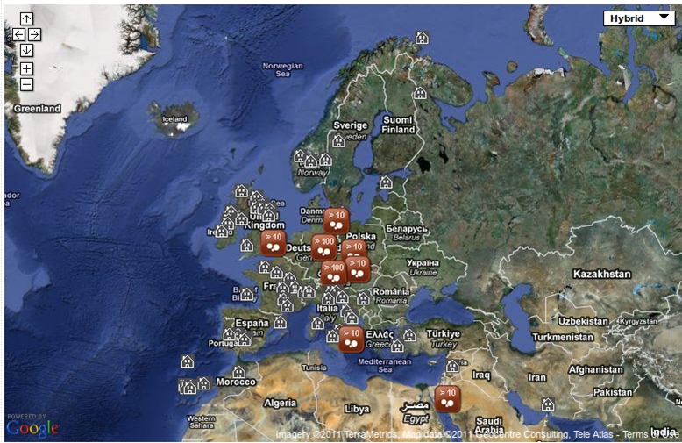

Figure 5‑1 DestiNet’s Atlas of Excellence

*Source: DestiNet, 2011*

DestiNet’s Atlas of Excellence includes good practice examples from various awards organizations, e.g. the VESTAS (The Visions/DestiNet European Sustainable Tourism Awards), Royal Awards for Sustainability etc., all of these are published good practice examples that showcase awarded tourism with fabulous initiatives and contributions to sustainable tourism development, see Figure 5-1 (DestiNet, 2009; RoyalAwards, 2011; VESTAS, 2011).

### Sorting Good Practice Examples

According to the FAST-LAIN project description, the good practice examples which are selected for the “Market Place” (Figure 4-7) should already meet some specified level of sustainability, for instance, they are eco-certified; they have already an implementation of environmental management system; they are winners of some certain awards, regarded as best practice examples or they belong to a group committed to sustainable development.

The examples selection used a random samples collecting manner, taking examples from the DestiNet’s Atlas of Excellence from their website, and also by consideration of covering different categories (Table 4-1), in order to have a general comprehensive overview. The original selection number is 50 (out of which there are more than 300 good practice examples listed in the DestiNet’s Atlas), due to some examples information are not very detailed and some websites linked to the examples are not valid currently, a final eleven examples with more details are presented here. However, given the rapid development and changes of the area, all relevant information or examples may not have been identified, especially more recent ones. It is, however, believed that the selected samples are suitably representative good practice examples to conduct this allocation into the Sustainable Tourism Research Framework.

The following Table 5-1 is the random examples selection of tourism businesses and services which might be promoted on a sustainable tourism “MARKET PLACE”: “title” is the name of organization; “description” refers to reasons for listing here (e.g. eco-certificate); “category” is the classification of sustainable tourism products and services chosen from Table 4-1; “topic” points out the keywords choosing from the eight topics of the sustainable tourism thematic research framework (Figure 4-4).

Table 5‑1 Samples’ Allocation of Good Practice Examples

|  |  |  |  |  |  |
| --- | --- | --- | --- | --- | --- |
| **Title** | **Description** | **Category** | **Country** | **Topic(s)** | **Webpage** |
| Accept-Reisen GmbH&Co.KG | certified by: CSR Tourism[17] | Tour operators, travel agents, Intermediaries | Germany | Sustainable travel | http://www.ac-cept.de - open in new window |
| Weltweitwandern GmbH | certified by: CSR Tourism | Tour operators, travel agents, Intermediaries | Austria | Sustainable travel | http://www.weltweitwandern.at/ |
| The Inland Railway | Running from Central to Arctic Sweden, the railway was developed to freight goods traffic but has since utilised extra capacity during the summer months to transport passengers to the Arctic in a more sustainable manner. | Transport & Mobility Services | Sweden | Sustainable transport | http://www.inlandsbanan.se/ |
| Hafnarholmi marina | Certified by Blue Flag Iceland | Transport & Mobility Services | Iceland | Sustainable transport | http://www.borgarfjordureystri.is/ |
| Soar Mill Cove Hotel | Finalist of the Royal Accommodation Award 2006 in the category hotel/guesthouse // awarded: Green Tourism Business Scheme. | Accommodation Providers | United Kingdom | Certification, marketing | http://www.soarmillcove.co.uk/ |
| The Regional Administration of Silistra, Bulgaria | The Winner of European Destination of Excellence (EDEN) 2010 Aquatic Tourism | Visitor Attractions | Bulgaria | Destination Management & Good Governance, natural heritage | http://ec.europa.eu/enterprise/sectors/tourism/eden/themes-destinations/countries/bulgaria/regional-administration-of-silistra/index_en.htm |
| Hardangervidda Mountain Guiding | January 2009 Hardangervidda Mountain Guiding received the eco-certificate, which guarantee that the services will always be provided in such ways that the environment will not be harmed | Activities | Norway | Knowledge Networking, Training & Education, natural heritage | www.fjellguiding.no |
| Wildlife & Wilderness | Certified by Pan Parks Initiative | Travel Packages | United Kingdom | Natural heritage, education | http://www.wildlifewilderness.com/itinerary.asp?pid=176&cat=27 |
| "WIENO" Wines of Vienna | Certified by: Österreichisches Umweltzeichen für Tourismusbetriebe / Austrian Ecolabel for Tourist Establishments | Restaurants & Catering Services | Austria | Sustainable Supply Chain Management, energy efficiency | http://www.umweltzeichen.at/cms/home/tourismus/gastronomieeinrichtungen/content.html?akt_id=25518 |
| Fuerteventura | QualityCoast winner 2009-10 | Visitor Attractions | Spain | Sustainable consumption and production and tourism, natural heritage | http://www.qualitycoast.info/fuerteventura/index.htm |
| Broads National Parc | The Norfolk and Suffolk Broads is Britain's largest protected wetland and third largest inland waterway, with the status of a national park. It is also home to some of the rarest plants and animals in the UK. | Visitor Attractions | United Kingdom | Natural and cultural heritage | http://www.broads-authority.gov.uk/index.html |

*Source: Adapted from DestiNet website. 2011[18], http://destinet.eu/market-place*

## The Value of Research Framework

### Findings from the Sorting of Good Practice Examples

Table 5-1 above shows some good practice examples taken from each category can be sorted by the eight thematic research topics, and sometimes the topics for every example is not only one, it might be one good practice examples involving with many topics.

For instance, Hardangervidda Mountain Guiding, one activity tourism from Norway, is a guided hike activity on the Hardangervidda mountain plateau between Oslo and Bergen. The tours include philosophy tour and the family tour. Philosophy tour is a guided walk leaded by the famous Norwegian philosopher Arne Næss, with an ecological philosophy, and based upon Arne Næss famous quote “*If nature dies, humans will die with it*”. During the alternative short walks or lengthy trips, tourists can gain a thorough knowledge and experience, as well as the amazing felling obtained from the beauty of nature. The family tour aims to find Huldra, a character from a famous Norwegian fairytale, by hiking though grand mountains, enjoying miles of wild beauty, pursuing fast flowing rivers, feeling the placid lakes and smelling the smiling flowers (DestiNet, 2011b; Hardangervidda, 2011).

In this case, the Hardangervidda Mountain Guiding not only enables tourists with beautiful natural scenery, but also gives tourists a kind of body training with walking long distance, together with knowledge charging. Thus, sorted by the thematic research framework, the Hardangervidda Mountain Guiding can take at least two topics, “Natural and Cultural Heritage” and “Knowledge Networking, Training & Education”.

Therefore, after sorting this place on the sustainable research framework and mapping it on the “Market Place”, stakeholders and interested people or group can easily access all the relevant information regarding this practice example, and learn from their good management and activities. In addition, by mapping this place on the research framework, it also can works as a monitoring tool, to continuously keep track with measurement and supervision, by themselves and by public.

### Observatory Research Framework

By reviewing and sorting different examples into the research framework above, it also can extract some useful information for the establishment of the observatory research framework, through a matrix which cross-combine the Global Sustainable Tourism Criteria and Sustainable Tourism Thematic Research Framework (Hamele & Sillence, 2011b).

The following Table 5-2 is an example matrix for the observatory research framework, the head row refers to the Sustainable Tourism Thematic Research Framework, including the eight thematic topics, using STRF as short name; the left column implies the four main sections in light of the Global Sustainable Tourism Criteria, shortened form as GSTC in the table.

Table 5‑2 Exemplified Observatory Research Framework

|  |  |  |  |  |  |  |  |  |  |
| --- | --- | --- | --- | --- | --- | --- | --- | --- | --- |
| **STRF**  **GSTC** | | **Natural and Cultural Heritage** | **Climate Change- Energy & Resource Efficiency** | **Sustainable Transport & Travel** | **Destination Management & Good Governance** | **Sustainable Supply Chain Management** | **Knowledge Networking, Training & Education** | **Quality Assessment, Certification & Marketing** | **Sustainable Consumption and Production & Tourism** |
| **Sustainability management** | **interest area** | The level for the protected area under national administration | Measurement Instruments | Number of travel agencies and their roles in influencing tourists | Monitoring Indicator and reporting Systems, CSR. Landscape planning | Customer satisfaction | Integration of sustainability aspects in old-fashioned training programme for tourism businesses | Certification | Agenda 21 for Tourism Destinations |
| **information needs** | Lists of cultural and natural heritage within this area | Benchmarking tools | Lists of travel agencies and their capacity statistic | Different indicator system, administrative level and relevant information | Questionnaires and surveys | Old-fashioned training programme and latest training style | Criteria for certification, and assessment process | The consumption and production statistic data from tourist destination |
| **socio-economic sustainability** | **interest area** | The local communities’ well-beings by sustain their nature heritage | The benefits of re-using some resources | The changes of local transportation | Destination security | If local and fair-trade services and goods are purchased by the business | Training programmes | Marketing | Local prosperity |
| **information needs** | The average salary an d other benefits from the tourist destination | Expense anticipation from a long-term of view | Statistic of transportation | The existing security management manners | Inventory of items purchased | The records and procedure of training programmes and activities | Bench marketing tools | The increase of local economics |
| **cultural sustainability** | **interest area** | If the cultural heritage is under well protected | Some traditional culture and customs | Best practice examples, how to combine public transport with events | How to maintain industrial heritage sites through tourism? Financial subsidies? | SME & Micro Enterprise Support | Events combined education | Cultural heritage certifications | Peace through Tourism |
| **information needs** | The re-construction and protection work for the cultural heritage | How many their traditional cultures still existed | Local transportation statistic, types and details of events | The initiatives concerning maintenance | Local or regional enterprise lists which supports the tourism | Education programme and schedule | Certification criteria | Events happened within tourism community |
| **environmental sustainability** | **interest area** | Protected natural area, cultural heritage | How can energy efficiency activities help to sustain tourist destination? | Reduced carbon emission by sustainable transport | The legislation and relevant requirements in terms of environment | The enterprise impact on environment | Training on environment protection | Eco-certification | Exploitation of natural sources |
| **information needs** | Natural heritage, biodiversity, ecotourism | Carbon dioxide Offset schemes, alternative energy, changes on resources utilization | Carbon emission data statistic | Sources of legislation and details | Annual environmental reports | Training programme and details | Inclusion of biodiversity criteria in certificates | The changes of landscape, soil quality etc. |

*Source: Adapted from FAST-LAIN workbook, 2011[19]*

By filling in the “interested area” and “information needs”, the observatory research framework can provide stakeholders and interested people with useful messages; meanwhile help to gather all relevant information to assist the criteria, which can be also used in the “data collection and information acquisition” for further assessment process of tourism sustainability (refers to the Table 7-1).

## Conclusions

The Table 5-1 above listed some good practice examples with various types/categories which are sorted into different thematic research topic. Since the examples’ selections from the DestiNet’s Atlas of Excellence are random, and also the selection is combining the consideration of different category, it can be regarded as small-scale samples. Hereupon, one of the hypotheses of this paper is proved, that good practice examples can be sorted by the Sustainable Tourism Research Framework.

In addition, by sorting the good practice examples into the research framework, it concludes that many good practice examples is in relation with one or more thematic topics, which implies that they are not only sustainable in one single area, but also showcase many sustainable area.

However, only collecting good practice examples is not enough, one of the constant activities is the evaluation of good practices, and finally good practices ought to be transferred to integrated activities that cover all of the sustainable tourism thematic topics described above. Therefore, they can move towards a more sustainable arena and improve the contribution to environment, economic and social-cultural aspects. So in the next chapters, a model assessment procedure for tourism sustainability will be provided.

Besides, the continuous collection of good practices examples will also be conducted through some open calls, presentations at various conferences, group activities and collaboration with regional and international organizations. Thus, to keep constant contacts with different organisations and research bodies is important on the way of progress.

Furthermore, the observatory research framework helps to gather and summarize some interested information obtained from different good practices examples and stakeholders, opening out a wide range of observation, eventually can provide guidance and diverse research topics for further studies.

# Sustainable Tourism Assessment Review

Based on reviews of previous research and studies, this chapter identifies and concludes some tourism assessment related problems and current concerns, as well as some findings about the important factors when processing a tourism assessment procedure. In the latter part, some commonly used assessment methods are introduced; also the basic manner to provide a model assessment procedure of this thesis is presented in the followings.

## Previous Research Findings

### Identifying Problems and Concerns

Though little standard sustainable tourism assessment procedures are available internationally or regionally, there are still many case studies of sustainability assessment in tourism. Based on previous research and studies (Eilleen, et al., 2005; J. T. G. Ko, 2001; T. G. Ko, 2005), many issues are identified and discussed:

1. Many tourism sustainability indicators and measurements and related issues and concerns are very diverse according to different tourist destination.
2. Many evaluation and judgements for the sustainable tourism are subjective depending on the authors or agencies’ own point of view without involving with different stakeholders.
3. Indicators and measurements selection processes are normally not presented, as well as data collection methods are not clear.
4. Sometimes scaling of sustainability sustained by tourist destination is not explicit, nor is the gradations (sectors of scaling) of sustainability illustrated. For instance, generally most authors used to divide two groups (sustainable and unsustainable) for identifying the sustainability.
5. Sustainability in a future context is not often expressed by authors. For the purpose of evaluating the sustainable trend in a limited period such as five to ten years, the assessment requires a monitoring system.

In short, a systematic standard assessment for tourism sustainability is not well developed and widely used in tourism. In addition, Ko et al. also identified some important factors for sustainable tourism assessment: space, time, and system quality in sustainability (J. T. G. Ko, 2001; T. G. Ko, 2005).

### Important Factors in Assessment

There are many important factors in the tourism sustainability assessment, here in this section, three factors are identified: space, time and system quality.

#### Space as a Factor

The space, as one the most important factors in making an attempt to move sustainability theory into practice, plays a pivotal role, since it can also estimated the level of sustainability in a tourist destination (T. G. Ko, 2005). Also a spatial scale can be categorized into five level, see Figure 6-1.

Figure 6‑1 Five Level of a Spatial Scale

*Source: Adapted from T.G.Ko, 2005*

Though it seems very simple to define an administrative area in a general way, as a matter of fact, a single destination can be one small scale tourist site, e.g. a museum, or overlap two or more administrative area, e.g. a big lake located in the boundary of two cities. Furthermore, it may require much more time, funds, appropriate approaches and advanced techniques.

#### Time as a Factor

Time scale is also quite hard to define, e.g. 5, 10, 50, or 100 years, because situation and systems can be varying from one to another. Some system such as in agriculture, it is better to check the scales during a 5 - 20 years’ period, according to Bell and Morse, while in terms of soil degradation, it may need a scale of 20 – 100 years (Bell & Morse, 1999a). As Ko suggested, the sustainability in tourist industry may take a shorter time scale, like 5 – 10 years, since a tourist destination would be affected comparatively easily both by external (e.g. terrors) and internal (e.g. sensitive ecological environment based tourism) factors (T. G. Ko, 2005).

#### System Quality as a Factor

The same important as space and time scale, system quality is also a vital element in developing tourism sustainability. In this paper, ***system quality*** refers “*the state of health in a tourist destination, sustaining the benefits of local community, satisfaction of tourist experience, and conservation of natural resource*” (T. G. Ko, 2005). As well as the definition of a tourist destination together, where a visitor attraction influenced by tourist activities and is composed of both human and ecosystem, it can be concluded that if a tourist destination achieve the three pillars / dimensions (environmental, economic and social-cultural) of sustainable tourism development, the health or the system quality of this destination would be regarded at a high level.

Therefore, both the human and ecosystem should be sustainable synchronously. Human beings and ecosystem are equally important. This is also one of the most vital assumptions in the establishment of model assessment procedure.

## Methods for Sustainable Tourism Assessment

There are many traditional methods to assess the sustainability of tourism, for instance, a curve diagram with energy or water consumption to show the environment impacts year by year; a bar chart with the different changes of well-beings to show the local prosperity; a SWOT[20] model assessment procedure for sustainable tourism and so forth (Eilleen, et al., 2005; Jules, 2005). However, they are either too simplex in emphasizing only one aspect, or lack of the interactions with different stakeholders which leads to a not very objective result.

Adapted and developed from previous research (Bell & Morse, 1999a; Eilleen, et al., 2005; J. T. G. Ko, 2001; T. G. Ko, 2005; Prescott-Allen, 1997; Simmons, 1994), this study will mainly choose two models of maps for the tourism sustainability assessment: “Barometer of tourism sustainability” (BTS) and “AMOEBA of tourism sustainability indicators” (ATSI).

BTS is a model which can display a relatively comprehensive level of tourism sustainability within a specific destination, with a combination of both human system and ecosystem into a representation of sustainable tourism development. The ATSI is a model which can make up the BTS assessment to interpret individual levels of indicators sustainability (T. G. Ko, 2005).

Ko (2005) suggested a eight-step assessment for tourism sustainability. In terms of dimensions, an eight-dimension framework as the sub-systems under the human system and the ecosystem was presented, namely: political, economic, socio-cultural, production structure, general environmental impacts, ecosystem quality, biodiversity, environmental policy and management. For the indicators, there were no specific indicators systems or sources pointed out; also there were no explicitly data collection methods.

Therefore, in this paper, based on Ko’s work, by integrating the sustainable tourism principles (with twelve aims) as the new twelve dimensions, and a cross-referenced Global Sustainable Tourism Criteria under the twelve dimensions, followed by identifying main indicators chosen from improved EC indicators (Appendix B) and/or UNWTO indicators (Appendix C) or some other specific corresponding indicators system, a nine-step model assessment procedure is provided in next chapter (see Table 7-1).

Since there are many different types in tourism industry as mentioned in Chapter two, the desire to build an entire and comprehensive assessment procedure is unlikely to come true in this study. Thus, in this paper, a tourist destination is taken, to scale down the scope; thus based on this smaller scope, a model assessment procedure could be developed further.

# A Proposed Model Assessment Procedure

In this chapter, a proposed model assessment procedure for tourism sustainability with nine steps is provided. Followed by some analysis and discussions in-between each step/section, a final conclusion for this chapter is also presented.

## Provide a Model Assessment Procedure

This section is going to provide a relatively practical and feasible methodology for assessing the sustainability of tourist industry. By taken “tourist destination” as a basic stone and illustrated example, nine steps of a model assessment procedure are presented in this chapter (Table 7-1), namely:

* Identify the systems (the human system and ecosystem);
* Identify twelve principles /dimensions;
* Identify criteria using the Global Sustainable Tourism Criteria;
* Identify main indicators;
* Scale tourism sustainability;
* Grade tourism sustainability;
* Develop assessment maps for tourism sustainability;
* Continuous assessment;
* Estimation.

### Identify the Systems

This work is based on Ko (2001, 2005), a conceptual framework for tourism sustainability assessment. In that model, Ko determined the human system and ecosystem based on a systemic (holistic) approach. Though it is argued that human beings are a part of ecosystem instead of being a separate part, since human beings have the responsibility to take care of the entire ecosystem, and the relationship between the two systems are mutualistic symbiosis (Mannion & Bowlby, 1992).

By realizing that human beings are an indispensable part of the ecosystem, a logical goal for society is to promote sustainability and continuously maintaining the benefits and welfare of human beings and ecosystem. To this extent, the assessment for sustainable tourism requires determine the system for human and ecological area, in order to achieve the goal moving towards sustainability (See Table 7-1).

Table 7‑1 A Proposed Model Assessment Procedure for Tourism Sustainability

|  |  |  |  |  |  |  |
| --- | --- | --- | --- | --- | --- | --- |
| **Society** | **System** | **Principles**  **/ Dimensions** | **Criteria** | **Indicators** | **Information needed and Data collection** | **5-9. Data analysis** |
| A Tourist Destination | 1. The human system | 1. Economic Viability | See Table 7-2 Matrix of Twelve Principles and Global Sustainable Tourism Criteria | Identify main indicators by choosing from different indicators systems, e.g. improved EC indicators by MESPOM (Appendix B), UNWTO indicators system (Appendix C) | Information needed:  Tourism’s dedication to the local and indigenous residents  Tourists’ satisfaction and fulfilment from tourism  The impacts on environment led by tourism  Data collection:  Questionnaire survey for local and indigenous residents  Questionnaire survey for tourists and visitors  Interviews for environmental group or professors | Define the scale of the tourism sustainability  Define the grades of the tourism sustainability  Develop tourism sustainability assessment maps  Continuously assess tourism sustainability over time  Make estimation on the results of assessment |
| 1. Local Prosperity |
| 1. Employment Quality |
| 1. Social Equity |
| 1. Visitor Fulfillment |
| 1. Local Control |
| 1. Community Wellbeing |
| 1. Cultural Richness |
| 1. The ecosystem | 1. Physical Integrity |
| 1. Biological Diversity |
| 1. Resource Efficiency |
| 1. Environmental Purity |

*Source: Adapted from Ko, 2001, 2005; UNEP & UNWTO, 2005[21]*

### Identify the Twelve Principles

In needs of tourism sustainability assessment, the twelve aims which are regarded as the sustainable tourism principles can be integrated and incorporated into the assessment procedure. These principles can be seen as twelve main dimensions under the systems (sub-systems). Besides, they are supporting the whole procedure as an intermediary element between the two systems and the Global Sustainable Tourism Criteria, including a number of indicators later.

In accordance with the spatial scale mentioned above (Figure 6-1), it is largely accepted that tourist industry ought to make contribution to the development of sustainability at different level (local, regional, national and international). That is to say, only if the main dimensions are achieving the goal of sustainability, the systems are unlikely to be levelled at sustainability.

Moreover, to be in line with the three pillars of sustainable development, the twelve aims’ principle can also match along with economic, environment and social-cultural aspects (see Figure 7-1), which again address the importance of the twelve aims/principles in tourism sustainability (Chelidze, 2011b).

Figure 7‑1 A Matrixes between Sustainable Development Pillars and Twelve Aims

*Source: Adapted from Chelidze, 2011[22]*

In this section, in order to develop a model procedure in correspond with the sustainability assessment, it categorized the twelve aims/principles into the two systems. The human system includes: economic viability, local prosperity, employment quality, social equity, visitor fulfillment, local control, community wellbeing and cultural richness; while the ecosystem contains physical integrity, biological diversity, resource efficiency and environmental purity (see Table 7-1).

### Identify Global Sustainable Tourism Criteria

Since the main aim of this study is assessing how the Global Sustainable Tourism Criteria can provide a model assessment for the tourism sustainability, the allocation of Global Sustainable Tourism Criteria into different principles is a crucial work. In this section, the basis to identify numbers of criteria is based on Ko (2005), a systemic (holistic) approach, as well as the foundation work from a master student’s thesis work (Chelidze, 2011b; T. G. Ko, 2005). See Table 7-2.

As the third steps in this model assessment procedure, the matrix of Table 7-2 ought to be incorporated into the whole framework of assessment in Table 7-1, to settle a strong foundation for the indicators selection in the fourth step.

Table 7‑2 Matrix of Twelve Principles and Global Sustainable Tourism Criteria

|  |  |
| --- | --- |
| **Dimensions/ Principles** | **Global Sustainable Tourism Criteria** |
| 1. Economic Viability | A.1. The company has implemented a long-term sustainability management system that is suitable to its reality and scale, and that considers environmental, socio-cultural, quality, health, and safety issues. |
| A.2. The company is in compliance with all relevant international or local legislation and regulations (including, among others, health, safety, labour, and environmental aspects). |
| 1. Local Prosperity | B.2. Local residents are employed, including in management positions. Training is offered as necessary. |
| B.3. Local and fair-trade services and goods are purchased by the business, where available. |
| B.4. The company offers the means for local small entrepreneurs to develop and sell sustainable products that are based on the area’s nature, history, and culture (including food and drink, crafts, performance arts, agricultural products, etc.) |
| 1. Employment Quality | A.3. All personnel receive periodic training regarding their role in the management of environmental, socio-cultural, health, and safety practices. |
| B.2. Local residents are employed, including in management positions. Training is offered as necessary. |
| B.3. The company offers the means for local small entrepreneurs to develop and sell sustainable products that are based on the area’s nature, history, and culture (including food and drink, crafts, performance arts, agricultural products, etc.) |
| B.7. The company is equitable in hiring women and local minorities, including in management positions, while restraining child labour. |
| 1. Social Equity | A.6.4. Provide access for persons with special needs. |
| B.7. The company is equitable in hiring women and local minorities, including in management positions, while restraining child labour. |
| 1. Visitor Fulﬁllment | A.3. All personnel receive periodic training regarding their role in the management of environmental, socio-cultural, health, and safety practices. |
| A.4. Customer satisfaction is measured and corrective action taken where appropriate. |
| A.6.4. Provide access for persons with special needs. |
| 1. Local Control | B.5. A code of conduct for activities in indigenous and local communities has been developed, with the consent of and in collaboration with the community. |
| 1. Community Wellbeing | B.1. The company actively supports initiatives for social and infrastructure community development including, among others, education, health, and sanitation. |
| B.2. Local residents are employed, including in management positions. Training is offered as necessary. |
| B.3. Local and fair-trade services and goods are purchased by the business, where available. |
| B.6. The company has implemented a policy against commercial exploitation, particularly of children and adolescents, including sexual exploitation. |
| B.7. The company is equitable in hiring women and local minorities, including in management positions, while restraining child labour. |
| B.8. The international or national legal protection of employees is respected, and employees are paid a living wage. |
| C.3. The business contributes to the protection of local historical, archaeological, culturally, and spiritually important properties and sites, and does not impede access to them by local residents. |
| C.4. The business uses elements of local art, architecture, or cultural heritage in its operations, design, decoration, food, or shops; while respecting the intellectual property rights of local communities. |
| 1. Cultural Richness | A.6.1. Comply with local zoning and protected or heritage area requirements. |
| A.6.2. Respect the natural or cultural heritage surroundings in sitting, design, impact assessment, and land rights and acquisition. |
| A.7. Information about and interpretation of the natural surroundings, local culture, and cultural heritage is provided to customers, as well as explaining appropriate behaviour while visiting natural areas, living cultures, and cultural heritage sites. |
| C.1. The company follows established guidelines or a code of behaviour for visits to culturally or historically sensitive sites, in order to minimize visitor impact and maximize enjoyment. |
| C.2. Historical and archaeological artefacts are not sold, traded, or displayed, except as permitted by law. |
| C.3. The business contributes to the protection of local historical, archaeological, culturally, and spiritually important properties and sites, and does not impede access to them by local residents. |
| C.4. The business uses elements of local art, architecture, or cultural heritage in its operations, design, decoration, food, or shops; while respecting the intellectual property rights of local communities. |
| 1. Physical Integrity | A.6.1. Comply with local zoning and protected or heritage area requirements. |
| A.6.2. Respect the natural or cultural heritage surroundings in sitting, design, impact assessment, and land rights and acquisition. |
| A.6.3. Use locally appropriate principles of sustainable construction. |
| C.1. The company follows established guidelines or a code of behaviour for visits to culturally or historically sensitive sites, in order to minimize visitor impact and maximize enjoyment. |
| C.2. Historical and archaeological artefacts are not sold, traded, or displayed, except as permitted by law. |
| D.3.3. The business uses native species for landscaping and restoration, and takes measures to avoid the introduction of invasive alien species. |
| 1. Biological Diversity | A.6.1. Comply with local zoning and protected or heritage area requirements. |
| A.6.2. Respect the natural or cultural heritage surroundings in sitting, design, impact assessment, and land rights and acquisition. |
| D.3.1. Wildlife species are only harvested from the wild, consumed, displayed, sold, or internationally traded, as part of a regulated activity that ensures that their utilization is sustainable. |
| D.3.2. No captive wildlife is held, except for properly regulated activities, and living specimens of protected wildlife species are only kept by those authorized and suitably equipped to house and care for them. |
| D.3.3. The business uses native species for landscaping and restoration, and takes measures to avoid the introduction of invasive alien species. |
| D.3.4. The business contributes to the support of biodiversity conservation, including supporting natural protected areas and areas of high biodiversity value. |
| D.3.5. Interactions with wildlife must not produce adverse effects on the viability of populations in the wild; and any disturbance of natural ecosystems is minimized, rehabilitated, and there is a compensatory contribution to conservation management. |
| 1. Resource Efficiency | A.5. Promotional materials are accurate and complete and do not promise more than can be delivered by the business. |
| B.9. The activities of the company do not jeopardize the provision of basic services, such as water, energy, or sanitation, to neighbouring communities. |
| D.1.1. Purchasing policy favours environmentally friendly products for building materials, capital goods, food, and consumables. |
| D.1.2. The purchase of disposable and consumable goods is measured, and the business actively seeks ways to reduce their use. |
| D.1.3. Energy consumption should be measured, sources indicated, and measures to decrease overall consumption should be adopted, while encouraging the use of renewable energy. |
| D.2.3. A solid waste management plan is implemented, with quantitative goals to minimize waste that is not reused or recycled. |
| 1. Environmental Purity | D.1.1. Purchasing policy favours environmentally friendly products for building materials, capital goods, food, and consumables. |
| D.1.4. Water consumption should be measured, sources indicated, and measures to decrease overall consumption should be  Adopted. |
| D.2.1. Greenhouse gas emissions from all sources controlled by the business are measured, and procedures are implemented to reduce and offset them as a way to achieve climate neutrality. |
| D.2.2. Wastewater, including gray water, is treated effectively and reused where possible. |
| D.2.4. The use of harmful substances, including pesticides, paints, swimming pool disinfectants, and cleaning materials, is minimized; substituted, when available, by innocuous products; and all chemical use is properly managed. |
| D.2.5. The business implements practices to reduce pollution from noise, light, runoff, erosion, ozone-depleting compounds, and air and soil contaminants. |

*Source: Adapted from Chelidze, 2011and GSTC, 2011[23]*

### Identify the Main Indicators

Indicators selection for the criteria and the twelve dimensions is also very essential to assess the sustainability of tourist industry. There are numerous and diverse indicators systems as mentioned before, like the EC-TSG indicator systems, UNWTO systems (see Appendix C), as well as some other indicators developed and improved by other authorities and research bodies (e.g. improved indicators by MESPOM 2011, see Appendix B).

These two systems (human system and ecosystem), twelve dimensions, a set of Global Sustainable Tourism Criteria, and a large number of different indicators mentioned above can be regarded as the core parts in the assessment of sustainable tourism. Though not all indicators ought to be selected and applied at one time in the cases. Therefore, it is good to identify those most important and relevant indicators for a tourist destination according to its actual situation, as well as identifying the most appropriate group of dimensions and criteria for assessing procedure. Each dimension is consisting of clusters of criteria and indicators concerning various tourism activities, and the whole structural hierarchy of the core part can be seen in Table 7-1.

In addition, the main indicators’ selection can be cited and developed from Tamar Chelidze’s measurement tools, a master student who is working on the indicator and measurement matrix, using three main set of indicators system, respectively from indicators system derived from VISIT[24], EC-TSG, UNWTO (Chelidze, 2011b; VISIT, 2004)

For instance, taking examples from best practice in the DestiNet’s Atlas of Excellence, e.g. New Lanark Visitor Centre from UK (NLVC), to estimate the entire human system, so the comprehensive sub-systems (economic viability, local prosperity, employment quality, social equity, visitor fulfillment, local control, community wellbeing and cultural richness) should be examined, as well as the corresponding criteria clusters ought to be selected, following by identifying the main indicators clusters for each criteria. The same to the ecosystem quality evaluation, if the sub-system “environmental purity” needs to be estimated, criteria “D.1.1, D.1.4., D.2.1., D.2.2., D.2.4., D.2.5.” needs to be selected first, then a number of relevant indicators (e.g. selected from Destination Management Indicators by EC) ought to be measured.

### Scale Tourism Sustainability

For the purpose of better comparing and evaluating one thing against another, it is crucial to provide a clear and measurable scale level for tourism sustainability. Lee-Smith (1997) addressed that the ordinal or interval scales are widely used and accepted in the sustainability assessment (Lee-Smith, 1997). For instance, in the Barometer of sustainability from Prescott-Allen, an interval scale from 1 – 100 was used to map the level of “bad – poor – medium – OK – good” (Prescott-Allen, 1997). Ko also suggested that as a crucial component, the level of sustainability is not easy to achieve unless using a numerical scale, same with the development prediction in economic area (T. G. Ko, 2005).

In terms of the grading in the next step, without numerical data, it will be hard to determine under which scale/level the sustainability is and at which grading level the position achieve. In addition, without a quantitative source, it is also difficult to define the qualitative level when a tourist destination’s sustainability moves from one level to another level. Thus, the quantitative data system is suggested to use in this assessment procedure.

In this step, by adopting approaches from Ko (2005) and Prescott-Allen (1997), a 1-10 point scaling format is suggested here, based on the perception of main stakeholders such as visitors, local residents etc. For instance, by using data collection methodology in Table 7-1, the sustainability of a tourist destination can be evaluated by measuring with individual indicator.

In other words, after all the selection and identification of main criteria and indicators for some a tourist destination, it requires a number of data and information collection for scaling tourism sustainability. The methods of this can be varies, while mainly based on the questionnaire surveys and interviews with different stakeholders and relevant people. Also the observatory research framework for sustainable tourism mentioned before (see Table 5-2) can be used as one manner to collect information and formula surveys’ questions.

### Grade Tourism Sustainability

There are many different ways to grade some level of sustainability, for example, “sustainable” and “unsustainable” are often used. However, only the two groups cannot tell a precise level of a tourist destination, since it may have sustainability in one dimension (e.g. employment quality) while it is evaluated as not very sustainable in another dimension (e.g. resource efficiency); thus, it is difficult and also unfair to define and explain whether this tourist destination is sustainable or unsustainable, because sustainability including a health quality system in all area.

Therefore, based on Prescott-Allen (1997) and Ko (2001, 2005), a proposed five-sector scale is suggested in this paper (J. T. G. Ko, 2001; T. G. Ko, 2005; Prescott-Allen, 1997), shown in the Table 7-3 as below:

Table 7‑3 Description of a Five-Sector Scale

|  |  |  |
| --- | --- | --- |
| Grade | Prescott-Allen Model | Scale |
| Sustainable | Excellent | 81-100% |
| Potentially Sustainable | Good | 61-80% |
| Intermediate | Medium | 41-60% |
| Potentially Unsustainable | Poor | 21-40% |
| Unsustainable | Bad | 1-20% |

*Source: Adapted from Prescott-Allen (1997) and Ko (2001, 2005)*

Though sometimes it can be grade into two-sector, three-sector or four-sector scale, since those models may give a simple and direct view to stakeholders, while they also has disadvantages of lacking detailed information and the covering capacity is not strong enough compared to the five-sector scale. On the other hand, a ten-sector scale could be presented, yet it is a little unrealistic to put in practice (T. G. Ko, 2005).

### Develop Tourism Sustainability Assessment Maps

The evaluation and results which presented in a massive quantitative source can be transferred into a visualized graphic map. The reasons and aims for the so called tourism sustainability assessment map can be expressed shortly as below (Clayton & Redcliffe, 1996; T. G. Ko, 2005):

* Assist to determine the actual condition in a tourist community;
* Predict the possible future scenarios depending on present status;
* Make the indicators selection clear and visualized;
* Help stakeholders obtain tourism information more easily;
* Guide stakeholders identify their aims and targets;
* Make each step of the evaluation clear and explicit;
* Can indirectly offer to educate and train relevant people.

There are two methods to display a tourism sustainability map, according to Prescott-Allen (1997) and Ko (2001, 2005). One is called Barometer of tourism sustainability (BTS), which can show a comprehensive level of sustainability from the human system and ecosystem; the other is named AMOEBA of tourism sustainability indicators (ATSI), which can illustrate the individual indicators explicitly (IUCN, 1997; J. T. G. Ko, 2001; T. G. Ko, 2005; Prescott-Allen, 1997). In this paper, two maps are both adapted and developed from their previous research, and explained as following.

#### Barometer of Tourism Sustainability (BTS)

As it is shown in Figure 7-2, the map adapted from (IUCN, 1997; Prescott-Allen, 1997), explains a general overview for the tourism systems, human system and ecosystem. In this developed map based on Ko, 2001, there is an innovation that different levels of sustainability are presented in various colors (Table 7-4):

Table 7‑4 Different Sustainability Level Presented in Various Colors

|  |  |  |  |
| --- | --- | --- | --- |
| **Grade** | **Prescott-Allen Model** | **Scale** | **Color** |
| Sustainable | Excellent | 81-100% | **Light green** |
| Potentially Sustainable | Good | 61-80% | **Grass green** |
| Intermediate | Medium | 41-60% | **Olive green** |
| Potentially Unsustainable | Poor | 21-40% | **Brown green** |
| Unsustainable | Bad | 1-20% | **Dark red** |

*Source: Adapted from Prescott-Allen (1997) and Ko (2001, 2005)[25]*

This model can give stakeholders a direct and vivid drawing of the place they stand and the future place where they will go (J. T. G. Ko, 2001). Also this model can serve as a tool for evaluating and expressing a community’s welfare and improvement towards sustainable development (IUCN, 1995).

Towards more sustainable

Figure 7‑2 Barometer of Sustainability

*Source: Adapted from IUCN, 1995 & Prescott-Allen, 1997[26]*

To take an example with some hypothetical data for the sake of convenience, if there are 36 indicators using for a tourist destination and each three indicators for the twelve dimensions respectively, and the scale and grade with a ten-point level are give to each indicator, the average scores (e.g. 7.3 vs. 5.5) can be presented in the BTS map, as it shown in Figure 7-3, which explains the given assumptive example (7.3, 5.5) a very clear and direct relationship between the human system and the ecosystem and a visual conclusion that how “healthy” the two systems are.

According to Ko (2005), the BTS map regards human beings and the ecosystem as one entire system, evaluates the two system together and takes them for importance in the same class. Each system may move along the axis from “unsustainable” to “sustainable”.

In short, BTS map is a useful tool to judge sustainability from an overall and comprehensive view, and can draw outcomes very clear and straightforward, provide an immediate recognize of the well being of both human system and ecosystem.

Figure 7‑3 Example Display of a BTS Map

*Source: Adapted from IUCN, 1995 & Prescott-Allen, 1997[27]*

#### AMOEBA of Tourism Sustainability Indicators (ATSI)

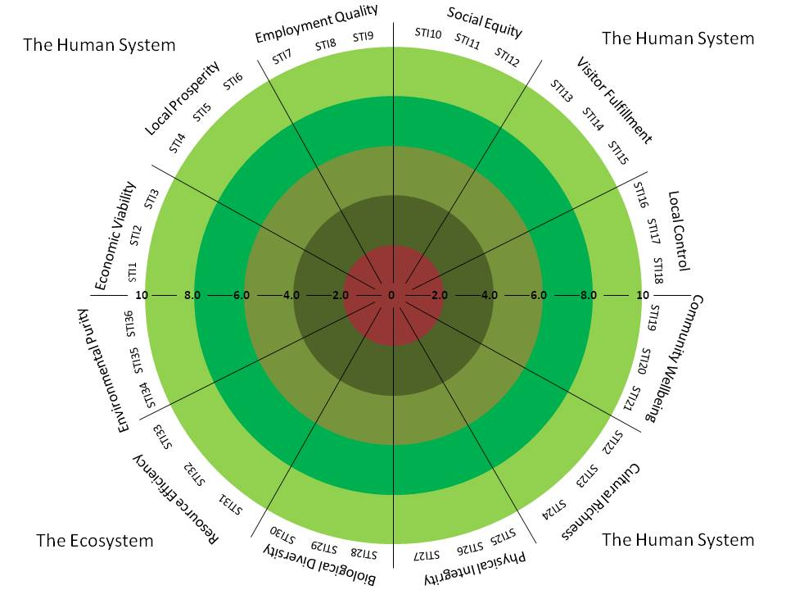

Figure 7‑4 AMOEBA of Tourism Sustainability Indicators

*Source: Based on Ko, 2005[28]*

In correspond with BTS model, the ATSI map can be seen in Figure 7-4, where the red part 0-2.0 refers to unsustainable, part 2.0-4.0 refers to potentially unsustainable, part 4.0-6.0 refers to intermediate, part 6.0-8.0 refers to potentially sustainable and part 8.0-10 refers to sustainable, similar as levels shown in Table 7-4.

To take another assumption example, the number of sustainable tourism indicators are 36 (every indicator is numbered in short such as STI 1, STI 2, STI 3…STI 35 and STI 36), each three indicators for one dimension respectively, and the ten-point scale is given to every indicator, the ATSI maps can be present as it is shown in Figure 7-5.

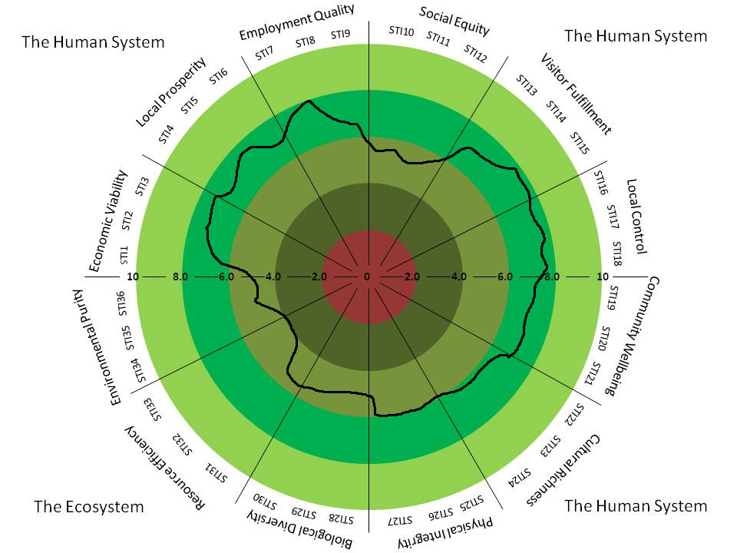

Figure 7‑5 Example Display of an ATSI Map

*Source: Based on Ko, 2005[29]*

The sustainable indicators can be put in each twelve dimensions around the circle: economic viability, local prosperity, employment quality, social equity, visitor fulfillment, local control, community wellbeing, cultural richness, physical integrity, biological diversity, resource efficiency and environmental purity. Then the AMOEBA can be brought out by using all the indicators (e.g. STIs), and the sustainable bands with a certain length can also be presented to drop a hint on the current situation, see Figure 7-6.

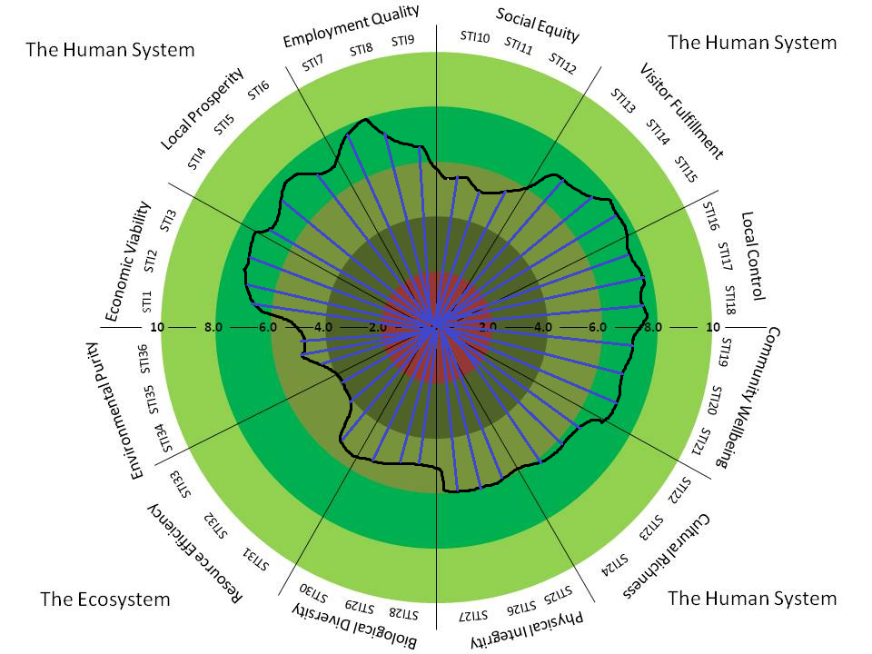

Figure 7‑6 AMOEBA with STI Bands

*Source: Based on Ko, 2005; Bell and Morse, 1999[30]*

The ATSI map has the following functions, developed based on Ko, 2005:

* The map can illustrate individual levels of sustainability;
* The individual levels of sustainability are all demonstrated by quantitative data;
* All the quantitative data can be get from diverse sources (e.g. interviews, surveys and questionnaires);
* The map has five vivid colors to indicate different levels of sustainability;
* The AMOEBA can easily and clearly show the sustainability of the system, while larger AMOEBA implies a more sustainable and health system; very much the other way, smaller AMOEBA means a less sustainable system.

### Continuous Assessment

A unitary time assessment is not adequate for drawing a concluding note in terms of sustainability. To identify a tourist destination’s sustainability, it needs successive assessment process during a certain period of time, e.g. for three or five years. In reality, it is expectant that the data collection will vary from time to time, as well as the BTS and ATSI models ought to be modified according to the actual situation. Thus, a progress monitoring can be sustained in a long-term (T. G. Ko, 2005).

In this study, the system is expected to move along the axes in the BTS map (“arrows” in Figure 7-2) while the AMOEBA shape extend larger in the ATSI map (Figure 7-6). However, the improvement might show very slow sometimes because stakeholders also perceive different factors over time. Therefore, to compile the BTS and ATSI models and corresponding indicators by time would contribute a lot on the monitoring progress towards tourism sustainability.

### Estimation

The valuation on the results from the above assessment is also crucial, as Simmons argued, it would be preferable to bring all the detection to stakeholder and see how this influence policy-decision and facts (Simmons, 1994). Thus, consideration ought to be also pointed as a measurable element of the assessment procedure.

One way to evaluate the process is to examine the effectiveness and efficiency of data gathering and analyses stage; while one way is to estimate the whole model, to see if it is helpful for stakeholders in reality. For doing this, it requires more interaction with stakeholders afterwards, to inspect if the outcomes from the assessment help them in decision-making.

## Further Analysis and Discussions

From the process of the above two model assessment maps, it is suggested not to compare one tourist destination with another due to the different types and characteristic. The basic aim for these models is to present whether the tourist destination is doing well itself, meanwhile monitor and guide itself towards a more sustainability.

However, for the future improvement, it is possible to step further the research if the BTS model can be improved; or in another word, turn the BTS model into another kind of model. For example, the Figure 7-7 shows a similar scale and grade as the BTS model, with different colours indicating different level of sustainability.

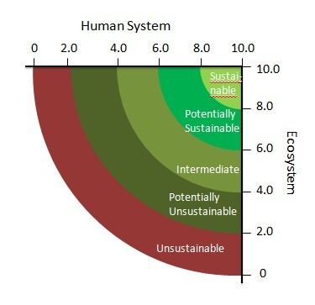

Figure 7‑7 Example Assessment Map of an Improved BTS Model

*Source: Based on Ko, 2005[31]*

However, regarding the original BTS model, it has a drawback that it is not good to compare two different places and their improvements towards more sustainable. For instance, after a great amount of evaluation work, if there are two tourist destinations which are turned out at the same level of sustainability, like both of them at the point A showing in the Figure 7-8. Then followed by a series of their activities to improve their own sustainability over a period of time, and here it is assumed that the amounts of improvements from both the tourist destinations are the same. The difference is one tourist destination improves only in terms of human system, which is their arrow of improvement is along the X axis and achieve point C; while the other tourist destination improves their sustainability by covering both human system and ecosystem, and their arrow reaches point B in the Figure 7-8.

Now it is very clear that the tourist destination improved from A to B, is suddenly promoted into another level of sustainability – potentially sustainable; while the tourist destination improved from A to C, is still in the original under level – intermediate sustainability level.

Though they were at the same level of sustainability before, and they improved their sustainability by doing the same amount of job, it can be found that one tourist destination is obvious in a higher level of sustainability than the other. Even if the lagging tourist destination can improve much more on the human system, which the arrow from A to C can be extended longer and longer; it will still stay in the intermediate level without showing a great progress entering another higher level of sustainability.

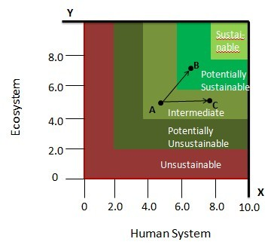

Figure 7‑8 A Comparison with Hypothetical Data Showing in BTS Map

*Source: Based on Ko, 2005[32]*

In this case, it is not that fair and objective to compare and judge two tourist destinations, to see which is doing better and which indeed make a great progress. Thus, a better possible model as Figure 7-7 may be studied further for future research, since the improved model may avoid the drawback as mentioned above in the current BTS model.

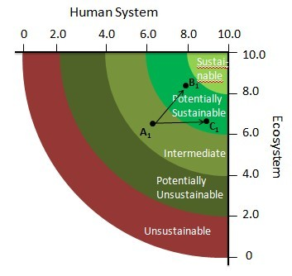

Figure 7‑9 A Comparison with Hypothetical Data Showing in an Improved BTS Map

*Source: Based on Ko, 2005[33]*

For instance, Figure 7-9 shows a similar situation for comparing two tourist destinations. Both tourist destinations are at the same level – point A1 in the map. After doing the same amount of job, one tourist destination moves from A1 to B1 with improvements in both systems; while the other tourist destination moves from A1 to C1, with improvement only along the human system.

However, in this improved BTS map model, after the same amount of their great efforts, they both achieve a new level of sustainability. Also it is obvious to see which tourist destination is doing better in which system. So now in this result, it will give confirmation and acknowledgement to both their progress and it won’t ignore the big improvement in term of human dimension for the case of A1 to C1 progress.

Moreover, when using the indicators systems, it is important that the selected indicators should be explicit and transparent, make stakeholders very easy to follow. For example, the general standard process for choosing some best practice example or winners from some awards or certification programme, is that first they should have many nominations, then followed by large numbers of investigations and indicators’ selection, as well as some essential interviews, then against their performance with each relevant criteria and indicators, to eventually find out the best ones[34].

However, it is normally that when choosing or/ and ranking the indicators, some indicators may be higher ranked than the others[35]. Though it is not exactly applicable in this proposed model assessment procedure, it also would happen sometimes during the assessment process. So if one indicator is changed or replaced by others, it may also appear changes in the entire ranking or its internal performance in a long-term view.

Therefore, each process has pros and cons; it indeed needs to have a documentation of indicators. Even it is not explicitly weighing, it is extremely important have a lot of facts and figures to support the process.

## Conclusions

The main contributions of the model assessment procedure are to:

* Firstly, to integrate and incorporate the supply aspects (e.g. existing research studies in related to environment, economic, and social-cultural impacts) and demand aspects (e.g. tourism service and quality) into the assessment process, in order to improve and promote the use of existing tourism sustainability studies.
* Secondly, to use and integrate the sustainable tourism principles (with twelve aims), the Global Sustainable Tourism Criteria and some certain indicators system. Since all of these are widely accepted and commonly used items, it can provide a coherence and consentience when assessing the sustainability and can be promoted globally with an easier manner.
* Thirdly, to develop a relatively quantitative data in sustainable tourism assessment which can be simply and expressly understand and used by various stakeholders.
* Moreover, to make tourism criteria and indicators easier to be presented at a concise level.
* Last but not least, to make it easy and accessible for stakeholders to obtain right information and implement appropriate strategies and so forth.

In terms of BTS map, it has its own advantage of giving a direct and immediate picture of the comprehensive level of sustainability in both systems, while it fails to illustrate the sustainability of individualised tourism indicators. On the other hand, ATSI map overcomes the drawbacks of BTS map, which can demonstrate individual levels of sustainability.

Moreover, it is suggested that the choice among all the model types (e.g. in this study the BTS and ATSI map) should be complied with the own unique feature of a tourist destination. Without doubt that a more detailed model map can imply more things, and may be more useful for policy-makers, e.g. scales more than five sectors are explained in this study. In short, the combination of BTS and ATSI map for evaluating a tourist destination can both show a comprehensive level and individual levels of sustainability.

In additions, outputs from these models cannot be compared between one tourist destination and another since the types and features of the selected examples may be distinct. Thus, this proposed model assessment procedure is more than a management tool than a comparing tool, since primary goal of these models is not to compare among different good practice examples, instead of showing which is better; it is mainly used for whether it is doing well itself. However, only if the same sets of indicators are selected and utilized, or/ and if change the current model to another possible model, it is also good to compare the results between two destinations.

# Conclusion and Recommendation

## Final Conclusions and Recommendations

In current world, tourism takes an important position in the contribution to the world’s development; this can be expressed as below:

* Tourism is a fast growing industry which contribute a huge amount to economic development;
* Tourism connects consumers, tourists, industry, environment and local communities, which is a joint ligament.

Thus, tourism sustainability influences a lot in the world’s sustainable development. There are three aspects between tourism and sustainability:

* Interaction
* Awareness
* Dependency.

This special relationship can either ruin the tourism, or build a positive and sound environment for a more sustainable development. Therefore, stakeholders and key actors involved in tourism have more responsibility to rise up the awareness and concerns. To accomplish this, a sound system to measure tourism sustainability, as well as monitoring and reporting systems needs to be developed.

To accomplish a comprehensive system, the Sustainable Tourism Principles, the Global Sustainable Tourism Criteria and the Sustainable Tourism Research Framework are first provided.

* The Sustainable Tourism Principle includes twelve equally important aims which emphasize economic, social-cultural and environmental aspects, based on two essentials:
  + Minimizing the negative impacts
  + Maximizing the positive contribution
* The Global Sustainable Tourism Criteria contains four main sections, which is about demonstrate effective sustainable management and maximize benefits meanwhile minimize negative impacts in terms of social-economic, cultural and environmental aspects.
* The Sustainable Tourism Research Framework is constituted of eight thematic topics, namely:
  + climate change – energy and resource efficiency;
  + natural and cultural heritage;
  + quality assessment, certification and branding;
  + sustainable supply chain management for SMEs;
  + destination management and good governance;
  + sustainable transport and travel;
  + knowledge networking, training and education;
  + sustainable consumption and production and tourism.

Only by noticing the principles, criteria and research framework is not enough to make up a conceptual framework and a measurement system for sustainable tourism, further detailed indicators systems is needed. Thus, an introduction to the current commonly used indicators system are provided, to measure different tourism aspects, for example, EC indicators, UNWTO indicators.

However nowadays, the EC-TSG drafted indicators system has been identified with many drawbacks, an improved indicators system by categorises was conducted and developed through the course Sustainable Tourism, which is also under the big methodology framework of this research. The improved indicators system divided all the basic indicators into four categories: management and governance indicators; environmental indicators; economic indicators; and social-cultural indicators. Though this indicators system is based on a coastal destination, its framework and baseline indicators and measurement still worth to be applicable in many tourist destinations.

Since there are many good practice examples in sustainable tourism, the difficulty is always to transparently measure, monitor and disseminate them. If using the mono-measurement to evaluate, it is difficult to avoid a subjective and inaccurate analysis. Thus, this paper aims to use the widely accepted sustainable research framework and the Global Sustainable Tourism Criteria to develop a measurement system.

Because the Sustainable Tourism Research Framework is still under development by the corresponding group and experts, one of the hypotheses in this research is to test the practicability of the research framework.

Therefore, by sorting some good practice examples into the Sustainable Tourism Research Framework with the eight thematic topics, this paper proved the practicability of the research framework, also provided an example observatory research framework to both improve the measurability of the Global Sustainable Tourism Criteria, and work as a information platform to promote more good practice examples, meanwhile showcase the openness of a monitoring system.

However, one of the consecutive processes for the progress of moving towards more a more sustainable area, and improving the positive contribution for the environment, economic and social-cultural aspects, is the continuous collection and evaluation of good practices in sustainable tourism. Consequently, the good practices can become more integrated activities that cover the main sustainable tourism themes as much as possible. In addition, the manners for collecting good practices can also be conducted by open calls, conferences’ presentations, and organizations’ initiatives,

For the reason of well evaluating and assessing the tourism sustainability, a model assessment procedure with nine steps is proposed, by integrating the twelve sustainable tourism principles and using the Global Sustainable Tourism Criteria and different indicators system:

* identify the systems;
* identify the twelve principles/dimensions;
* identify the Global Sustainable Tourism Criteria;
* identify the main indicators;
* scale tourism sustainability;
* grade tourism sustainability;
* develop tourism sustainability assessment maps;
* continuous assessment
* and estimations.

Concerning the study of the assessment procedure for tourism sustainability, there are a number of conclusions and suggestions might be listed as below:

* The improvement of tourism development can be assessed and valuated to inspect whether and how much tourist industry proffer to the development of sustainability. Sustainable development calls for a comprehensive sustainability development in terms of economic, environment, social-cultural aspects. Thus, as an important section of sustainable development, tourist industry needs a sound monitoring system to supervise its contribution and improvement.
* In consideration of the progress of assessment itself cannot be evaluated and defined, a standard is demanded to estimate the progress of tourism sustainability, by which a comparison of a former and present situation can be checked.
* For making a standard, both qualitative sources and quantitative sources can be utilized. Thought numerical data sometimes might contain more merits than qualitative sources for the assessment of sustainability, it does not imply that quantitative sources are better and superior than qualitative sources. They ought to work synchronously and complementarily.
* In terms of obtaining quantitative sources, a perception study conducted via questionnaire surveys or other kinds of surveys is recommended, especially when some technical sources and information are missing, it is very helpful and favourable to get needed information by a perception study. Besides, the observatory research framework discussed above can be well used to provide needed information and relevant interested topics for data obtaining.
* Although a five-point scale is normally conventional in different level rating, a ten-point scale is advised in this study, because it is more easily and explicitly presented in the tourism sustainability assessment maps.
* Four-level gradations for sustainable tourism assessment are recommended, despite the fact that two or three level gradation “from unsustainable to sustainable” are prevalently applied, they may illustrate a more detailed information and condition.
* Two kinds of sustainability assessment maps BTS and ATSI should be used complementarily and simultaneously. BTS is a tool to display an overview situation of a current tourist destination while ATSI map explains the sustainability of individualized tourism indicators, to further illustrate the complexity and diversity of tourism aspects.
* Both BTS and ATSI maps can be extended time by time to keep a constant monitoring of the tourist destination.
* Both BTS and ATSI should be used together to assess a tourist destination, and it’s suggested that the proposed assessment procedure in this thesis is more than a management tool than a comparing tool, to evaluate and monitor the own progress of sustainability within one tourist destination over time, and provide guides moving towards more a sustainability. Though it might be possible for the future research to study some improved models, it is not analysing in this paper.
* It is extremely important to have the transparent documentation. Whenever using the procedure for onetime measuring or future monitoring or dissemination, it always needs to have various facts and figures to support.

Whereas a great number of uncertainty and unaccountability appear very often in sustainable tourism, the experience and intelligence of stakeholders are more important and meritorious than simplex and humdrum quantitative sources. Last but not least, though the Global Sustainable Tourism Criteria is used in the model assessment procedure, and two assessment maps can present some profitable information to stakeholders and interested people, the results is not an utter solution, but as a reference.

## Recommendations for Future Research

Throughout the process of the research and study for this paper, it has become obvious that there are a huge number of directions for future research in relation to this similar area. In order to conduct a further and deeper research study, some indications are provided as below:

* Further analysis of the Sustainable Tourism Research Framework’s practical applicability is needed, so as to build the potential effectiveness and value of the framework as pragmatical tool. This study can be ideally followed out after the framework has arrived at the end of operational stage at a level of implementation.
* Further analysis of the development of good practice in sustainable tourism, through developing a transparent measurement, monitoring and reporting system. This research can be based on the further development of the Sustainable Tourism Research Framework, and a more correct and adaptable criteria and indicators system.
* Further test performance of the model assessment procedure for tourism sustainability. This study can be carried out by taking many good practice examples and test them step by step with the current assessment model, to identify the infeasible and blinded sides of this model, in order to perfect and complete a more suitable assessment procedure. Examples selected should not be limited within Europe or some specific region, it is better to sample from a worldwide level.
* Further improvement of BTS map model. It was not explicitly analyzed and discussed in this paper for the proposed new BTS map, since it requires plentiful information and data collection, it might be interesting to make some further research, to find out how to use practice, to improve the current model system, and make it possible to compare among different tourist destination.
* It would be also interesting to use the current proposed assessment procedure to evaluate the already awarded good practice examples, e.g. Fiskars Village (Finland), the winner from the Royal Awards for sustainable tourism in 2007. Would it change the result of winner and turn into another destination? This needs large numbers of questionnaire surveys and interviews for collecting information and qualitative and quantitative data.

# Bibliography

Archer, B. (1996). Sustainable Tourism: An Economist's Viewpoint. *Sustainable Tourism in Islands & Small States: Issues and Policies,* 6-17.

BBNP, Brecon Beacons National Park. (2005). Wales Sustinable Tourism Initiatives Retrieved June 20, 2011, from <http://www.breconbeacons.org/the-authority/working-in-partnership/tourism-industry/wales-sustainable-tourism-initiative>

Bell, S., & Morse, S. (1999a). Sustainability indicators: Measuring the immeasurable. London: Earthscan.

Bell, S., & Morse, S. (1999b). Sustainable Tourism: An Evolving Global Approach. *Journal of Sustainable Tourism, 1*(1), 6-16.

Chelidze, Tamar. (2011a). *Developing content for the Sustainable Tourism Observatory - Destination Management Indicators*. FAST-LAIN Meeting. Saarbrücken.

Chelidze, Tamar. (2011b). *Measurement Tools_V8*. FAST-LAIN Project Meeting. Saarbrücken.

Clayton, A.M.H., & Redcliffe, N.J. (1996). *Sustainability: A systems approach*. London: Earthscan.

DestiNet. (2003). About the DestiNet: Background Retrieved August 31, 2011, from <http://destinet.eu/background>

DestiNet. (2007). DESTINET: Sustainable Tourism Information & Communications Portal Retrieved August 25, 2011, from <http://destinet.eu/>

DestiNet. (2009). Atlas of Excellence - awarded tourism world wide Retrieved August 31, 2011, from <http://destinet.eu/market-place/nominees-and-winners-awards>

DestiNet. (2011a). DestiNet Atlas Retrieved August 31, 2011, from <http://destinet.eu/portal_map/>

DestiNet. (2011b). Hardangervidda Mountain Guiding Retrieved August 29, 2011, from <http://destinet.eu/market-place/certified-tourism-norway/hardangervidda-mountain-guiding>

DG-ETU, DG Enterprise Tourism Unit. (2004). Tourism Learning Area Handbook Gordon Sillence (Ed.)

Driml, S., & Common, M. (1996). Ecological Economics Criteria for Sustainable Tourism: Application to the Great Barrier Reef and Wet tropics World Heritage Areas, Australia. *Journal of Sustainable Tourism, 4*(1), 3-16.

ECOTRANS. (2011). *Sustainable Tourism Information & Communications Portal*. Paper presented at the Fast-Lain-DestiNet, Budapest. [www.destinet.eu;](http://www.destinet.eu;) [www.ecotrans.org](http://www.ecotrans.org)

ECOTRANS, & DestiNet. (2011, 2011 May 25th - 26th). *The FAST-LAIN Project - Developing an Information Research Framework for a European Tourism Observatory.* Paper presented at the FAST-LAIN Project Kick Off Meeting, Saarbrucken.

ECOTRANS, Ecotrans Network for Sustainable Tourism Development. (2011). *Knowledge Networks for the Competitiveness and Sustainability of Euroopean Tourism*. Paper presented at the FAST-LAIN (Further Action on Sustainable Tourism - Learning Area Innovation Networks) Project Overview, Brussels.

Eilleen, Gutierrez, Lamoureux, Kristin, Matus, Seleni, & Sebunya, Kaddu. (2005). Linking Communities, Tourism and Conservation: a Tourism Assessment Process - Tools and Worksheets. *Assessment for Sustainable Tourism, Module 2*(Handout 2.2).

Fennell, David A. (1999). *Ecotourism: an introduction*. London and New York: Routledge, the Taylor & Francis Group.

Green, H. (1995). *Planning for Sustainable Tourism Development*. London: Toutledge.

Griffin, K.A. (2000). The implication of Agenda 21: A pracitical investigation of sustainable tourism in Ireland. *Environmental Papers Series, 3*(1), 34-43.

GSTC, Global Sustainable Tourism Council. (2011a). Global Sustainable Tourism Criteria Retrieved August 19, 2011, from <http://new.gstcouncil.org/page/adopt-the-criteria>

GSTC, Global Sustainable Tourism Council. (2011b). Travel Forever - Global Sustainable Tourism Council Retrieved August 19, 2011, from <http://new.gstcouncil.org/>

Hamele, Herbert (2011, August 16). [GSTC Criteria (Version 2) Public Comment Period Open].

Hamele, Herbert, & Sillence, Gordon. (2011a). FAST-LAIN Project Detailed Overview. In ECOTRANS (Ed.), *Knowledge networks for the competitiveness and sustainability of European tourism*.

Hamele, Herbert, & Sillence, Gordon. (2011b). *FAST-LAIN workbook_Final_290411-v1.2*.

Hardangervidda. (2011). Velkommen til Hardangervidda Fjellguiding Retrieved August 29, 2011, from <http://fjellguiding.no/>

Harris, Jonathan, & Goodwin, Neva. (2001). *Survey of Sustainable Development: Social and Economic Dimensions*. Washington: Island Press.

Huang, Wei (2011). [Tourism Assessment Procedure].

Hunter, C. (1995). On the need to re-conceptualise sustainable tourism development. *Journal of Sustainable Tourism, 3*(3), 155-165.

Hunter, C., & Green, H. (1995). *Tourism and the Environment: A sustainable relationship?* London: Routledge.

ISEAL, ISEAL Allicance. (2009). ISEAL Codes of Good Practice Retrieved August 2, 2011, from <http://www.isealalliance.org/code>

IUCN, International Union for Conservation of Nature and Natural Resources. (1995). *Assessing progress toward sustainability: A new approach*. Paper presented at the A sustainable world: Defining and measuring sustainable development, Sacramento.

IUCN, International Union for Conservation of Nature and Natural Resources. (1997). *Overview: Approach, methods, tools and field experience*. Paper presented at the IUCN, An approach to assessing progress toward sustainability: Tools and training series for institutuions, field teams and collaborating agencies, Gland.

Jules, Sharmon. (2005). Sustainable Tourism in St. Lucia. In IISD (Ed.), *the Trade Knowledge Network*. Manitoba, Canada: International Institute for Sustainable Development.

Khatri, Upasana. (2010). *Sustainable Development and Ecotourism: Theory and Application.*

Ko, James T. G. (2001). Assessing Progress of Tourism Sustainability. [Research Notes and Reports]. *Annals of Tourism Research, 28*(3), 817-820.

Ko, T. G. (2005). Development of a tourism sustainability assessment procedure: a conceptual approach. *Tourism Management, 26*(3), 431-445.

Lee-Smith, D. (1997). *Community-based indicators: A guide for field workers carrying out monitoring and assessment at the community level*. Paper presented at the IUCN, An approach to assessing progress toward sustainability: Tools and training series for institutuions, field teams and collaborating agencies, Gland.

Mannion, A.M., & Bowlby, S.R. (1992). Introduction. *Environmental issues in the 1990s,* 3-36.

Meldon, J., Walsh, J., & Kenny, M. (2000). Local Government, Local Development and Citizen Participation: Lessons from Ireland Retrieved June 28, 2011, from <http://eprints.nuim.ie/272/2/Paper_on> Local_Government_Draft.pdf

MESPOM, Masters in Environmental Sciences Policy and Management 2009-2011. (2010). Sustainable Tourism Indicators: Case Study for Sigri, Greece. Sigri, Greece.

MESPOM, Masters in Environmental Sciences Policy and Management 2010-2012. (2011). Project Dilbert: Development of Indicators in (Sigri) Lesvos for Benchmarking Environmentally Responsible Tourism. Sigri.

Nanos, Janelle. (2009). Dubai Announces Sustainable Tourism Initiative. *National Geographic: Travel & Cultures* Retrieved June 26, 2011, from <http://intelligenttravel.nationalgeographic.com/2009/03/25/dubai_announces_sustainable_to/>

NLVC, New Lanark Visitor Centre. New Lanark: World Heritage Site Retrieved August 31, 2011, from <http://www.newlanark.org/index2.shtml>

Prescott-Allen, R. (1997). *Barometer of sustainability: Measuring and communicating wellbeing and sustainable development*. Paper presented at the IUCN, An approach to assessing progress toward sustainability: Tools and training series for institutuions, field teams and collaborating agencies, Gland.

Quebec. (2002). Quebec Declaration on Ecotourism *World Ecotourism Summit*. Quebec: International Year of Ecotourism.

RoyalAwards. (2011). Royal Awards for Sustainability Retrieved August 31, 2011, from <http://www.royalawards.org/>

Sillence, Gordon, & Hamele, Herbert. (2011a). *FAST-LAIN Expert Group Orientation Paper July 2011*. Orientation paper for expert group. FAST-LAIN group.

Sillence, Gordon, & Hamele, Herbert. (2011b). *Further Action on Sustainable Tourism Learning Area Innovation Networks Project Description*. Germany: FAST-LAIN.

Simmons, D. (1994). Community participation in tourism planning. *Tourism Management, 15*(2), 98-108.

Sofield, T.H.B., & Li, F.M.S. (1998). Historical methodology and sustainability: An 800-year-old festival from China. *Journal of Sustainable Tourism, 6*(1), 267-290.

Swarbrooke, John. (1999). *Sustainable Tourism Management*. Sheffield: CABI Publishing.

TF, Travel Forever. (2011). GSTC Criteria Consultation - 2011- English. *GSTC, Global Sustainable Tourism Council* Retrieved August 31, 2011

Tosun, C. (1998). Roots of unsustainable tourism development at the local level: The case of Urgup in Turkey. *Tourism Management, 19*(6), 595-610.

TourCert. (2011). Corporate Social Responsibility in Tourism Retrieved September 8, 2011, from <http://tourcert.org/index.php?id=csr-zertifizierung&L=1>

TSG, Tourism Sustainability Group. (2007). Action for More Sustainable European Tourism: Report of the Tourism Sustainability Group. In Report of the Tourism Sustainability Group (Ed.): TSG, Tourism Sustainability Group.

TSG, Tourism Sustainability Group. (2011). *Indicator System for Sustainable Tourism Destinations - Final Draft*. European Commission.

UAB, Universitat Autonoma de Barcelona. (2010). Evaluation report: Test to implement tourist indicators in EDEN Destinations. Barcelona, Spain.

UN, United Nations, & EU, European Union. (1992). Economic Aspects of Sustainable Development in the European Union Retrieved September 1, 2011, from <http://www.un.org/esa/agenda21/natlinfo/countr/ec/Eco.htm#tour>

UNCED, United Nations Conference on environment and Development. (1992). *Earth Summit: Agenda 21*. Rio de Janerio: UNCED.

UNEP, United Nations Environment Programme. (2004). Sustainable Tourism: Definition. *Tourism* Retrieved July 19, 2011, from <http://www.unep.fr/scp/tourism/sustain/>

UNEP, United Nations Environment Programme, & UNWTO, United Nations World Tourism Organization. (2005). *Making Tourism More Sustainable: A Guide for Policy Makers*. Paris and Madrid: UNEP and WTO.

UNF, United Nations Foundation. (2011). Global Sustainable Tourism Criteria: Working together for the universal adoption of sustainable tourism principles Retrieved August 19, 2011, from <http://www.unfoundation.org/global-issues/sustainable-development/global-sustainable-tourism-criteria.html>

UNTWO, United Nations World Tourism Organization. (2004). *Indicators of Sustainable Development for Tourism Destination: A Guidebook*. Madrid, Spain: the World Tourism Organization.

UNTWO, United Nations World Tourism Organization, & TSG, Tourism Sustainability Group. (2004). Sustainable Development of Tourism: Tourism Sustainability Group Retrieved August 20, 2011, from <http://sdt.unwto.org/en/content/tourism-sustainability-group-tsg>

UNWTO, United Nations World Tourism Organization. (2002, 2011 June 23). Global Initiatives for Sustainable Development of Tourism Retrieved July 1, 2011, from <http://www.unwto.org/sdt/fields/en/global.php#9>

UNWTO, United Nations World Tourism Organization. (2004a). Indicators of Sustainable Development for Tourism Destinations. Madrid.

UNWTO, United Nations World Tourism Organization. (2004b). Sustainable Development of Tourism Retrieved July 19, 2011, from <http://sdt.unwto.org/en>

VESTAS. (2011). VESTAS - Vision/DestiNet European Sustainable Tourism Awards Retrieved August 31, 2011, from <http://destinet.eu/tools/fol703514/fol588962/travelmoledestinet-sustainable-tourism-awards/>

VISIT. (2004). Voluntary Initiatives for Sustainability in Tourism Retrieved September 8, 2011, from <http://www.visit21.net/>

WCED, World Commission on Environment and Development. (1987). *Report of the World Commission on Environment and Development: Our Common Future* (Vol. UN Documents: Gathering a Body of Global Agreements). Oxford: Oxford University Press.

Weaver, David. (2006). *Sustainable Tourism: Theory and Practice*. Oxford: Elsevier.

WSSD, World Summit on Sustainable Development , & UN, United Nations. (2002). Johannesburg Summit 2002: World Summit on Sustainable Development Retrieved July 18, 2011

YCELP, Yale Center for Environmental Law & Policy, & CIESIN, Center for International Earth Science Information Network. (2010). 2010 Environmental Performance Index. In World Economic Forum & Joint Research Centre of the European Commission (Eds.).

# Appendix

## Appendix A - Global Sustainable Tourism Criteria

**Preamble**

Sustainable tourism is on the rise: consumer demand is growing, travel industry suppliers are developing new green programs, and governments are creating new policies to encourage sustainable practices in tourism. But what does “sustainable tourism” really mean? How can it be measured and credibly demonstrated, in order to build consumer confidence, promote efficiency, and fight false claims?  
The Global Sustainable Tourism Criteria are an effort to come to a common understanding of sustainable tourism, and will be the minimum that any tourism business should aspire to reach. They are organized around four main themes: effective sustainability planning; maximizing social and economic benefits for the local community; enhancing cultural heritage; and reducing negative impacts to the environment. Although the criteria are initially intended for use by the accommodation and tour operation sectors, they have applicability to the entire tourism industry.  
The criteria are part of the response of the tourism community to the global challenges of the United Nations’ Millennium Development Goals. Poverty alleviation and environmental sustainability – including climate change – are the main cross-cutting issues that are addressed through the criteria.   
Beginning in 2007, a coalition of 27 organizations – the Partnership for Global Sustainable Tourism Criteria – came together to develop the criteria. Since then, they have reached out to close to 100,000 tourism stakeholders, analyzed more than 4,500 criteria from more than 60 existing certification and other voluntary sets of criteria, and received comments from over 1500 individuals. The Sustainable Tourism Criteria have been developed in accordance with the ISEAL Code of Best Practice, and as such will undergo consultation and receive input every two years until feedback is no longer provided or unique.  
Some of the expected uses of the criteria include the following:

* Serve as basic guidelines for businesses of all sizes to become more sustainable, and help businesses choose sustainable tourism programs that fulfill these global criteria;
* Serve as guidance for travel agencies in choosing suppliers and sustainable tourism programs;
* Help consumers identify sound sustainable tourism programs and businesses;
* Serve as a common denominator for information media to recognize sustainable tourism providers;
* Help certification and other voluntary programs ensure that their standards meet a broadly-accepted baseline;
* Offer governmental, non-governmental, and private sector programs a starting point for developing sustainable tourism requirements; and
* Serve as basic guidelines for education and training bodies, such as hotel schools and universities.

The criteria indicate **what should be done, not how to do it or whether the goal has been achieved.** This role is fulfilled by performance indicators, associated educational materials, and access to tools for implementation, all of which are an indispensable complement to the Global Sustainable Tourism Criteria.  
The Partnership conceived the Global Sustainable Tourism Criteria as the beginning of a process to make sustainability the standard practice in all forms of tourism.

**A.        Demonstrate effective sustainable management.**

* A.1.   The company has implemented a long-term sustainability management system that is suitable to its reality and scale, and that considers environmental, socio-cultural, quality, health, and safety issues.
* A.2.   The company is in compliance with all relevant international or local legislation and regulations (including, among others, health, safety, labor, and environmental aspects).
* A.3.   All personnel receive periodic training regarding their role in the management of environmental, socio-cultural, health, and safety practices.
* A.4.   Customer satisfaction is measured and corrective action taken where appropriate.
* A.5.   Promotional materials are accurate and complete and do not promise more than can be delivered by the business.
* A.6.   Design and construction of buildings and infrastructure:
  + A.6.1.      comply with local zoning and protected or heritage area requirements;
  + A.6.2.      respect the natural or cultural heritage surroundings in sitting, design, impact assessment, and land  rights and acquisition;
  + A.6.3       use locally appropriate principles of sustainable construction;
  + A.6.4       provide access for persons with special needs.
* A.7.   Information about and interpretation of the natural surroundings, local culture, and cultural heritage is provided to customers, as well as explaining appropriate behavior while visiting natural areas, living cultures, and cultural heritage sites.

**B.       Maximize social and economic benefits to the local community and minimize negative impacts.**

* B.1.    The company actively supports initiatives for social and infrastructure community development including, among others, education, health, and sanitation.
* B.2.    Local residents are employed, including in management positions. Training is offered as necessary.
* B.3.    Local and fair-trade services and goods are purchased by the business, where available.
* B.4.    The company offers the means for local small entrepreneurs to develop and sell sustainable products that are based on the area’s nature, history, and culture (including food and drink, crafts, performance arts, agricultural products, etc.).
* B.5.    A code of conduct for activities in indigenous and local communities has been developed, with the consent of and in collaboration with the community.
* B.6.    The company has implemented a policy against commercial exploitation, particularly of children and adolescents, including sexual exploitation.
* B.7.    The company is equitable in hiring women and local minorities, including in management positions, while restraining child labor.
* B.8.    The international or national legal protection of employees is respected, and employees are paid a living wage.
* B.9.    The activities of the company do not jeopardize the provision of basic services, such as water, energy, or sanitation, to neighboring communities.

**C.    Maximize benefits to cultural heritage and minimize negative impacts.**

* C.1.   The company follows established guidelines or a code of behavior for visits to culturally or historically sensitive sites, in order to minimize visitor impact and maximize enjoyment.
* C.2.   Historical and archeological artifacts are not sold, traded, or displayed, except as permitted by law.
* C.3.   The business contributes to the protection of local historical, archeological, culturally, and spiritually important properties and sites, and does not impede access to them by local residents.
* C.4    The business uses elements of local art, architecture, or cultural heritage in its operations, design, decoration, food, or shops; while respecting the intellectual property rights of local communities.

**D.    Maximize benefits to the environment and minimize negative impacts**.

* D.1.   Conserving resources
  + D.1.1.      Purchasing policy favors environmentally friendly products for building materials, capital goods, food, and consumables.
  + D.1.2.      The purchase of disposable and consumable goods is measured, and the business actively seeks ways to reduce their use.
  + D.1.3.      Energy consumption should be measured, sources indicated, and measures to decrease overall consumption should be adopted, while encouraging the use of renewable energy.
  + D.1.4.      Water consumption should be measured, sources indicated, and measures to decrease overall consumption should be adopted.
* D.2.   Reducing pollution
  + D.2.1.      Greenhouse gas emissions from all sources controlled by the business are measured, and procedures are implemented to reduce and offset them as a way to achieve climate neutrality.
  + D.2.2.      Wastewater, including gray water, is treated effectively and reused where possible.
  + D.2.3.      A solid waste management plan is implemented, with quantitative goals to minimize waste that is not reused or recycled.
  + D.2.4.      The use of harmful substances, including pesticides, paints, swimming pool disinfectants, and cleaning materials, is minimized; substituted, when available, by innocuous products; and all chemical use is properly managed.
  + D.2.5.      The business implements practices to reduce pollution from noise, light, runoff, erosion, ozone-depleting compounds, and air and soil contaminants.
* D.3.   Conserving biodiversity, ecosystems, and landscapes
  + D.3.1.      Wildlife species are only harvested from the wild, consumed, displayed, sold, or internationally traded, as part of a regulated activity that ensures that their utilization is sustainable.
  + D.3.2.      No captive wildlife is held, except for properly regulated activities, and living specimens of protected wildlife species are only kept by those authorized and suitably equipped to house and care for them.
  + D.3.3.      The business uses native species for landscaping and restoration, and takes measures to avoid the introduction of invasive alien species.
  + D.3.4.      The business contributes to the support of biodiversity conservation, including supporting natural protected areas and areas of high biodiversity value.
  + D.3.5.      Interactions with wildlife must not produce adverse effects on the viability of populations in the wild; and any disturbance of natural ecosystems is minimized, rehabilitated, and there is a compensatory contribution to conservation management

## Appendix B - List of Indicators by Categories from MESPOM 2011

Notes:

The first level, represented by one star is that of individual participation, reflecting the willingness to change behaviour. All actions start from this point as in order for interest to be taken to change a community there has to be a willingness from individual stakeholders to adjust their behaviour as identified with the indicators in this report. This is because the change to a sustainable community will have repercussions for all members of the community and can have a direct and indirect consequence.

The second level which has a two-star symbol is community involvement. While policy is obviously important in the actual implementation it takes the interest and willingness of the community to make these policies function, so community involvement is a prerequisite for an adequate policy implementation. Communities can quite often also make suggestions or set out a change within governmental policies (Meldon, Walsh, & Kenny, 2000).

The last level, which constitutes the three-star symbol, is dedicated to the policy level and is perhaps the most important in an official sense. This is due to the fact that policies are highly influential in their ability to rally communities and individuals to implement day-to-day projects. Drafts can be made by the executive committee which then can be communicated to the public (Meldon, et al., 2000).

Improved EC Indicator System – through the course Sustainable Tourism in Sigri

* **Management and Governance Indicators**

|  |  |  |  |
| --- | --- | --- | --- |
|  |  |  |  |
| 1. |  | Visitor management plan | Policy for energy  Policy for solid waste management  Policy on water management  Policy for waste treatment  Policy for landscape/biodiversity protection  Policy of accessibility/equal opportunities  Policy for light and noise management  Policy on land use management  Policy on cultural identity and assets |
| 2. | Stakeholders represented in this council | Sustainability council  Sustainable tourism strategy/action plan | Sustainable Tourism officer (acquainted with the principle of PDCA and training) |
| 3. | Inclusive management practices by stakeholders | Inclusive management practices by the community | Inclusive management practices by the government |
| 4. | Stakeholder meetings  E-mail address for critique (# of e-mails answered per year)  Critique box (# of letters of critique received annually) |  | Mechanisms in place so that stakeholders can contribute recommendations wit regards to Sustainable Tourism |
| 5. | Stakeholders putting forward proposals | Implemented proposals forwarded by stakeholders | Implemented proposals forwarded by stakeholders |
| 6. | Frequency of engagement by type and by stakeholder group | Frequency of engagement by type and by stakeholder group |  |
| 7. | Effective destination management and access to information for customers | Effective destination management and access to information for customers | Effective destination management and access to information for customers |
| 8. | Percentage of residents satisfied with their involvement and their influence in the planning and development of tourism | Percentage of the destinations with a sustainable tourism strategy/ action plan | Percentage of the destinations with a sustainable tourism strategy/ action plan |
| 9. |  |  | Percentage of official tourism information with a specific section about sustainability issues  How much of the destination’s budget is allocated by this participatory council |
| 10. | Percentage of participating stakeholders | Number of workshops per year |  |
| 11. | Sustainable tourism management practices in tourism enterprises  Percentage of tourism enterprises/establishments in the destination with externally verified certification/ labeling for environmental/ sustainability and/ or CSR-measures  Percentage of local services and goods sources locally  Percentage local tour handlers and guides used within the destination |  |  |
| 12. | Sustainability reporting: Is there an annual report? |  | Frequency with which the highest governance body assesses sustainability performance |

* **Environmental Indicators**

|  |  |  |  |
| --- | --- | --- | --- |
|  |  |  |  |
| ENERGY |  | Total energyused per year  Energy use per tourist per year | Energysource  Total amount of energy used per year |
| BIODIVERSITY |  | Land use change (% of land covered by vegetation)  Trawling and dredgingintensity | % of land designated as protected/% marine habitat protected  Change in number of native species |
| WASTE | Tonnes of non biodegradable solid waste produced per capita | % of solid waste recycled |  |
| WATER | Fresh water consumed per tourist/night  Agriculturalwaterintensity | % of population with access to clean water  Waterquality  Waterscarcity | % of sewage water undergoing preliminary treatment  Waterquality  Waterscarcity |
| FOOD | Foodsource | Foodsource |  |
| TRANSPORT | Carbon footprint of transport within destination |  |  |
| AIR | Indoor air pollutionindex | Outdoor air quality |  |

* **Economic Indicators**

|  |  |  |  |
| --- | --- | --- | --- |
|  |  |  |  |
| SEASONALITY | Percentage of accommodation and services open all year | (Peak month of tourists arrivals) |  |
| LEAKAGES | Visible leakages (value of imported/subsidized goods and services used by tourists; remittances abroad)  Invisible leakages (Foreign exchange losses due to differences between official and market exchange rates, and non-licensed/ un-taxed services) |  |  |
| EMPLOYMENT | Number of local employees per sector and the average lengths of their contracts, as registered by the local tax authority |  | Number of local employees per sector and the average lengths of their contracts, as registered by the local tax authority |
| FINANCING CONSERVATION OF NATURAL PROTECTON AND HERITAGE SITES | Percentage of the protected area/ conservation site budget originated from tourism activities |  | Percentage of the protected area/ conservation site budget originated from tourism activities |
| ECONOMIC BENEFITS TO THE LOCAL COMMUNITY | Percentage share of tourism in local GDP | Percentage share of tourism in local GDP | Returns on tourism-related public expenditure: Ratio of public revenue from tourism to public expenditure on tourism  Percentage share of tourism in local GDP |

* **Social-cultural Indicators**

|  |  |  |  |
| --- | --- | --- | --- |
|  |  |  |  |
| TOURIST FULFILMENT | Percentage of visitors satisfied with overall experience in coastal destination  % of tourists that are return visitors  Tourists level of feeling of having had positive impact on coastal destination  Tourist’s level of feeling of connectedness to coastal destination |  |  |
| LOCAL ACCEPTANCE | Percentage of locals satisfied with nature of tourism in the destination  Locals’ level of acceptance of tourism  Frequency of tourist related complaints  Percentage of locals communicating with tourist after departure | Percentage of conflict local-tourist out of total conflict.  Percentage of tourist involvement in local events | Existing mechanism to mediate these conflicts |
| QUALITY OF LIFE & WELL-BEING | People suffering from serious illnesses  Level of functional second language (English) knowledge  Level of Internet accessibility | Physical violence and theft | Existing medical facility, security personnel |
| CULTURAL RICHNESS & PROTECTION | Tourist feelings toward cultural intactness  Local feelingtoward cultural intactness | Numerical/spatial ratio of tourists to locals | Numerical/spatial ratio of tourists to locals |
| SOCIAL EQUITY | % of employees suffering from fatigue/stress as a result of work  % of employees who believe that discrimination has affected their job advancement, payment or benefits |  | % of employees suffering from fatigue/stress as a result of work |

## Appendix C - UNWTO Baseline Indicators of Sustainable Development for Tourism Destinations (ISDTD)

|  |  |
| --- | --- |
| **Baseline Issue** | **Baseline Indicator(s)** |
| Local satisfaction with tourism | * Local satisfaction level with tourism (Questionnaire) |
| Effects of tourism on communities | * Ratio of tourist to locals (average and peak period/days) * % who believes that tourism has helped bring new services of infrastructure. (questionnaire-based) * Number and capacity of social services available to the community (% which and attributable to tourism) |
| Sustaining tourist satisfaction | * Level of satisfaction by visitors (questionnaire-based) * Perception of value for money * Percentage of return visitors |
| Tourism seasonality | * Tourist arrivals by month or quarter (distribution throughout the year) * Occupancy rates for licensed (official) accommodation by month (peak periods relative to low season) and % of all occupancy in peak quarter of month * % of business establishment open all year * Number and % of tourist industry jobs which are permanent or full-year (compared to temporary jobs) |
| Economic benefits to tourism | * Number of local people (and ratio of men to women) employed in tourism (also ratio of tourism employment to total employment) * Revenues generated by tourism as % of total revenues generated in the community |
| Energy management | * Number of local people (and ratio of men to women) employed in tourism (also ratio of tourism employment to total employment) * Revenues generated by tourism as % of total revenues generated in the community |
| Energy management | * Per capita consumption of energy from all sources (overall, and by tourist sector – per person day) * Percentage of businesses participating in energy conservation programmes, or applying energy saving policy and techniques * % of energy consumption from renewable resources (at destinations, establishments) |
| Water availability and conservation | * Water use (total volume consumed and liters per tourist per day) * Water saving (% reduced, recaptured or recycled) |
| Drinking water quality | * Percentage of tourism establishments with water treated to international portable standards * Frequency of water borne diseases: number/percentage of visitors reporting water-borne illness during their stay |
| Sewage treatment (wastewater treatment) | * Percentage of sewage from site receiving treatment (to primary, secondary, tertiary levels) * Percentage of tourism establishments (or accommodation) on treatment system(s) |
| Solid waste management (Garbage) | * Waste volume produced by the destination (tones) (by month) * Volume of waste recycled (m3)/Total volume of waste (m3) (specify different types) * Quantity of waste strewn in public areas (garbage counts) |
| Development control | * Existence of a land use or development planning process, including tourism * % of area subject to control (density, design, etc.) |
| Controlling use intensity | * Total number of tourist arrivals (mean, monthly, peak periods) * Number of tourists per square meter of the site (e.g. at beaches, attractions), per square kilometer of the destination – man number/peak period average[36] |

1. FAST-LAIN: The Further Action on Sustainable Tourism – Learning Area Innovation Networks
2. In this context, EU value does not mean some monetary value; instead, it refers to add quality of tourism research activities, e.g. make it possible to compare two different places in a transparent and scientific manner.
3. DestiNet: Sustainable Tourism Information & Communications Portal, jointly administrated by many international organizations, DestiNet, 2003.
4. VESTAS: the Visions/DestiNet European Sustainable Tourism Awards, VESTAS, 2011
5. IIIEE: International Institute for Industrial Environmental Economics.
6. MESPOM: Masters in Environmental Sciences, Policy and Management, supported by the European Commission’s Erasmus Mundus Programme.
7. This Table 2-3 is own summaries of sectors and aspects of the tourism industry, which is based on review from J. Swarbrooke, 1999.
8. This Figure 2-4 is based on reviews from both Swarbrooke and Weaver’s books, then integrated with all findings, to create this new figure.
9. System quality refers to the state of health in a tourist destination, sustaining the benefits of local community, satisfaction of tourist experience, and conservation of natural resource. (T. G. Ko, 2005)
10. This Figure 3-1 is own created picture with a visual loop cycle to explain the equal importance of the four leading topics.
11. ISEAL, ISEAL Allicance. (2009). ISEAL Codes of Good Practice Retrieved August 2, 2011, from http://www.isealalliance.org/code
12. This Figure 3-2 is own created picture with vivid pictures plus main criteria sections.
13. MESPOM: Masters in Environmental Sciences Policy and Management
14. The information in this table is all own summaries which are based on reviews of different indicators systems.
15. SME refers to Small and Medium Enterprises
16. This Figure 4-1 is own created picture based on reviews from Sillence & Hamele, 2011a and FAST-LAIN project, 2011. At the same time, this figure is also innovated with the hierarchic level of different involved bodies for the process.
17. “CSR-Tourism-certified” – The label for sustainability and corporate responsibility in tourism. (TourCert, 2011)
18. The Table 5-1 is own created table based on information which is collected from DestiNet. All the examples selection are randomly, and the allocation manner is according to their actual types. When sorting the examples into the research framework, exploitations from their own official websites were conducted, to find out what aspects they are mainly focusing on and allocated them into different topics.
19. The Table 5-2 is own created table based on a workbook from FAST-LAIN project. The original table is empty with only criteria and the research framework titles (the first row and first column) there, all information and examples filling in are based on own findings and analysis.
20. Eilleen et al., 2005. Linking Communities, tourism and Conservation: a Tourism Assessment Process – Strengths, Weaknesses, Opportunities, Threats
21. Based on Ko’s (2001, 2005) eight step, this table with nine steps improves the procedure by using and integrating the twelve principles/dimensions and the Global Sustainable Tourism Criteria, as well as identifying main indicators by choosing from widely-accepted indicators systems. Moreover, when it comes to the information collection, it can also use Table 5-2, the exemplified observatory research framework, which is one of the big improvements comparing to the previous research.
22. This figure is own created picture, based on Chelidze’s finding, to further illustrate the interactions between the three sustainable development pillars and twelve aims.
23. By taking the sub-items from Global Sustainable Tourism Criteria, this table allocates relevant criteria to each related principle/ dimension.
24. Voluntary Initiative for Sustainability in Tourism, 2004. Retrieved September 8, 2011, from http://www.visit21.net/
25. Based on Prescott-Allen (1997) and Ko (2001, 2005), this table innovates and creates a “color” column, to explicitly show a vivid picture that how sustainable it would be, by indicating with different colors.
26. Figure 7-2 is own drawing picture of map, with different colors to indicate the level of sustainability.
27. Figure 7-3 is own drawing picture with some hypothetical data.
28. Figure 7-4 is own created map picture, with improvement of different colors to indicate the level of sustainability; it also improves the assessment map by using the twelve principles / dimensions for sub-systems under the human system and ecosystem.
29. Figure 7-5 is own drawing map with some hypothetical data.
30. Figure 7-6 is own drawing map with some hypothetical data.
31. Figure 7-7 is own created possible map model for future research, to make a big improvement comparing to the current BTS model.
32. Figure 7-8 is own drawing map with some hypothetical data.
33. Figure 7-9 is own created map for future research, which makes it possible and better to compare two tourist destinations.
34. Personal communication with Mikael Backman (Senior Research Fellow) and Lars Hansson (Associate Professor) at IIIEE, Lund University. (Huang, 2011)
35. Case study can be referred to Report: 2010 Environmental Performance Index (YCELP & CIESIN, 2010)
36. Manning, E.W. et al. 2004. Indicators of Sustainable Development for Tourism Destinations – A Guidebook. World Tourism Organization, Spain