COSME Programme 2019 (Call for proposals COS-TOURCOOP-2019-3-01):
Boosting sustainable tourism development and capacity of tourism SMEs through transnational cooperation and knowledge transfer

Proposal: European Tourism Going Green 2030
Time: 1st June 2020 – 30th November 2022 (30 months)
SUMMARY
The SMEs will achieve the following objectives in the European Tourism Going Green 2030 Programme, which itself has the overall aim of being a leading part of the EU sectoral vector to drive the overall EU Agenda 2030 implementation:
SME Objective 1: Understanding what ‘sustainable’ really means in a global economy with its current challenges and opportunities. SMEs will initially improve their understanding of what sustainable and responsible tourism actually means by placing themselves in the ETGG 2030 training and innovation programme.
SME Objective 2: Understanding the practical benefits and challenges for their business. By seeing the pros and cons, the owners and managers can weigh up the business case for sustainable tourism, including the monetary advantage of sustainability activities. e.g. a reduction of water consumption in showers in hotel rooms can save annual costs in energy consumption, a reduction of waste reduces waste charges. How can a Hotel increase its GOP by different sustainably activities. With other words: strengthening SME and higher added value for SMEs through sustainability activities.
SME Objective 3: Creating sustainability business value systems. The SMEs will learn how to think about their business following sustainability principles, to be able have the wisdom to process the knowledge, information and data they deal with in conducting a modern knowledge economy business in a global marketplace.
SME Objective 4: Benefiting from Knowledge Transfer to Improve Collaboration: Cooperation or Competition or both? SMEs will become part of multi-level tourism knowledge and innovation cluster that enables competitors to work together as cooperators to better collaborate to open up the full potential market access for their future businesses in the European and global marketplace, and in their home markets.
SME Objective 5: Developing a Sustainability Strategy: Businesses will all develop a triple bottom line business strategy to make their ideas practical, using the Tourism 2030 Portal as an evidence based best practice policy and research decision support system to model their sustainability strategy based on SME relevant sustainable consumption and production supply chain maps of local sustainability product and service suppliers.
SME Objective 6. SMEs Business Plan expert consultations. The ETGG 2030 training and innovation process will give each SME in the programme a 10 year (2021 -2030) business planning process.
SME Objective 7: Improving SME Market Place Competitiveness and Sustainability Access and Performance. SMEs will be placed in the Tourism 2030 Global Sustainable Tourism Market place -currently the largest international listing of 14,000 third party certified tourism business for b2c, b2b and b2g connectivity using the Travel Green Europe App and Tourism 2030 Portal as the information hub.
SME Objective 8 Having a Monitoring, Reporting and Feedback System. The SMEs will be monitored in the ETGG SCP post-project innovation support programme, which itself will feedback to the EU and UN Agenda 2030 reporting processes (such as the UN’s One Planet Network).

Fig 1 Basic Overview of ETGG 2030 Methodological Steps
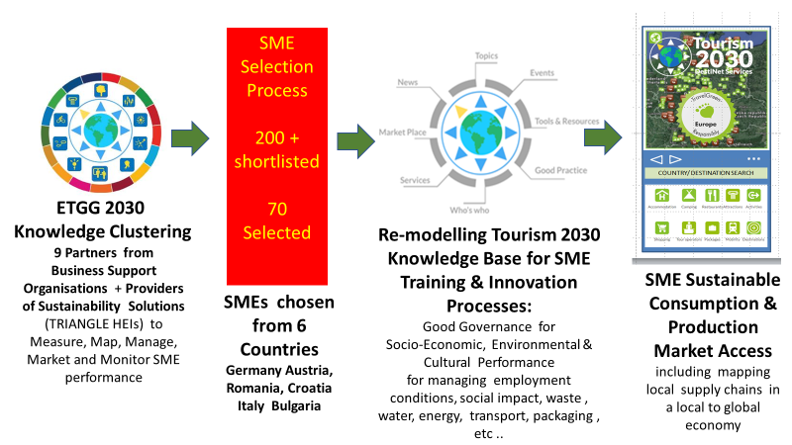
The Consortium that forms the ETGG 2030 project will pool expertise from higher education, chambers of commerce, tourism business associations and NGOs to establish an ICT-based cluster approach to developing and transferring innovative sustainable tourism best practice between countries. This cluster will have the project partners as its executive body for the duration of the project.
Using their network links in the cluster, they will build an expert knowledge base & support system to enable SMEs and supporting organisations to make evidence-based decisions to implement sustainability in their organisations.
From a selection list of 200-240 SMEs from 6 countries, 70 SMEs will be chosen to undertake a sustainable tourism improvement process in a 6 month training period.
The Cluster Partners will build maps of local supply chains and potential partners that will help improve SME sustainability performance.
They will then demonstrate their performance through applying for and obtaining third party certification as an objective proof of improvement. SMEs will then be able to raise their market profile by being placed in the worlds’ largest independent sustainable & responsible tourism market place – the Tourism2030 Certified Sustainable Tourism Market Place. The business and technical support organisations will then work with the SMEs using the Travel Green Europe App to develop: local to global sustainable supply chains; market access; consumer visibility, and also performance feedback.
The ETGG2030 project has an ICT based, knowledge-driven clustering methodology that has been supported by the Commission since 2002 – from DestiNet through Tourlsm Learning Areas and Tourism Knowledge & Innovation Communities to the TRIANGLE Tourism 2030 Portal. Now the Tourism 2030 system will be redesigned to contain a focus on boosting SME sustainability. Inside the cluster, the ICT knowledge base, training and innovation system will be built by a technical team that is already familiar with the networking technology.
Business Support Organisations will be provided with national language systems cloned from the overall European system to engage, train and support the SME moves towards more sustainable consumption and production in a circular economy approach.
The clustering methodology will enable timely and effective knowledge transfer throughout the EU to develop a set of evidence-based best practice examples to guide SME sustainability development. By using the GSTC as the global standard for measuring SME sustainability process and performance, the business support organisations will take the SME through a bespoke training package that will be related to local supply chain maps of sustainability solutions providers to ensure sustainability is actually implemented in the company. The certification process allows continued SME monitoring and certification beyond the life of the project.
Given the above methodological approach, the project calendarised methodological steps include;
- Establishing the consortium of nine business networks/ Chambers of Commerce and TRIANGLE Knowledge Alliance HEIs as a coherent European wide knowledge and innovation information sharing community to support SME sustainability implementation
- Developing a EU wide - all member state - sustainability toolkit and training service based on the long established Tourism2030.eu platform that has been already been geared to European and UN Agenda 2030 tourism sustainability processes and will now be remodeled to support the SMEs in their sustainability improvement programmes.
- Implementing that service in an exemplary manner in 9 destinations in 6 countries, choosing priority European tourism destinations including UNESCO cultural heritage sites and Natura 2000 sites in which SME sustainability is not an option but an immediate necessity
- Bringing the 70 tourism SMEs to be selected in the ETGG 2030 scheme into a common continuous development process that improves their knowledge acquisition, market access and local to global promotion in the worlds’ first consumer-facing app – Travel Green Europe – that links businesses going green to other businesses including tour operators and travel agencies reservation and booking systems as well as to customers who are contributing to sustainable tourism implementation.
Finally, the overall project methodology includes the definition of a post-project EU-wide business sustainability knowledge acquisition and training system that can function in the Agenda 2020-2030 policy-making decade as a service to support all European tourism SMEs throughout the supply chain in their move towards sustainable consumption and production (SCP12), minimizing their environmental impacts on the European territory (SCP 13, 14 and 15) and creating worthwhile and lasting employment opportunities (SCP8).

Participants | Participant Organisation Name | Short Name | Country | Typology
1 (Coordinator) | Modul University Vienna | Modul | Austria | PSS
2 | Ecotrans | Ecotrans | Germany | PSS
3 | ÖHV Touristik Service | ÖHV | Austria | BSO
4 | Croatian Chamber of Economy | CCE | Croatia | BSO
5 | Eberswalde University of Sustainable Development | HNEE | Germany | PSS
6 | Camera di Commercio Industria Artigianato e Agricoltura di Pordenone-Udine | CC Udine | Italy | BSO
7 | ASSET Basilicata - Azienda Speciale della Camera di commercio della Basilicata | ASSET | Italy | BSO
8 | European Center for Development, Execution and Management of Projects | ECDEMP | Bulgaria | BSO
9 | Asociatia Judeteana de Turism Sibiu | AJTS | Romania | BSO

