CSRTTC Examination System – Comprehension and Application of Tourism Sustainability Certification
Competence in Sustainable & Responsible Travel & Tourism Course TRIANGLE
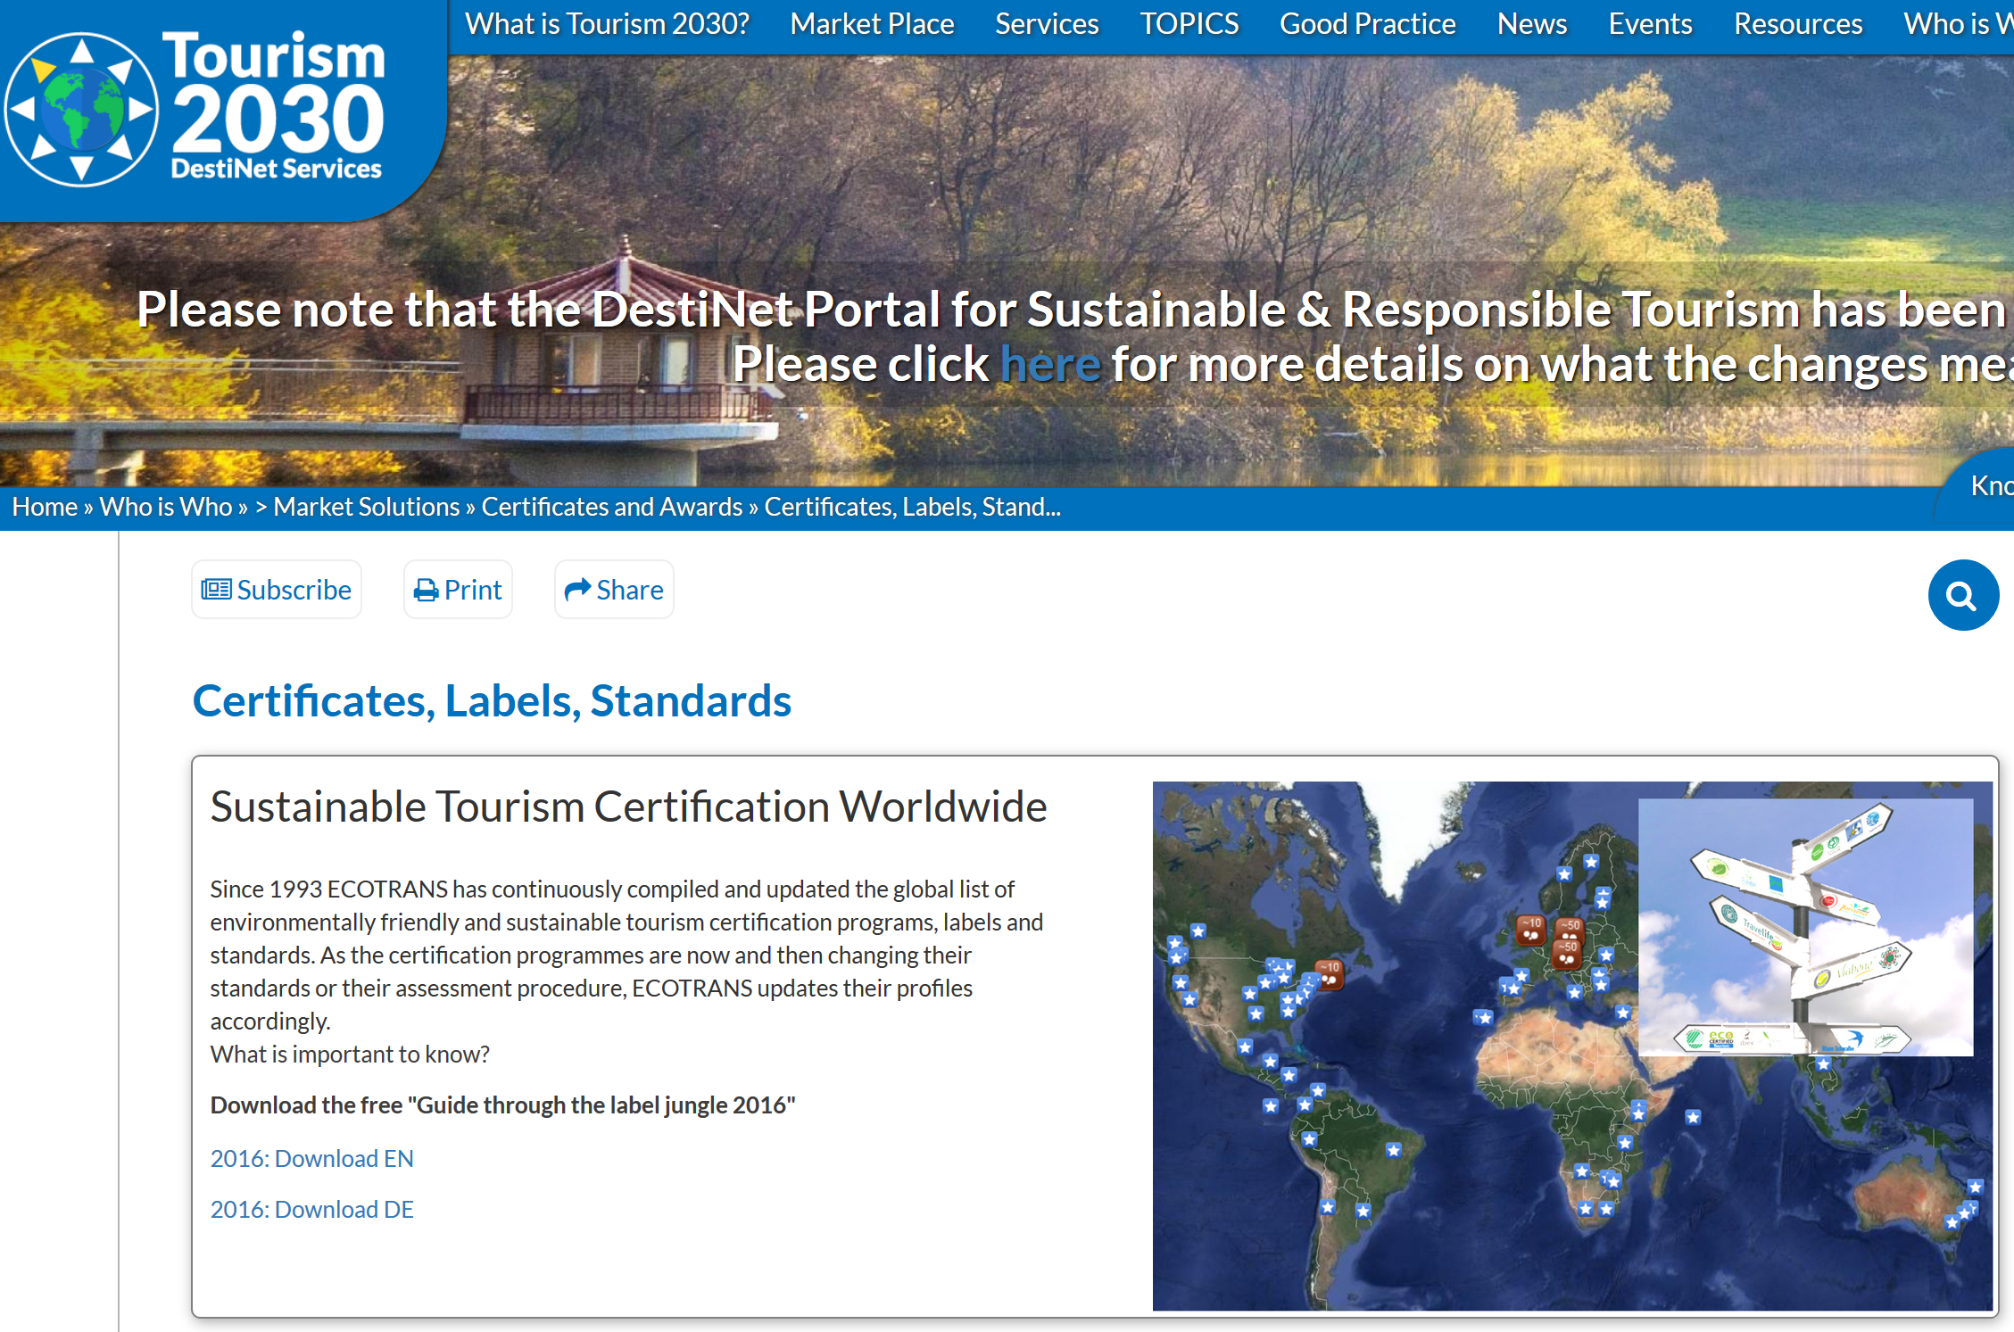
THE GSTC AND SUSTAINABLE TOURISM Certification

Notes for Students & Tutors
The examination system for the CSRTTC course has been devised as an ‘assessment for learning’ process, with the aim of developing in successful participants the knowledge and skills involved in the certification of sustainable and responsible tourism development. This has been designed in accordance to ISEAL guidance on evaluation of auditor competence, from which the assessment process is given structure. (cf:Evaluation of Auditor Competence R074 Internal Version 1 - September, 2007 www.isealalliance.org)
Introduction to the exam
This section of the CSRTTC course examination method is to ensure you are fully informed of the Global Sustainable Tourism Council and its role in the current world of tourism sustainability certification, within the overall context of sustainable development vis a vis the SDG 2030 Goals. Success in this part of the examination aims to show you have the competence to accurately portray the GSTC accreditation process and can a) achieve their course examination standard, from which many of these questions are derived to preserve the integrity, and b) apply the Tourism 2030 Portal tool kit alongside your conceptual understanding of tourism sustainability certification.
Examination Questions 2018

Name of Examinee:
Email contact:
Date of Assessment:

Qu 1 Sustainable Development and Tourism Activity -Use your own words to describe the four key principles of sustainable development that should be followed in order to ensure the long-term sustainability of the tourism industry.
Principle 1
:Principle 2
:Principle 3
:Principle 4:
Qu 2. List three publications/initiatives you could name as the important milestones in sustainable tourism certification since 1987?
A
B
C
Qu 3. What year was the GSTC formed?
1895
1967
2009
2015

Qu 4. Describe the main part of the GSTC’s mission? (Choose one)
a. To help all tourism organizations become accredited to the GSTC according to the GSTC criteria.
b. To encourage sustainability in all aspects of travel & tourism.
c. To develop an award for the most sustainable businesses
d. To promote sustainable travel and tourism to an international market-place.
Qu 5. Describe the four key areas of the GSTC’s objectives (choose one):
a. Certification – developing an international certificate for sustainable tourism businesses and destinations
.b. Accreditation – setting up an international organisation to develop and verify standards and practices applied by sustainable tourism certification programs.
c. Promoting greater market access for GSTC-accredited sustainable tourism certification programs.
d. Guiding destination management for better implementation of sustainable tourism development.
e. Requiring national tourism organisations to implement sustainable tourism policies marketing based on the GSTC Criteria.
Qu 6. Write down the GSTC’s four pillars of sustainability that structure the GSTC Criteria,
A
B
C
D
Qu 8. Which organisation below is not a certification body? (Select one)
a. Biosphere Responsible Tourism
b. Travelife
c. Global Sustainable Tourism Council (GSTC)
d. TourCert
Qu 9. The GSTC currently offer a sustainable tourism standard the “GSTC-Recognized” status? Select one of criteria used for this purpose:
a. That the standard only works with sustainable products and service that have been assessed by the GSTC’s marketing group.
b. That the GSTC has verified that the standard aligns with the GSTC Criteria and is administered by an organisation that is a member of the GSTC.
c. That the standard has been reviewed by GSTC Accreditation Panel and deemed equivalent to the GSTC Criteria.
Qu 10 Which of the following is a correct statement regarding the “GSTC Certified” status? (Select one)
a. Certification bodies that have been awarded the GSTC-Approval for their standards can claim to be “GSTC Certified”.
b. Businesses (hotels, tour operators, attractions, destinations) certified by certifying bodies that are GSTC-Recognized or GSTC-Approved are designated as “GSTC Certified”.
c. Businesses (hotels, tour operators, attractions, destinations) certified by certifying bodies that are GSTC-Approved or GSTC-Accredited are designated as “GSTC Certified”.
d. Accreditation bodies that comply with the highest ISO or ISEAL social and environmental standards can use the “GSTC Certified” mark.
QU 11. Are the following statements about the GSTC Industry Criteria (“GSTC-Industry”) correct?
a. The GSTC-Industry can benefit all tourism entities, but some criteria may be justifiably not applicable to the specific local context. Is this True or False? T/F (delete as necessary)
b. GSTC-Industry should be used with the understanding that micro businesses may not achieve comprehensive application of all criteria. Is this True or False? T/F (delete as necessary)
Qu 12. Describe, in your own words, what a tourism business needs to consider in order to meet the GSTC sustainable tourism standard?

Qu 13. Is the following description of the term “conservation management” as used in the GSTC Industry Criteria - ie- ‘A planned intervention in order to maintain a species or habitat in a favourable condition’. - an appropriate definition? Is this True or False? T/F
Qu 14. A destination can achieve the “GSTC Certified” mark by: (Select one)
a. Creating a national sustainable tourism standard that meets the “GSTC Recognized” requirements.
b. Becoming certified by a certifying body that has achieved the “GSTC Recognized” status.
c. Becoming certified by a certifying body that has achieved the “GSTC Approved” or “GSTC Accredited” status.
d. Becoming certified by the GSTC’s marketing group.
Qu 15. Which of the following are key aspects of a sustainable destination management strategy?
Mark as either T/F
a. A destination needs to develop a tourism strategy appropriate to its scale. T/F
b. Destination management organizations (DMOs) do not need to develop a sustainability strategy unless it is required by law. T/F
c. The GSTC require that a sustainable destination management strategy must be published and reviewed periodically. T/F
d. The development of a destination’s sustainability strategy requires permission of the regional government. T/F
e. The destination sustainability management strategy must cover environmental, social, cultural and economic issues. T/F
.
Qu 16. Could you see how to use the GSTC Criteria in practical terms in an organisation or place you know? List three ways in which you can now apply the GSTC Industry Criteria and/or the Destination Criteria in your own work.
200 words
List three certificates that have received ‘GSTC – Recognized’status.
A
B
C

List three tourism sustainability certificates with more than one hundred businesses in Europe.
A
B
C

Please state in your own words the benefits of certification for

A a business such as ah hotel or tour operator
100 words

B a destination
100 words

C from the traveler’s point of view
100 words

Thank you for completing this examination. Now please upload your completed submission to your CSRTTC Course folder, and inform your tutor by email or Skype that you have completed all your modules, including this comprehension assessment.

